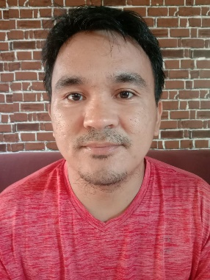

Christian M. Monteverde
Blk 1 Lot 4 Phase 2 Talomo
Teachers Village Talomo
Davao City 8000 Philippines
+639338239204/+639912306429
montechuck9@gmail.com
FB: Christian Monteverde

Responsible, innovative, passionate and committed professional with a get-it-done approach.

EXPERIENCE:
2005-2009: Delivery Man, Merchandiser, Junior Salesman, Warehouseman
2010-Up to Present: Logistics, Driver
SKILLS:
Warehousing, Computer Literate, Professional Driver
EDUCATION:
1990-1995: Talomo Central Elementary School
Talomo Davao City Philippines

1996-1999: St. Peters College of Toril
Toril Davao City Philippines

2000-2004: University of Mindanao
Bachelor of Science in Commerce Major-Management
Bonifacio st. Davao City Philippines

