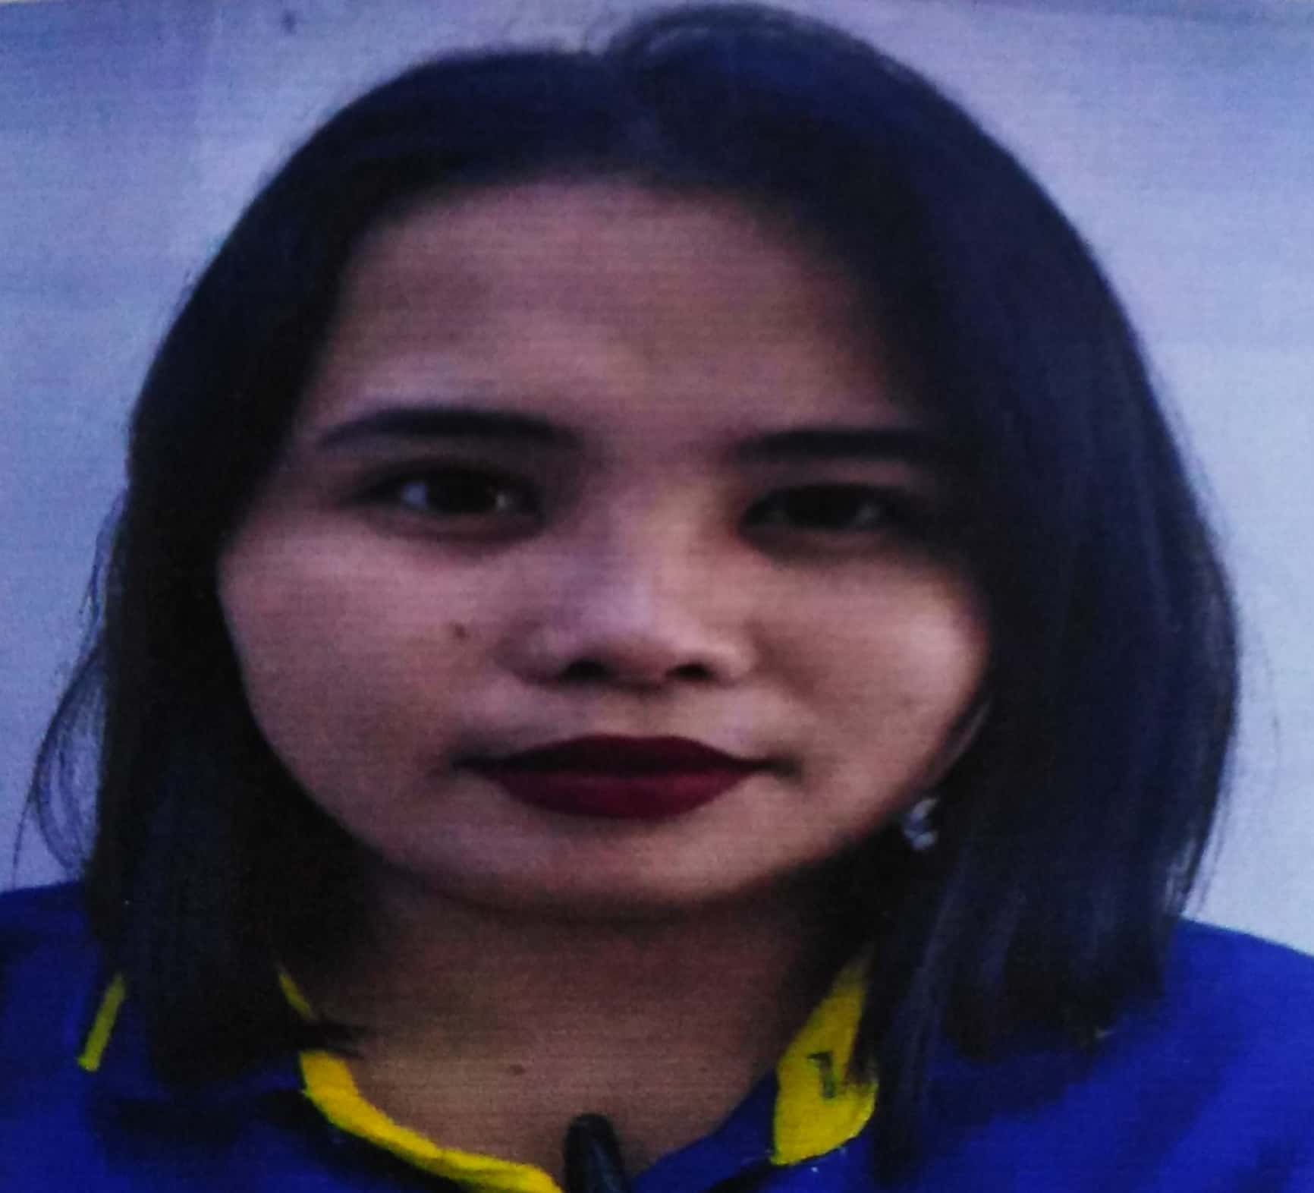
ELLEONY REGUDO
Email address: elleony68@gmail.com

Cell #+639324344767/ +639324281499
Address:198 A.Lopez Street Cebu City Phillipines

OBJECTIVES
- To secure a challenging position in a reputable organization to expand my learnings, knowledge, and skills.
- Secure a responsible career opportunity to fully utilize my training and skills, while making a significant contribution to the success of the company.
- Seeking an entry-level position to begin my career in a high-level professional environment.
- A highly organized and hard-working individual looking for a responsible position to gain practical experience.

PERSONAL DATA
Age: 28
Birthday: October 23, 1992
Birth Place: Cebu City, Cebu
Height: 5'0
Weight: 56
Gender: Female
Religion: Roman Catholic
Civil Status: Single
Language:English ,Tagalog

Educational Background
Elementary: Labangon Bliss Elementary School ( 2004-2005)
Labangon Cebu City

High School: Don Sergio Osmena Sr National High School (2009-2010)
Labangon Cebu City

SKILLS AND CAPABILITIES
- Good in communication skills
- Flexibility/Adaptability
- Able to work on task individually or as part of a team
- Able to focus on accuracy and attention to detail while under pressure and against deadline
- Customer Service
- Team Work
- Computer Skills
- Problem Solving
- Customer Service
- Collaboration /Team Work

WORK EXPERIENCES

- Fruitas Group Of Companies (Service Crew /Cashier 2011-2013)
- Dav Kev Kira Inc. (Service Crew /Cashier 2014-2015)
- Brownies Group Of Companies(Service Crew /Cashier April 9,2015-October 2015)
- Rulls Cellphone and Accessories (Cashier 2015 - 2020 )

CHARACTER REFFERENCES
- Therese Jane Bual
Hr Toyoflex
09664154235

- Norjane Balbuena
OIC Rulls Cellphone and Accessories
09658248162

- Michael Villarin Ramonida
Team Leader of Real me
09950585761

