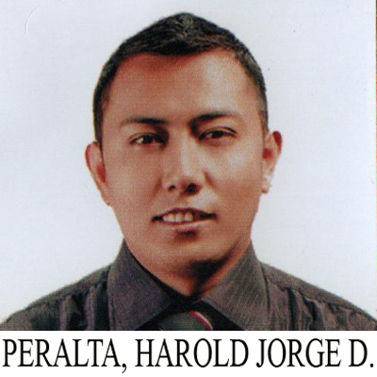
HAROLD JORGE D. PERALTA

Address: #35 Ilang - Ilang Street Block III Barangay San Vicente, Tarlac City
Email Add: peraltaharoldjorge@gmail.com
Contact Number: 09057832446

OBJECTIVE:_____________________________________________________________

To strength my knowledge and skills to utilize professional capabilities through continuous contribution, high degree of dedication and learning, and to build up on that involvement in achieving the aims and goals of the establishment.

CARREER HISTORY

Company Name : King Quest Food Corporation ( McDonald’s Paniqui Branch )
Company Address: Matatalaib, Tarlac City
Position: Assistant Manager
Date: May 10,2018 Up To Present
Job Description:
- Shift Leader
- Preventive and Building Maintenance Manager
- Service Manager
- Food Safety Manager
- Safety Officer
- Inventor Manager
- Production/Kitchen Manager

Company Name : Golden Arches Development Corporation ( McDonald’s Tarlac Branch )
Company Address : Paseo De Roxas Makati City, Philippines
Position : Service Crew
Date : November 27, 2014 To May 09, 2018
Job Description:
- Lobby/Dinning Person
- Batch Fried/ Fried Chicken Person
- Batch Grill Person
- Assembler Breakfast/Regular Menu
- Initiator
- Prepping/Preparation Person
- Transition
- Receiving Deliveries
- Maintenance Person
- Assembly Taylor
- Inventory Assistant

SEMINAR/TRAINING ATTENDED_________________________________________

- Virtual Customer Experience And Food Quality Management Course
( October 5-8, and December 2, 2021 )

- Introduction to Department Manager Course
( November 11 – 15 , 2019 )

- Operator’s Training Program ( Taylor C70 6 Soft Serve Machine )
( June 24, 2019 )

- Shift Management Excellence Course
( October 02-05, 2018 )

- Food Safety Course
( October 01, 2018 )

- Basic People Class
( August 13, 2018 )

EDUCATIONAL BACKGROUND:_____________________________________________

Tertiary: Bachelor of Science in Industrial Education
(Major in Industrial Arts)
Villa Lucinda Campus Binauganan, Tarlac City
Tarlac State University
School Year 2017

Secondary: Tarlac National High School
San Roque, Tarlac City
School Year 2010

PERSONAL INFORMATION:

Age: 27
Date of Birth: April 14, 1994
Place of Birth: Tarlac, Tarlac
Height: 5’6”
Weight: 78 kg
Religion: Roman Catholic
Civil Status: Married

REFERENCE:

Rhianna L. Balubayan
Operation Consultant McDonald’s

Jessa Mae Gazmin
Restaurant General Manager

I hereby certify that the above statements are correct to the best of my knowledge and beliefs.

HAROLD JORGE D. PERALTA
Applicant Signature over Printed Name

