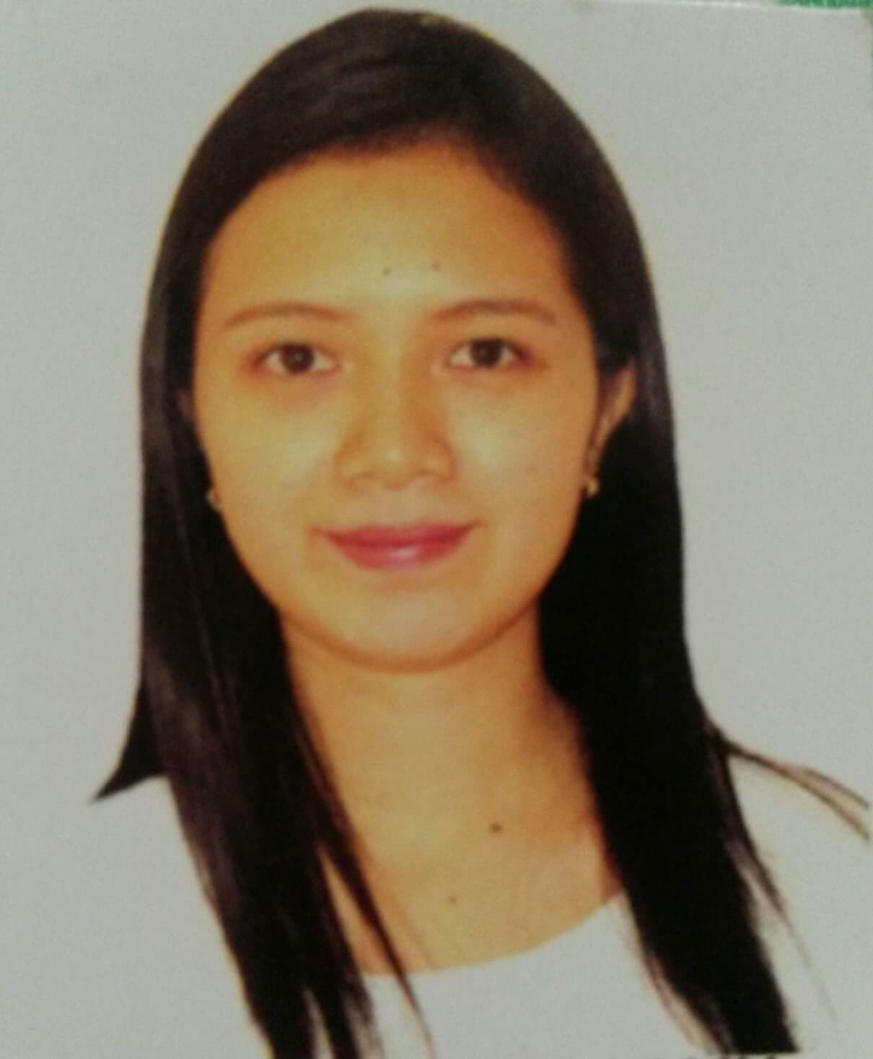
Mariel Grace Kwan Lagañosa
Address: Teacher’s Village, Maranding, Lala, Lanao del Norte
Mobile no: +639977438812 / +639268388990
Email: marielkwan@yahoo.com
Birthday: 26th March 1992
Place of birth: Baroy, Lanao del Norte, Philippines
Civil Status: Married
Sex: Female
Religion: Roman Catholic
Weight: 101lbs
Height: 4’11”
Citizenship: Filipino

Summary
Compassionate and friendly registered nurse with exceptional interpersonal skills. Highly motivated and looking for a position where my vast experience, deep passion and skills in providing a safe, effective and efficient nursing care can be utilized by following established processes, policies and practice of the institution. Furthermore, to contribute towards promotion of health and ensuring a better quality of life for everyone.

Education
Bachelor of Science in Nursing  Southwestern University, Cebu City, Philippines  Academic Achievement: Cum laude | 2009 - 2013
National Certificate II  Course: Caregiving | 2010

Certificates and Training
Parenteral Nutrition in Surgery July 2021
Basic Life Support April 2021
Lactation Management Training July 2019
Basic Wound Care and Wound Closure Technique February 2019
Basic Life Support Training February 2017
Basic Intravenous Therapy Training | February 2016
Leadership Formation Course and Leadership Development Program | July 2012
First Aid Training, Philippine Red Cross | July 2012
Personality Development | January 2011
Basic Life Support and Physical Assessment | December 2009

Current Employment

Nurse I , Kapatagan Provincial Hospital (Provincial Government of Lanao Del Norte)  (Pediatric Ward & Adult Medical Ward, Labor and Delivery Room Department, Infant Observatory Room Department) | May 2017 - present
Duties and responsibilities
- Receiving client from other caretaker and making sure of her safety.
- Providing quality nursing care; identifies nursing needs of client, establishes or contribute to an existing plan, gives and evaluates nursing care.
- Performing complete physical examinations on client.
- Consult with physicians and other members of the health care team as necessary.
- Assist physicians during treatments and examinations.
- Monitoring vital signs.
- Administering medications as ordered, observing for any reaction to drugs and recording those observations.
- Cleaning and setting beds in order and changing bed sheets and pillow covers.
- Providing advice and emotional support to client’s family members.
- Teaching patients and their families how to manage their illness.
- Providing physical and mental diversional activities.
- Providing safety measures as indicated by individual situations.

OTHER EMPLOYMENT
Staff Nurse, ASENTISTA DOCTOR’S HOSPITAL
September 2013—May 2017
(Out-Patient Department, Pediatric Ward, Adult Medical Ward, Emergency Department

References
Evelyn B. Mahusay, RN, MN
Nurse Supervisor-OR/DR DEPT.
Kapatagan Provincial Hospital
Mobile No.: 09352336532
Valentina I. Angod RN,MN
Chief Nurse
Kapatagan Provincial Hospital
Mobile No.: 09173240214

Elisa M. Unsang, RN
Retired Nurse Supervisor- OR/DR Dept.
Kapatagan Provincial Hospital
Mobile No. : 09263681732

