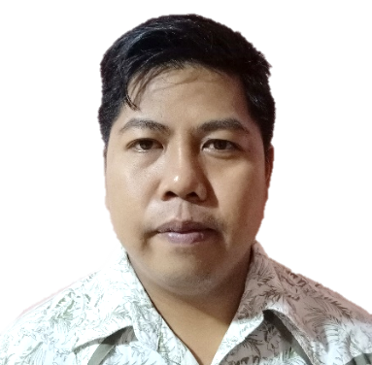
JAYSON PALOMIQUE FRAJENAL
Purok 2 Brgy. Pansol, Pila, Laguna
0921 8093 770
frajenaljayson1@gmail.com

____________________________________________________________________________

SKILLS AND COMPETENCIES
- Positive attitude in work
- Dedicated and hard-working in performing duties
- Willing to learn more

WORK EXPERIENCE
Company: San Miguel Brewery
Position: PQC Inspector
Date: May 16, 2011 – present
Nature of Work:
- Check the machine if they are within specs or if they fir for running for the production;
- Make test bottles and also test it to the machine;
- Release and hold goods;
- Inspect materials that is used for a packaged beverage like new and used bottles, shell, pallet, and crowns;
- Assign commission of new machine and make the machine perform to the need of production with passing compliance according to Quality Assurance parameters;
- Conduct trial to improve and to save basic needs of the company; and
- Make a report at the end of the shift and give it to the superior.

Other Experience
- On-the-job training at Honda Cars and assigned at Production Planning Control (PPC)
- Supply reliable parts on the given unit of car that have been produced
- Ensure that all the product that we supply are well inspected and fit for use

EDUCATIONAL ATTAINMENT
Tertiary
Dual Tech
Electromechanics Course – Electrical, Electronics, Mechanics
Year Graduated: 2011

Secondary
Don Manuel Rivera Memorial National High School
Brgy. Bulilan Sur, Pila, Laguna
Year Graduated: 2003

Elementary
Pansol Elementary School
Brgy. Pansol, Pila, Laguna
Graduated: 1997

OTHER PERSONAL DETAILS
Date of Birth: January 9, 1991
Place of Birth: Sta.Cruz, Laguna
Height: 5’5”
Weight: 80 kgs.
Nationality: Filipino
Religion: Roman Catholic
Civil Status: Married
Spouse’s Name: Rosie Furto Frajenal
Occupation: Housekeeper
Names of Children:
Thessa Jane F. Frajenal
Laureen Jenae F. Frajenal
Mother’s Name: Erlinda P. Frajenal
Occupation: Housekeeper
Father’s Name: Winifredo L. Frajenal
Occupation: None

REFERENCES
John Vito Grafil
PQC Inspector – San Miguel Brewery
09281822375

Jayson Velasco Millo
Supervisor– San Miguel Brewery
09184774761

____________________
Applicant’s Signature

