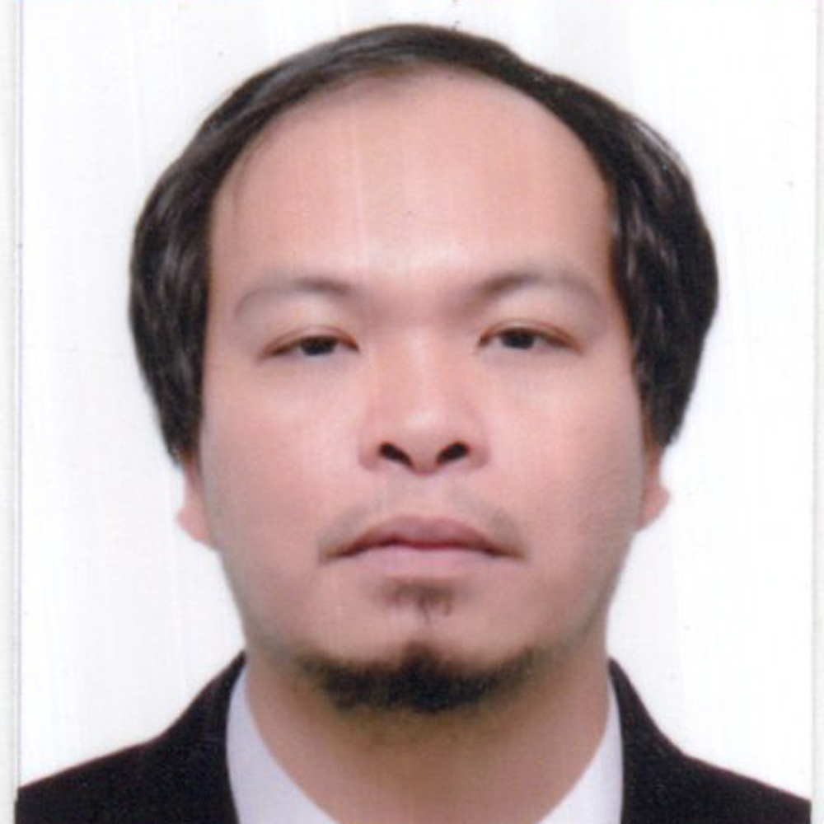

SABADO, ARIEL VILOAN
129 Zone, Kasag Calawisan, Lapu-Lapu CIty
09661468771
032-232-7387
arielsabado1982@gmail.com

___________________________________________________________________________________
OBJECTIVE: TO SECURE A POSITION WITH A WELL ESTABLISHED ORGANIZATION WITH A STABLE ENVIRONMENT THAT WILL LEAD TO A LASTING RELATIONSHIP IN THE FIELD OF INDUSTRY.
___________________________________________________________________________________
PERSONAL INFORMATION:

DATE OF BIRTH: April 6, 1982
AGE: 39
GENDER: Male
RELIGION: Roman Catholic
CIVIL STATUS: Married
HEIGHT: 5’4
BIRTH PLACE: Midsayap North Cotabato
LANGUAGE SPOKEN: Visayan, Tagalog, English

EDUCATIONAL ATTAINMENT:

TERTIARY:

Agro Industrial Foundation College of the Philippines 2001-2004 BSMT

SEA SERVICE EXPERIENCE:

FOREIGN LOCAL RANK VESSEL NAME YEARS TYPE
PRINCIPAL AGENCY & FLAG OF VESSEL
& ADDRESS

UNITEAM CYPRUS PTC OS COOK MV BUGOE 2019-2021 GEN. CARGO

DEDE GERMANY DOHLE A/B MV TROUPER 2017-2018 CONTAINER
SEAFRONT

MIDOCEAN CHILI DOHLE O/S MV TUBUL 27/01/16-19/10/16 CONTAINER
SEAFRONT

HERMS DHELSBERG NAVIA O/S MV ZIMBEIJING 23/03/15-08/10/15 CONTAINER
GERMANY

FOREIGN LOCAL RANK VESSEL NAME YEARS TYPE
PRINCIPAL AGENCY &FLAG OF VESSEL
& ADDRESS

HERMS NAVIA O/S MV BELLAVIA 10/04/13-31/10/13 CONTAINER
DHELSBERG

SPLIETHOFF SPLIETHOFF O/S MV DOLFINGRACHT 07/07/12-06/02/13 GEN. CARGO
MANILA HEAVY LIFT

SPLIETHOFF SPLIETHOFF O/S MV DOUWE-S 29/08/11-05/02/12 GEN. CARGO
MANILA

CERTIFICATE OF COMPETENCY

NCIII
11/4
11/5

TRAINING CERTIFICATE

BT, PSCRB, ATFF, SSA, MARPOL 1&2, PADAMS, ME, SCC

VISA

SCHENGEN VISA - Exp: 2024
U.S VUSA - Exp: December 2021

