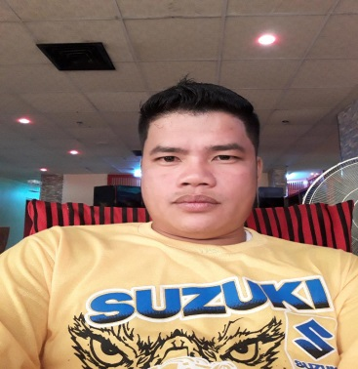
LEO O. VILLAFUERTE
UDDIAWAN SALAMAGUE SOLANO NUEVA VIZCAYA
CEL NO. +966550665241
EMAIL: leovillafuerte502@yahoo.com
__________________________________________________________________________________________________

OBJECTIVE:
To obtain a position where I could effectively apply my skills and knowledge I’ve learned and to give an opportunity to work productively and accurately in your company.

PESONAL INFORMATION:

Date of Birth: December 13 1986
Place of Birth: UDDIAWAN SALAMAGUE SOLANO NUEVA VIZCAYA
Age: 34
Nationality: Filipino
Gender: Male
Civil Status: Single
Religion: Roman Catholic
Heigth: 5’6”
Weight: 83kg

EDUCATION:

Primary: Uddiawan Elementary School
Secondary:
Vocational: Solano Institute of Technology
Course: Electrical Technology
Graduate: 2009-2010

WORK EXPERIENCE:

Company: Asia Manpower
Work: Electricain,Carpenter,Plumber
November 15 2011 to December 3 2013

Company: Jeddah clinic Hospital
Work: Electrician
June 8 2015 – Present

Responsibilities:

- Isolates defects in wiring, switches, motors, and other electrical equipment.
- Replaces faulty switches, sockets, plugs, fuses, insulators, and other simple elements of electrical systems, fixtures, and appliances.
- Checks clearance of moving parts.
- Install new wiring and electrical machinery.
- Fastens fixtures, switches, and outlet boxes in position.
- Operating generators and monitoring the currency.
- Applying the principles and rules of general safety during the work.
- Carrying out any other tasks charged to him within his field of specialization.

Special Skills:

- Must have knowledge of electrical installation in public building and safety codes.
- Ability to handle a variety of changing duties resulting from the complexities of electrical apparatus and equipment.
- Capable of working under emergency conditions.
- Must speak and understand English and Arabic are highly desirable.
I hereby certify that the above information are correct with the best of my knowledge.

Mr. Leo O. Villafuerte
Applicant’s Signature

