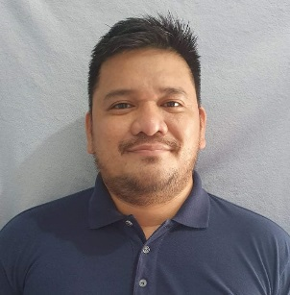
RENATO H. DELA PEÑA JR
0056 door 2 Apt, Sunrise Street, Sunrise Subdivision,
Barangay San Isidro Taytay Rizal
Rjdelapena@gmail.com
+63-917-742-4708 / +63-949-197-9915

OBJECTIVE:
To be a part of a progressive organization in which I can contribute my knowledge and skills as well as to gain more experience for the advancement of my potentials, work effectively with people and acquire fulfillment in the field I have chosen
WORK EXPERIENCE

Information Express
Company Driver / Messenger
September 2013 to October 2015
Paco Manila , Philippines
- Driving clients daily to their desired destinations
- Perform some other undertakings like shopping, dropping and picking clothing, getting lunch, and running errands

JLA Movers Incorporated
Trailer Truck Driver
March 2015- Present
Pasig City, Philippines
- Trailer drivers transport a range of materials, merchandise, or equipment using heavy-duty vehicles.
- Drive for long periods, carrying out long-distance deliveries, adjusting to driving conditions appropriately and safely
- Loading and unloading materials or merchandise, preparing delivery papers, and keeping records of their daily tasks.

ACADEMIC PREPARATION
- Tertiary
Bachelor in Secondary Education Major in PE
Trinity University of Asia
Undergraduate ( S Y 2003-2005
- Secondary
Pasay City West High School
S Y 1995-199

INTERNSHIP TRAINING / CERTIFICATE

Phil Asia technical Consultant
And General Services
Trailer Truck Driver
Training Passer
S Y 2020

SKILLS AND QUALIFICATION
- Good communication. A lot can happen while a driver is over-the-road that doesn't fit into the day's original plans.
- Proven work experience as a Truck Driver
- Hands on experience with electronic equipment and software (GPS, AVL units, CB etc.)
- Have skilled at driving a commercial truck,
- Patient: able to accept or tolerate problems without becoming annoyed

- Helpful: giving or ready to give help

- Flexible: ready and able to change so as to adapt to different circumstances

- People-Oriented: focused on interaction with people

PERSONAL INFORMATION

Birth Date : August 14, 1981
Birth Place : Pasay City
Height : 5’5
Weight : 73kilo
Sex : Male
Civil Status : Single
Religion : Roman Catholic
Nationality : Filipino

CHARACTER REFERENCES
- Mr. Elmer Ignacio
Mandaluyong City
+966-926-600-9600

- Mr. Oliver Pangan
Mandaluyong City
+966-908-896-6736

- Mr. Rellie Abustan
Taytay Rizal
+966-961-283-8588

I hereby certify that the above information is true and correct to the best of my knowledge and belief.

Renato H. Dela Peña JR
Applicant Signature

