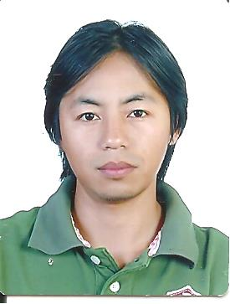
 Curriculum Vitae

EFREN M. MATINAC
Address: San Luis Village, Baguio City
E-Mail Address: matinacefrenmurphy@yahoo.com
Contact #: 09631591667

Objective: To be able to build a career showcasing my skills in an excellent and fast-growing company for the benefits of the company and my family.

Work Experience:
- SB Tech
Chungcheong buk Do
South Korea
Duration: April 7 2015- March 2, 2020
Position: Factory Worker
- Machine operator (Aluminium Die Casting M/C, Hydraulic Press M/C)
- Forklift operator, Overhead Crane operator
- Welder (SMAW,MIG)

- Advantest (Site Plant: Texas Instruments Phil Inc.)
PEZA Loakan Road
Philippines
Duration: Jan 2014- Feb 2015
Position: Field Service Engineer

- Nagae Techno Arts and Trades
Takaoka Shi, Toyama Ken
Japan
Duration: Oct 2010- Oct 2013
Position: Factory worker
- Machine operator (Die Casting M/C)

- RNM Dynamics (Site Plant: Texas Instruments Phil Inc.)
PEZA Loakan Road
Philippines
Duration: Feb. 2009- Aug. 2010
Position: Field Service Engineer

- Pythos Philippines Inc. (Site Plant: Texas Instruments Phil Inc.)
PEZA Loakan Road
Philippines Duration: Jun. 2006- Dec. 2008
Position: Technician

Skills:
- Computer Hardware Maintenance
- Computer Troubleshooting
- MS office application
- Electronics Diagram interpreting and application
- Knowledge in Carpentry and masonry
- Heavy Equipment operations ( Excavator, Bulldozer, Wheel Loader)
- Welding (SMAW and MIG)

Language: Filipino
English (IELTS band score= 6.0)
Basic Korean
Basic Japanese

Educational Attainment
Elementary
Barlig Central School (1997) - Graduate
-Barlig, Mountain Province

Secondary
Barlig National High School (2002) –Graduate
-Barlig, Mountain Province

Tertiary
BETI College of Technology (2006) – Graduate (Bachelor of Science in Information Technology)
-Harrison Road, Baguio City

Personal Details
Age: 36 Religion: Christian (Roman Catholic)
Weight: 65kgs Height: 167cm
Marital Status: Married Birthdate: Dec. 29, 1984

Character References:
1. Joy M. Kinfia
TI (Phil) Production Specialist
09360260073

3. Mrs. Josie Argonza
TI (Phil.) Inc. Shift Supervisor
0107063055

