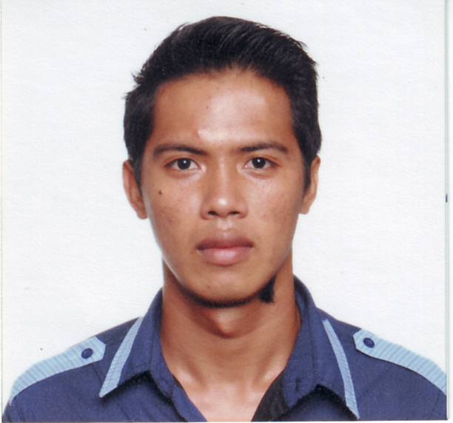
KELVIN V. SABIDALAS
#580 ML.F, Subdivision, Brgy Nueva,
San Pedro, Laguna.
Contact no. 0998-354-57-55 / 0915-219-72-23
sabidalaskelvin@yahoo.com

OBJECTIVE

To obtain a position in your company which will help me to develop my Professional skill, improve my knowledge and attain experience that will benefit my present and future.

WORK EXPERIENCE:

- Sales Executive
Weathertech Refrigeration and Aircon Co.
Lot 5 Block 11 Lodora Ave, Lodora Village, Tunasan Muntinlupa City
August 1, 2017 – March 12, 2021

- Machinist & Fabricator / Sales Representative / Facilities Custodian
Synergi Machine & Design Co.
565 ML. F Subd. Nueva, San Pedro, Laguna
October 18, 2015 – June 30, 2017

- Store Specialist
Bounty Agro Ventures Inc.
Unit 1008 Taipan Place Building, Emerald Ave.
Ortigas Center, Pasig City
March 16, 2015 – August 31, 2015

- Liaison Officer
Bounty Agro Ventures Inc.
Unit 1008 Taipan Place Building, Emerald Ave.
Ortigas Center, Pasig City
September 6, 2013 – March 13, 2015

- Liaison Officer and Researcher
Enclave Estate Corporation
Labo, Camarines Norte
May 2, 2011 up to July 26, 2013

- Technical Support
St. John the Apostle Academy
Labo, Camarines Norte
May 24, 2010 up to August 31, 2010

- Project-in-charge
Enclave Estate Corporation
Labo, Camarines Norte
April 19, 2009 up to September 23, 2009

EDUCATION:

College Computer System and Network Technology
AMA Computer Learning Center College
2ndflr. Maristel Bldg. Mc – Arthur Hi- way
Calvario, Meycauayan, Bulacan.
October 2008

Secondary St. John the ApostleAcademy
Villaflores St. Labo, Camarines Norte
March 2006
Primary LaboElementary School
Burgos St. Labo, Camarines Norte
April 2002

SKILLS:

- Basic Auto-cad drafting
- Knowledgeable in MS (Word, Excel, Power Point)
- Knowledgeable in Computer Troubleshooting and hardware
- Knowledgeable in Computer Networking.
- Operating CNC Lathe & Milling Machine
- Operating Basic Conventional Lathe & Milling Machine
- Basic Tig Welding

SEMINARS AND WORKSHOP:

- PC Trouble Shooting
AMA Computer Learning Center College of Meycauayan
September 29, 2008

- Interfacing Assembly Language using Turbo C
AMA Computer Learning Center College of Meycauayan
February 27, 2008

- Leadership Training Seminar
AMA Computer Learning Center of Daet
August 23, 2007

PERSONAL DATA:

Name: Kelvin Valenzuela Sabidalas
Present Address: #253 Sgt. Ramores Ext., Brgy. Pinya, Labo, Camarines Norte
Date of Birth: April 16, 1990 Age: 28
Height: 5’4 ft. Weight: 59
Citizenship: Filipino
Civil Status: Single
Father: Eduardo L. Sabidalas Occupation: Vendor
Mother: Amalia V. Sabidalas Occupation: Vendor
Language/Dialects: Tagalog, English and Bicol

CHARACTER REFERENCES:

- Ms. Jovilyn Sicat
Finance Supervisor
Bounty Agro Ventures Inc.
Mobile No. 09756885330

- Mr. Concepcion Dalanon
Synergi Machine and Design.
Mobile No. 09177574743

- Mr. Royden Calibuso
General Manager
Kapu Engineering Services
Mobile No. 09178624322 / 09201170690

I hereby certify that all information given is correct and true

__________________________
KELVIN V. SABIDALAS

