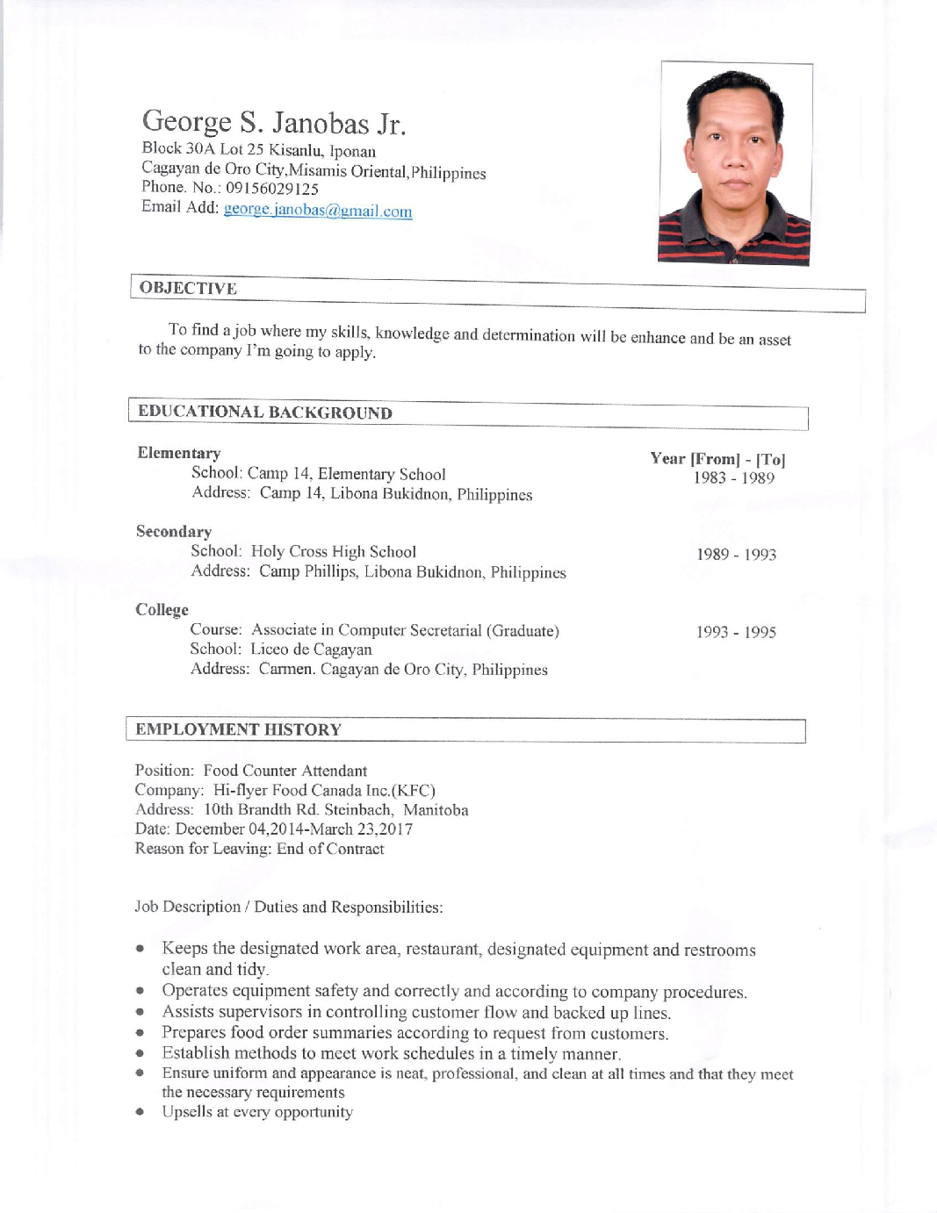
George S. Janobas Jr.
Block 30A Lot 25 Kisanlu, Iponan
Cagayan de Oro City
Phone. No.: 09156029125
Email Add: george.janobas@gmail.com

OBJECTIVE

To find a job where my Skills, Knowledge and Determination will be enhance and be an asset to the company I’m going to apply.
EDUCATIONAL BACKGROUND

Elementary. Year [From] – [To]
School: Camp 14, Elementary School. 1983 - 1989
Address: Camp 14,Libona Bukidnon
Secondary
School: Holy Cross High School 1989 - 1993
Address: Camp Phillips, Libona Bukidnon
College
Course: Associate in Computer Secretarial (Graduate). 1993 - 1995
School: Liceo de Cagayan
Address: Carmen, Cagayan de Oro City
EMPLOYMENT HISTORY

Position: Shift Manager
Company: Hi-flyer Food Canada Inc. (KFC)
Address: 10th Brandth Rd. Steinbach, Manitoba
Date: June 05, 2018 – June 05, 2020
Reason for Leaving: End of Contract
Job Description / Duties and Responsibilities:

- Supervice and coordinate activities of staff who prepare and portion food,
- Ensure food service and quality control,
- Train staff in job duties, sanitation and safety procedures.

Position: Food Counter Attendant
Company: Hi-Flyer Food Canada Inc. (KFC)
Address: 10th Brandth Rd. Steinbach, Manitoba
Date: December 04, 2014 – March 23, 2017
Reason for Leaving: End of Contract

Job Description / Duties and Responsibilities:

- Keeps the designated work area, restaurant, designated equipment and restrooms clean and tidy.
- Operates equipment safely and correctly and according to company procedures.
- Assists supervisions in controlling customer flow and backed up lines.
- Prepares food order summaries according to requests from customer.
- Establish methods to meet work schedules in a timely manner.

Position : Restaurant Team Leader
Company: Tummy Bliss Corporation (KFC)
Address: Limketkai Drive, Rosario Arcade, Lapasan Cagayan de Oro City, Philippines Date: April 03, 2003 – November 16, 2014
Reason for Leaving: Resigned
Job Description / Duties and Responsibilities:

- Assist in training RTMs using the STAR 2000 Training System.
- Supervices daily and weekly cleaning, checks cleanliness and sanitation of work area.
● Checks product and holding equipment is in good running condition(2x).
● Ensures FIFO method of products.
● Checks the quality of cooked / finished product
● Ensures that expired products are properly endorsed to the duty manager
● Ensure that LO. Lapsed and off quality products are handled properly. ( Documentation to be done
By the duty manager)
● Maintain orderliness and cleanliness of stockroom and overall restaurant area.

TRAININGS / SEMINARS ATTENDED

Training Center: Kentucky Fried Chicken (KFC)
Duration: March 16, 2017
Address: Winnipeg
Title: Product Roll Out (OR Tenders)
Training Center: Kentucky Fried Chicken (KFC)
Duration: April 22, 2012
Address: Limketkai, Cagayan de Oro city
Title: Back to Basic Program

Training Center: Kentucky Fried Chicken (KFC)
Duration: September 17, 2005
Address: Limketkai, Cagayan de Oro city
Title: Pest Control, Pollution Control & Drug Awareness

Training Center: RAMCAR CENTER
Duration: December 06 to 10, 2006
Address: Davao City
Title: Team Leader Development Program

Train the Trainer Workshop
Product Quality Workshop
SING Workshop
Centralized Cashier Program
Customer Mania 1,2,3,4
Health Seminar, Safety and Security Orientation
Lakad 1998-2010
ACHIEVEMENTS / SPECIAL SKILLS / INTEREST

● Top 1 Champs Challenge Vismin 2 Area Competition 2012
● Best Cook Champs Challenge Vismin 2 Area Competition 2012
● Top 1 Champs Challenge Vismin 2 Area Competition 2010
● Best Cook Champs Challenge Vismin 2 Area Competition 2010
● Best Pantry Champs Challenge Vismin 2 Area Competition 2010
● Representative Champs Challenge PC6 Competition 2010
● Top 1 Champs Challenge Area Finals 2008
● Top 4 Champs Challenge Vismin 2 Area Competition 2005
● Top 5 Champs Challenge Vismin 2
● Representative 14th National Champs Challenge held in KFC Liberty, Mandaluyong City, Philippines 2008
● Most Improve Team Member 2007
● Best Team Leader 2006
● Best in Pantry 2003
● Being the Most Valuable support given to operations
● Skilled in food preparation
● Active team player
● Ability to train others
● Remain calm under pressure
● Demonstrates willingness to learn
CHARACTER REFERENCES

Mila Milar Paguia
Public School Teacher
Bonbon, Cagayan de Oro City
Tel. No.: 09354721575

