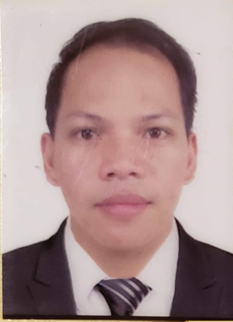
Israel caesar d. Tamang
Sta.Cruz, Angat, Bulacan Philippines.
israeltamang@ymail.com/israeltamang@gmail.com
Facebook Account: IC Tamang

OBJECTIVE
Seeking a job position with a company which will require me to utilize my skills, abilities and experience in the dairy field to ensure the company success.

Experience
- PURENUTS DAIRY FARM
086-0216 Hokkaido Notsuke-Gun Betsukai-cho Betsukai 156-2
Hokkaido Japan.
Contact No: (+81 ) (0) 90-1640-1608 ( Farm owner)
August 25, 2017 up to Present
(End of contract by September 2022)

Dairy Farm Worker
- Directly responsible in milking the cows twice a day.
- Follow recommended pre- milking preparation of cattle before milking.
- Milk all cows in an orderly proper and consistent manner.
- Cows that may have mastitis or other problems and inform to farm owner for possible treatment
- Made milk testing in every teat when mastitis are arising and provide necessary treatment for infected teat.
- With a knowledge To treat a mastitis cow’s using a appropriate antibiotics
- Directly responsible to transfer the dry cow to calving pen.
- Assist cow if having a difficulty in calving .
- Assist technician when artificial insemination are made
- Maintain treatment records and identify treated cows with the appropriate markers such as legs band etc.
- Observe heat/ estrus cow
- Feeding the cow’s using TMR Mixer attached to tractor.
- Routinely check freshening area and assist in birth- ing process as needed
- Check all animals on a timely basis two to three times per day to be certain they are receiving adequate feed be certain clean water is available at all times.
- Be certain barns and bed of the cow cleaned daily and change the beddings using farm equipment like pay loader, roll hay cutter and tractor etc.
- With a knowledge to dry a cow using appropriate antibiotics.
- Perform routine vaccinations under supervision of the farm owner.
With a knowledge to operate farm machineries equipment but also willing to enhance and Develop the driving skills.
- Use farm equipment to move feeds, animals ( lame cow) into appropriate areas on the farm.
- Monitor dairy cows for signs of potential disease to ensure that all livestock remain in optimum health And produce high quality milk.
- Treat minor injuries or illnesses as they occur.

PERSONAL INFORMATION
BIRTHDATE: December 13, 1992
BIRTHPLACE: Sto. Cristo Angat Bulacan Philippines
GENEDER: Male
CIVIL STATUS: Single
NATIONALITY: FILIPINO
HEIGHT : 5’0 & WEIGHT: 65Kg

EDucational background
College : BULACAN STATE UNIVERSITY
- BACHELOR IN INDUSTRIAL TECHNOLOGY
MAJOR IN COMPUTER TECHNOLOGY
- Year: 2009-2011

TRAINING ATTENDED
- SPECIALITY GRADE OF DAIRY
Certificate holder passed the evaluation examination of Technical Skill Training system of Agriculture on January 17, 2020 Hokkaido Japan.
- ELEMENTARY GRADE OF DAIRY
Certificate holder passed the evaluation examination of Technical skill Training System of Agriculture on May 29, 2018 Hokkaido Japan.
- Production Agriculture – DAIRY INDUSTRY given on August 2016 by AUSTRALIAN AND
INTERNATIONAL AGRICULTURAL EXCHANGE “ AGRICULTURAL EXPERIENCE IN AUSTRALIA"
( Under by Special Program subclass 416 visa)
- Animal production NATIONAL CERTIFICATE II
TESDA CONCEPCION TARLAC PHILIPPINES.

