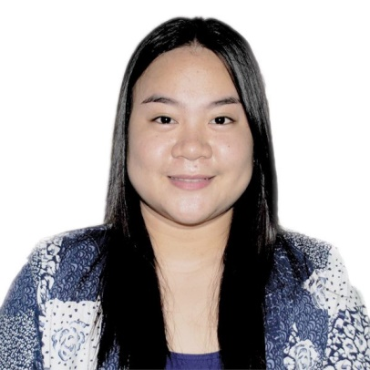
CAREER OBJECTIVE

To work in a respectable organization that will harness my work background. To contribute to the organization’s noble vision and simultaneously provide excellent opportunities for personal growth and career development.

Tertiary:
Saint Louis College
Carlatan, City of San Fernando,
La Union
BSBA Major in Financial Management
S.Y. 2016-2019

San Pedro College of Business Administration
San Pedro, Laguna
BS in Accountancy
2015-2016

Secondary:
Regional Science High School for Region 1
Bangar, La Union
SY 2011-2015

Primary:
Sengngat Elementary School
Seng-ngat, Sudipen, La Union
SY 2005-2011

TESDA
Brgy. Catbangen, San Fernando City La Union
Feb. 15, 2019 – April 1, 2019 (157 hrs.)

Philippine Red Cross La Union Chapter
Don Pablo Bldg. Widdoes St. San Fernando City La Union
May 27, 2019 - June 6, 2019 (84 hrs.)

- 2nd Honorable Mention from Gr. 1-6
- Alay Pamasko Scholar-
S.Y. 2017-2018
- Deans Lister S.Y. 2017-2018
(Second Semester)

Available upon request.

CELINE N. ANCHETA
#69 Sitio Camanggaan II,Sengngat, Sudipen, La Union
Contact #: 09982871022
E-mail Address: enilecancheta@gmail.com
SUMMARY OF QUALIFICATIONS

- Budgeting and finance
- Dedicated and hardworking individual
- Exposed and interact with a wide variety
of personality
- Can manage time wisely
EDUCATION

- Able to work effectively within team
- Computer literate
SEMINARS ATTENDED

- Train Law Phase I (March 18, 2019)
Social Center, SLC, City of San Fernando La Union

- Stocks Fundamental Analysis and Mutual Funds vs. Uitf Seminar (Feb.16,2019)
Social Center, SLC, City of San Fernando La Union

- National Finance Summit (Jan. 12, 2019)
SMX Convention Center, Pasay, City

- Stock Trading Seminar (Nov.17, 2018)
SLC Elementary Canteen, Carlatan, City of San Fernando, La Union

- Entrepreneurship: Building Local and International Business (Oct. 13, 2018)
ON THE JOB TRANING

Social Center (SLC), Carlatan, City of San Fernando La Union

- English Now Program (Bryce)
(Oct. 7, 2017)
Café Louisino (SLC), Carlatan, City of San Fernando, La Union

- An Empowered Personality (Jan. 14, 2017)
BSP,City of San Fernando La Union

PERSONAL INFORMATION

Birthdate : December 31, 1998
Place of Birth : Muntinlupa City
Age : 22 yrs. old
Gender : Female
Civil Status : Single
Religion : Roman Catholic
Citizenship : Filipino
WORK EXPERIENCE

RNP GAS STATION (PETRON) – Administrative Assistant
July 28, 2019 - PRESENT
CHARACTER REFERENCES

- Arnel A. Francisco
Service Manager
Eastwest Bank
09328471572

- Astaire Vance Iedritz P. Pinzon
Station Manager
RNP GAS STATION (PETRON)
Bangar, La Umion
09157977515

- Wilfredo M. Macanas
Brgy. Chairman
Seng-ngat, Sudipen, La Union
09193887783

