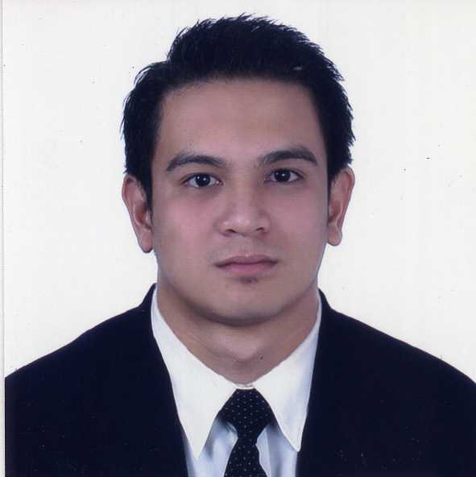
Jianh Paulo A. Crucillo
377 A. Bonifacio St. Poblacion 2
Indang, Cavite
0915-888-4692
cjianhpaulo@yahoo.com

OBJECTIVE:

To obtain a responsible and challenging position that will develop my skills and knowledge and will promote professional development and career growth, thereby become a mover, an interacting member, and a contributor to your company’s goal to progress.

WORK EXPERIENCE:

Casino/Cage Cashier
October 24, 2016- Present
Resorts World Manila
Newport Boulevard, Newport City
Pasay 1309, Metro Manila, Philippines

- Provide excellent service, consistent with the property’s core service standards and brand attributes.
- Assists patron with general information
- Perform procedures in accordance with the gaming regulations, company policies and departmental procedures.
- Perform cash out and purchase of chips and tickets (ticket in ticket out).
- Conduct front money transactions on patrons account, group account (deposits, withdrawals, redemptions and issuance)
- Redeem all acceptable foreign currencies.
- Proactively greet, interact, and assists resort staff in a professional manner to foster and promote a cooperative and harmonious work environment.
- Secure company assets.
- Document all recordable transactions in accordance with the company standards.
- Perform all other job related duties as requested.
.

Front Office Supervisor
January 11, 2014- January 18, 2016
Hospitality International Inc.
Parque España Residence Hotel
5309 East Asia Drive Filinvest Corporate City
Alabang Muntinlupa City, Philippines

- Assist the Front Office Manager in ensuring the smooth and efficient overall day-to-day operations of the Front Desk
- Provide excellent customer service per the standards of the hotel, and assist in situations to ensure customer satisfaction.
- Assist in providing staff with ongoing coaching, training and development.
- Responsible in scheduling staff and manning.
- Over all in charge of Front Office Cashiering
- Transportation Officer in Charge
- Relieves Duty Manager during days off.

Front Office Agent/Bellman
July 19, 2010- January 10, 2014
Hospitality International Inc.
Parque España Residence Hotel
5309 East Asia Drive Filinvest Corporate City
Alabang Muntinlupa City, Philippines

- receive reservations for accommodation from clients, either in person or by telephone, fax or email
- take guests' details and allocate their rooms
- talk to transport carriers (e.g. airlines, bus companies, rental car agencies) to make travel arrangements for guests and to find lost luggage
- inform guests about the hotel facilities, policies and procedures
- provide tourist information to guests
- make reservations for sightseeing tours, restaurants, the cinema and live entertainment
- deal with inquiries and requests from guests
- take messages for guests
- calculate guests' bills and issue receipts upon payment
- arrange accommodation for guests travelling to other destinations
- perform cashier duties, and exchange foreign currency
- place guests' possessions in a safe if requested
- coordinate the cleaning of guests' personal laundry and room service deliveries
- follow in-house procedures to help ensure the security of guests and employees
- Conducting the Bell service activities such as luggage service upon guest's arrival and departure, luggage storage, message service fax delivery, parcel and mail hand-over, information service and other related tasks.
- Opening the door of the car for the guest in a professional manner at the main entrance of the hotel and assisting to unload the luggage if any.
- Extend warm welcome and appreciation to everyone
- Rooming the guest in a professional way, this includes addressing the guest by name, holding the lift for guest and extending hotel introduction to guest, etc.

EDUCATION:

- Bachelor of Science in Tourism Management
De La Salle University-Dasmariñas
2007-2010
- Bachelor of Science in Electronics and Communication Engineering
De La Salle University-Dasmariñas
2004-2007

SEMINARS/TRAININGS ATTENDED:

- Fraud Detection on Peso, Dollar and 3rd Currencies
AIM Conference Center Manila, Makati City
July 7, 2012
- Banco De Oro- Credit Card Seminar
Parque España Residence Hotel
April 8, 2012
- Hospitality International Inc. Customer Service Training: Revisited
(People and Processes, Emotional Connection and Capturing Every Opportunity)
Picasso Boutique Serviced Residences Makati City, Philippines-
February 24, 2011
- Abacus Functionalities for Tourism Students
Abacus Distribution Systems Phils. Inc
3/F Trafalgar Plaza H.V. Dela Costa St.
Salcedo Village, 1227 Makati, City
December 7-11, 2009

PERSONAL BACKGROUND:

Age: 31 years old
Religion: Roman Catholic
Citizenship: Filipino
Civil Status: Married
Birthday: October 13, 1986
Birthplace: Quezon, City
Height : 5’10
Weight: 180 lbs.

CHARACTER REFERENCES:

Available upon request

Jianh Paulo Crucillo

