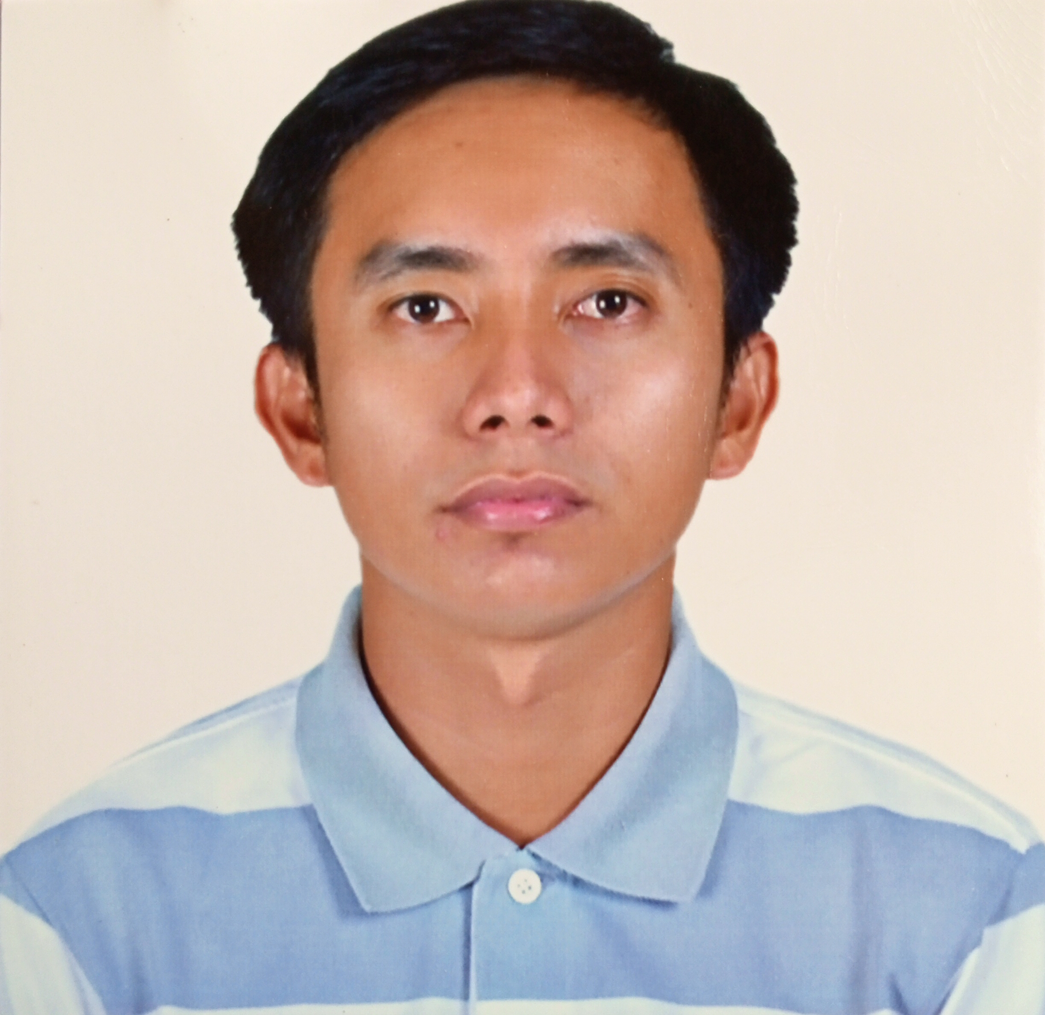
JELJOHN M. SUMAYA
Purok Lubi, New Bulatukan, Makilala, Cotabato, Philippines
+639517359338
Email: jeljohn.sumaya2018@gmail.com

Experienced Swine Technician with 3 years work experience in swine farming at Q-Pigs Livestock Corporation (powered by Topigs Norsvin). Has knowledge and experience in different aspects of swine production. A fluent speaker of English language, self motivated, creative, resourceful and adaptable to different working environment.

RESUME SUMMARY
Position Applied for : Swine Technician
Latest Position : Swine Technician
Latest Industry Sector: Livestock Production
Highest Education : College Graduate

CAREER OBJECTIVE
- To be part of a reputable company and enhance my skills and deliver the best work results out of my consistent hard works.
- To apply my skills in hands-on operation of a swine farm.

SKILLS
- Knowledge and experience with swine production and management
- Leadership
- Great communication skills (oral and written)

EMPLOYMENT HISTORY

PRESENT:
Company Name : Q-pigs Livestock Corporation, powered by: Topigs Norsvin
: Purok Capareda Barangay Acmonan, Tupi, South Cotabato
: Tunnel ventilated farm and a nucleus farm
: December 2018 up to present
Job Position : Swine Technician

Duties and Responsibilities

GENETIC CENTER
- Conducts manual and automatic ejaculation in collecting semen.
- Assists in laboratory processing.
- Performs feeding, medication and vaccination.
- Monitors health status.
- Monitors building.
- Performs cleaning, and disinfection for biosecurity measures.
- Record keeping.

BREEDING SECTION
- Conducts artificial insemination to sows and gilts detected in-heat.
- Conducts heat detection to sows and gilts.
- Vaccinates and deworms pregnant sows and replacement gilts.
- Medicates sick pigs.
- Conducts pregnancy detection every 3-4 weeks after insemination and monitor conception rate.
- Facilitates movement of pigs, from breeding section to farrowing and vice versa, and inside the building.
- Dispose culls and mortalities.
- Forecasts semen requirement based on the number of weaned sows and replacement gilts on estrus.
- Updates record of population, insemination, movement of pigs, abort, culled, death, candidate for culling, vaccination date and number of vaccinated pigs, vaccines needed and other needs for breeding section such as catheter, medicines, syringes, etc. All records will be forwarded to admin section.
- Reports any cases of troubles, problems and concerns to admin section.
- Records the body condition score (BCS) of weaned sows as basis for selecting weaned sows for breeding.
- Feeds the pigs with right amount of feeds based on their body condition score.
- Monitors the amount of feeds given.
- Cleans the building as part of the biosecurity measures.
- Monitors the health condition and temperature of pigs.
- Assists in measuring the backfat thickness of gilts and sows as one of the basis in selecting gilts and sows for breeding.
- Assists in blood collection for research purposes and health monitoring.
- Monitors and records cases of abortion.
- Makes a list of pregnant sows days before transferring them to farrowing section.

FARROWING SECTION
- Assists farrowed sows and list details in Daily Farrowing Record.
- Assists newly born piglets and ensures colostrum intake within 24 hours after birth.
- Gives oxytocin to sows starting to farrow.
- Process day old piglets (ear notching – according to week born and farm code, teeth cutting, tail docking) and castrates week old piglets.
- Fosters piglets from high to low litter size and low milking sows. Sizing of piglets is done after 24 hours of farrowing.
- Administers iron supplement to 3 days old piglets.
- Monitors scouring cases and gives water soluble electrolytes and antibiotic, as necessary.
- Receives pregnant sows and transfers weaned sows.
- Collects daily mortalities.
- Vaccinates and medicates pigs.
- Ensures cleanliness of the building (scraping of manures and disinfection).
- Harvests weaned piglets to nursery houses. Low viable piglets, low weights or runts and with defects are condemned.

EDUCATIONAL BACKGROUND:

Education Level : College Graduate
Education Field : Bachelor of Science
Course : Agriculture
Year Graduated : June 2018
School/ University : University of Southern Mindanao
Location/ Address : Kabacan, Cotabato, Philippines
Education Level : Secondary
Year Graduated : March 2012
School/ University : Kisante National High School
Location/ Address : Kisante, Makilala, Cotabato, Philippines
RELEVANT TRAININGS ATTENDED

- Topigs-Norsvin – How to Prevent Disease and Measures to Produce Healthy Pigs, Q-Pigs Livestock Corporation, Acmonan, Tupi, South Cotabato - June 19, 2019
- Topigs-Norsvin - Training on Artificial Insemination, Q-Pigs Livestock Corporation, Acmonan, Tupi, South Cotabato - June 19, 2019
CHARACTER REFERENCE
PERSONAL PARTICULAR

Age : 27 years old
Civil Status : Single
Religion : Roman Catholic
Citizenship : Filipino
Gender : Male
Date of Birth : August 16, 1994
Place of Birth : Makilala, Cotabato
Height : 5’2”
Weight : 50 kg
Languages and Dialect Spoken: English, Tagalog and Cebuano
Father’s Name : Faustino B. Sumaya
Mother’s Name : Myrna M. Sumaya

WORK REFERENCES
Referee: Charmie D. Laude
Mobile No. +63-997-665-4697
Company where you worked together: Q-Pigs Livestock Corporation
Company Address: Purok. Capareda, Acmonan, Tupi, South Cotabato, Philippines
Working Relationship/Reporting Line: Site 2 Area Leader
Period of working together: December 2018 - present
Email address: charmielaude.cl@gmail.com
Referee: Yvonne S. Mari
Mobile No. +63-997-511-8250
Company where you worked together: Q-Pigs Livestock Corporation
Company Address: Purok Capareda, Acmonan, Tupi, South Cotabato, Philippines
Working Relationship/Reporting Line: Farrowing attendant
Period of working together: December 2018- December 2020
Email address: mariyvonne0303@gmail.com

