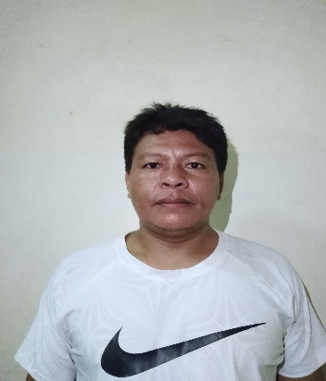
ARCHIE A. LADERO
Banilad Mandaue City
09225053699
Position Applied: Carpenter

PERSONAL QUALIFICATION

Age : 41 years old
Date of Birth : April 23, 1980
Place of Birth : Tagana-an Surigao del Norte
Religion : Roman Catholic
Civil Status : Married
Nationality : Filipino
Height : 5’3
Weight : 130 lbs.

EDUCATIONAL BACKGROUND

Elementary : Lower Libas Elementary School
Lower Libas, Tagana-an Surigao Del Norte
1991-1992
Secondary : Sison National High School
Sison Surigao Del Norte
1995-1996

GENERAL QUALIFICATION
PLD Construction
PC Suico St. Tabok, Mandaue City
(032) 422 9365
2020 - present
Position: General Foreman

DDTKI KONSTRUCT INC.
Fourth Floor Lancaster Hotel
622 Shaw Boulevard
Mandaluyong City
(632) 571-8668 to 70
2018-2020
Position: Foreman

Makati Development Corp.
FGU Building 10th Floor Cebu Business Park Cebu City
2015 – 2018
Position: Foreman

Whiteport Inc.
Lancaster Tower Suite 2 Shaw Boulevard Mandaluyong City
2012-2014
Position: Foreman

H.S. POW CONSTRUCTION DEVELOPMENT CORPORATION
Sgt. Esguerra Mother Ignacia St. Quezon City
2009-2012
Position: Foreman

TKN JOINT OPERATION
Cantho City Vietnam South Republic
2008-2009
Position: Foreman

BBR PHILIPPINES CORPORATION
78 Kapitol Bldg. Kapitolyo Pasig City
2004 -2008

SCB CONSTRUCTION
Kamagong St. Pasong Tamo Makati City
2000-2004
Position: Foreman Steelman

DMCI
Quirino Ave. Pandakan Manila
1998-2000
Position: Steelman

CHARACTER REFERENCES

Franco Junasa
Freelancer Manager
09332929376

Irish Gian Torregosa
PLD Project Manager
09270093706

