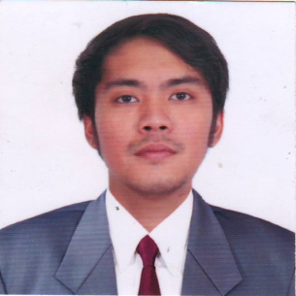
RICHARD P. MANUEL
182 Jose Abad Santos St. Sta. Lucia, Novaliches, Quezon City
chard201529@gmail.com
+639366724169

OBJECTIVE

To obtain aposition that will enable me to use my skills and competencies and the ability to work and socialize with other people.

EDUCATIONAL ATTAINMENT

Computer Technology
St. Technological College of the Philippines
2008-2010

WORK EXPERIENCES
J2MB Engineering
Electrician
-responsible for electrical data works
-build electrical houses
-reading of electrical diagram according to the plan of engineer
November 2020- present

LSG Skychef
Generic Catering
-preparing food for lufthansa airline under the quality of basic standard cleanliness.
-work under the quality of food safety, HACCP( hazard analysis critical control point), GMP(good manufacturing procedure).
-responsible for the cleanliness in the work area/station to create a good, clean and safe food for the airline customer/passenger to avoid such sudden incident like vomitting and food poisoning.
-May 1 2019 – May 2020
-company closure due to pandemic

Sky Kitchen Catering Philippines Inc.
2ndcommis de cuisine ( meal portioning economy team leader)
Service provider of Philippine airline
- responsible for cleanliness in the working area.
- supervise meal portioning economy personnel’s hygiene and sanitation in the working area
- prepares and getting load to set up for the flights.
- checks the quality of food set up by appearance and taste.
- assists hot kitchen personnel.
- runs Hazard Analysis Critical Control Point (HACCP), Good Manufacturing Procedure (GMP), Food safety and proper temperature for the food set up to avoid spoilage.
- manage personnel of meal portioning economy food set up by order to follow the cycle by looking the menu matrix.
February 2016 – march 2018

4th Dimension Multi-purpose Cooperative
Production Personnel
Service provider of Sky Kitchen Catering Philippines Inc.
-meal portioning economy food set up.
- set up food with quality and standard procedure.
- prepares food under a quality of hygiene and sanitation in the working area.
March 2012 to February 2016

SEMINARS ATTENDED

- Good Manufacturing Procedure (GMP)
- Hazard Analysis Critical Control Point (HACCP)
- Food safety
- HALAL

CHARACTER REFERENCES

Jerome Evangelista
2ndcommis de cuisine
09177581518

Cristine Gail Ramos
Globe Telecom. (Head Cashier)
09058144903

I hereby certify that the above information is true and correct to the best of my knowledge and belief.

Richard P. Manuel
Applicant

