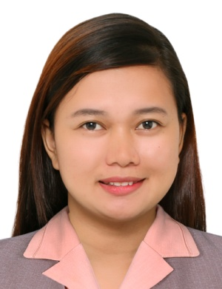

MARY ROSE R. REPOLONA
Purok 7, Iraya Norte, Oas, Albay
Contact number: +639989658782
maryroserepolona@yahoo.com

PERSONAL INFORMATION

Age : 30 y/o
Birthday : October 25, 1990
Height : 5’2”
Weight : 57 kg

CERTIFICATION/BOARD EXAM PASSED

Real Estate Broker
PRC License No. 0019508
March 2014

CSC Career Service Professional Eligible
April 2013

Educational Attainment

Comprehensive Real Estate Seminar and Review
Date Attended: November 2013 – February 2014
Units Earned: 120 units
Facilitator: Philippines Association of Real Estate Brokers (Naga City Realty Board)
Institute/University: Ateneo de Naga University

Bachelor of Science in Business Administration
Date Graduated: March, 2011
Major: Financial Management
Institute/University: Bicol University,
- College of Business Economics and Management

PROFESSIONAL EXPERIENCE

Feb 18, 2021 – present : Professional Service Representative
GETZ PHARMA (PHILS) INC
- Responsible for the effective promotion and sales of ethical pharmaceutical products of the company.

October 25, 2016 – Feb 27, 2021: Professional Service Representative
NATRAPHARM INC
- Responsible for the effective promotion and sales of ethical pharmaceutical products of the company.

July 2015- Aug 2016: MUNICIPAL FINANCIAL ANALYST
Department of Social Welfare and Development
KALAHI CIDSS NCDDP
Responsibilities:
- Ensures that costs of subproject proposals are complete, economic and reasonable.
- Ensure compliance to internal control measures put in place for the economical, efficient and effective implementation of community-approved subprojects.
- Ensures compliance to the Project’s financial reportorial requirements.

July 2011 – May 2015: BUSINESS AND CLIENT RELATIONS ASSISTANT 3
PJ Lhuillier Inc.
Responsibilities:
- Prepares daily, weekly and monthly financial reports.
- Performs excellent customer service when providing them information about their loan and remittance transaction.
- More on vault custodianship. Thus, performs filing and inventory.
- Acts as cashier if necessary.

SKILLS

Computer Literacy
Studies and experiences at work helped me improved my literacy on computer most especially on MS Word, MS Excel and MS Powerpoint.

Communication
Communication skill was developed through trainings attended that taught me how to relay information to client and helped me on the conduct of trainings to community volunteers and doctors.
.
Versatility
Can accomplish admin reports while doing the basic task of being a Medical Representative.

Organization and Documentation Skills
I have developed my own time management plan that is detailed in a daily and weekly manner that it allowed me to prioritize tasks and ensures time for additional tasks.

MARY ROSE R. REPOLONA
APPLICANT

