 |  | Allen Alcaraz
CONTACT   +639173427404  allen.alcaraz0029@yahoo.com   linkedin.com/in/allen-alcaraz |  |  | PROFILE  Allen is a former Workstation Engineer. She has 4 years of experience in the Information Technology industry. She has a technical knowledge comes from Cloud Administration and Cloud Migration.  She’s been part of Cloud Infrastructure for almost 3 years as Associate SQL DBA doing SQL database migration, monitoring, replication, SQL documentation processes and rollforward activity. And provide KT session to another new member of the team and other DB related tasks. She makes sure that all tasks assigned to her was facilitated and resolved in the same business day. And assures that quality assistance was given and provided.  She is also resourceful and a fast learner. She is dependable and was able to handle multiple tasks on her own.
SKILLS  - MSSQL Database Administrator  - SQL Database  - DB monitoring, Backups, High availability and DB restore.  - Knowledgeable on Microsoft Azure  - Knowledgeable on Google Cloud Platform  - Knowledgeable on AWS  - Knowledgeable VMware vSphere: Install, Configure, Manage V6.7  - Computer Hardware Servicing/ Actual assembly/disassembly, computer upgrading, computer systems diagnostics and troubleshooting.  - Experienced in Networking (Cabling, SETUP)  - Experienced in Printer troubleshooting, Printer sharing and installation. |  |  | EXPERIENCE  Insurance Company in Australia – Cloud trans & arch Analyst  (May 2021 – Present)  - Doing Discovery Agile, by collecting and analyzing information that needed in this project.  - Responsible on migrating the application.  Cloud Migration – Enablement  (Dec 2020- Present)  - Doing initiatives here in Cloud Migration ex. Recruitment Management.  - Conducting initial screening for intern candidates.  - Validate internal applications  - Schedule and arrange interview with hiring manager and applicant  - Monitor candidate’s application until onboarding  - Attend different trainings under Cloud Infra.  Large US Chemical Company – Database Administrator as Associate  (Nov 2018 – Nov 2020)  - Responsible for Implementation, build and migration, deployment and validation of SQL Database Environments, configuration, monitoring DB backups, and perform DB Rollforward and DB restore.  - Setup Clustering and High Availability, Replication.  - Troubleshoot all the error that users encountered.  - SQL Documentation process.  Integrated Workstation Engineer / Hypercare Support Team (HST) as New Associate  (Sept 2017 - Nov 2018)  - Responsible for the initiatives like compliance, walk-in users, laptop and workstation rebuild and remediation, etc.  - Dedicated support engineer in a project  - Responsible for the delivery of infrastructure-related services (workstation, network, server, voice and capacity monitoring)  - Collaborates with other internal and external teams as needed to ensure seamless delivery of IT services to the Project  - Maintains data integrity and ensures workstation security in accordance with standards and best practices  - Adheres to internal controls, processes, and standards based on the guidelines set forth by the organization  - Ensures that assigned incident tickets are resolved within the Same Business Day (SBD) Service Level Agreement (SLA)  - Updates Incident and Service Requests ticket Management status using available tools (e.g., case notes or work info)  Human Resource (Background Check)  (June 2015 - Sept 2017)  - Manage the recruitment background verification process and completion of the candidate’s pre –employment documents.  - Coordinate with stakeholders regarding with the status of the candidate.  - Initiate and create process improvement.  - Handle other tasks such as ensuring quality assurance and data review of the background check report.  - Provide support within recruitment administrative operations  - Validation, compilation, and keep of the personnel records.

EDUCATION

STI College Recto
Bachelor of Science in Information Technology
Doña Faustina Bldg.
1914 C.M. Recto Ave.,Manila
2010 - 2014

Trainings / Certificates

- Training in MS Azure Administrator. (Sept 14-22,2020)

- Training Google Cloud Platform - Associate Cloud Engineer (April 5-13,2021)

- Training in VMware vSphere: Install, Configure, Manage V6.7. (April 26-20,2021)

- Training in Architecting on AWS – (May 24-31, 2021)

- Azure Microsoft Fundamental Certificate. (May 8, 2020)

- Scrum Foundation Professional Cert. (Dec 29,2020)

- Microsoft Azure
Administrator Associate Certificate. (March 25,2021)

- AZ-400 Designing and implementing Microsoft Devops Solution Certificate. (May 21 25,2021)

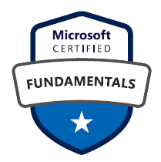
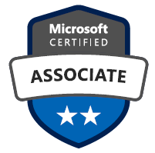
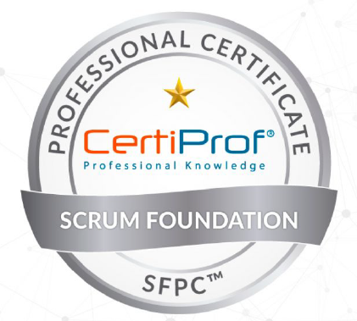
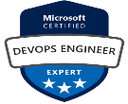

I hereby certify that the above information is true and correct to the best of my knowledge and belief.

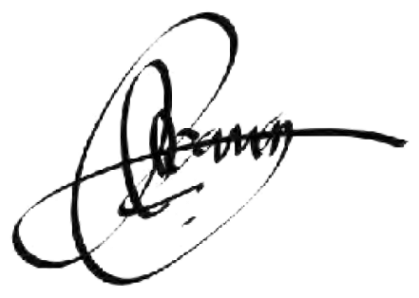
Allen T. Alcaraz

