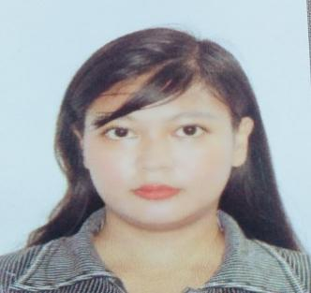  roechelle a. dassun, rmt  roechelle525@gmail.com  09772636385 | REFERENCES:  ELOISA MAE ALCARTADO, RMT  MEDICAL TECHNOLOGIST  MAKATI MEDICAL CENTER  09957833912 / eloisa36@ymail.com  MARILYN MOLITAS TOMILAS, RMT  CLINICAL INSTRUCTOR  UNIVERSITY OF BAGUIO CLINICAL LABORATORY  09566123775 / tomilasmarilyn@gmail.com  MARITES LIMON, MD  PEDIATRICIAN  KONSULTA @ RESULTA MEDICAL CLINIC & LABORATORY  09178615750 / konsulta_resulta@yahoo.com
  Objective
  To find a platform where I can use my skills and understanding regarding Medical Technology in performing test in a Laboratory setting and to serve the institution with the fullest of my abilities with strong determination.
  Skills
  I have a basic knowledge of collecting, processing, analyzing specimens. I can perform laboratory procedures and maintain instruments used inside of the laboratory. I have good communication skills, critical thinking, science skills, technology knowledge, care about the patients, working around the clock, and ability to work in a team.
  certification and Experience
  certification as medical laboratory scientisT intern in baguio general hospital medical center
  JULY 15, 2018 – JANUARY 15, 2019
  POSITION: INTERN
  Performed routine laboratory tests in Bacteriology, Hematology, Clinical Chemistry, Histopathologic Techniques, Blood Banking Services, Serological Tests, Clinical Microscopy, Parasitic Identifications through microscopy, and Phlebotomy.
  certification as medical laboratory scientist intern in university of baguio clinical laboratory
  JANUARY 16, 2019 – JULY 13, 2019
  Performed routine laboratory tests in Bacteriology, Hematology, Clinical Chemistry, Histopathologic Techniques, Blood Banking Services, Serological Tests, Clinical Microscopy, Parasitic Identifications through microscopy, and Phlebotomy.
  Education
  BACHELOR OF MEDICAL LABORATORY SCIENCE
  UNIVERSITY OF BAGUIO
  PERSONAL INFORMATION
  BIRTHDATE: APRIL 3, 199
  BIRTHPLACE: RIZAL, CAGAYAN
  HOMETOWN: TUGUEGARAO CITY, CAGAYAN

ROECHELLE A. DASSUN
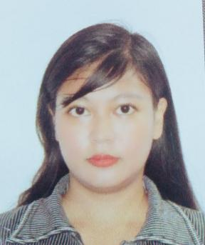
112 PROVINCIAL ROAD, BUNTUN, TUGUEGARAO CITY, CAGAYAN
Phone: 09772636385
E-mail: roechelle525@gmail.com

EDUCATION
CURRICULUM VITAE
TERTIARY EDUCATION
BACHELOR OF MEDICAL LABORATORY SCIENCE
UNIVERSITY OF BAGUIO
2019

SECONDARY EDUCATION
HIGH SCHOOL DIPLOMA
UNIVERSITY OF SAINT LOUIS
TUGUEGARAO CITY
2011

PRIMARY EDUCATION
ELEMENTARY DIPLOMA
GAGGABUTAN ELEMENTARY SCHOOL
2007

LICENSE AND CERTIFICATIONS

PROFESSIONAL REGULATION COMMISION LICENSE
REGISTERED MEDICAL TECHNOLOGIST
MARCH 2021

CERTIFICATE OF INTERNSHIP II
UNIVERSITY OF BAGUIO
JANUARY 16, 2019 – JULY 13, 2019

CERTIFICATE OF INTERNSHIP I
BAGUIO GENERAL HOSPITAL MEDICAL CENTER
JULY 15, 2018 – JANUARY 15, 2019

WORK EXPERIENCES

KONSULTA@RESULTA MEDICAL CLINIC & LABORATORY
MAY 10, 2021 - PRESENT

JOB DESCRIPTIONS

- ) HEMATOLOGY SECTION
- can do and read CBC with platelet count manually and in automated machines.
- can do PT and aPTT in automated machine.
- can do ESR test procedures
- can do clotting time and bleeding time manually
- can do and read malarial smears manually and used of test kits
- can do hematocrit and hemoglobin determination manually and with the used of machine
- can do dengue test by the used of test kits

- ) BLOOD CHEMISTRY SECTION
- can do the following tests manually and in machines - FBS, lipid profile, creatinine, BUN, BUA, SGPT, SGOT, OGTT, and etc.
- can do NEQAS for clinical chemistry

- ) CLINICAL MICROSCOPY SECTION
- can do and read routine urinalysis together with multi-stix reagent strips
- can do and read fecalysis with proper identification of parasites and it’s ova.
- can do pregnancy test using test kits.
- can do analyse 24 hr urine specimen, creatinine clearance.

- ) MICROBIOLOGY SECTION
- can prepare media like chocolate agar, blood agar, Mckonkey agar, etc.
- can do and read gram staining and acid fast staining procedures
- can do KOH and identifying fungal elements
- can do manual identification of microorganisms based on their biochemical reactions

- ) IMMUNOLOGY AND SEROLOGY SECTIONS
- can do RPR/VDRL titer and screening
- can do Hepa B and A screening using test kits
- can do HIV, H-pylori screening using test kits

- ) BLOOD BANKING SECTION
- can do blood extraction in vacutainer and in syringe
- can do blood typing including ABO, RH, and crossmatching

- ) PHLEBOTOMY
- can do proper identification and extraction using closed and open method

- ) OTHERS
- can do quality controls and standards in chemistry, hematology, and immunology machines
- can do paper works including the renewal of license of the laboratory
- can do census, inventory, etc.
- can do swab and read COVID 19 rapid antibody and antigen kits.

