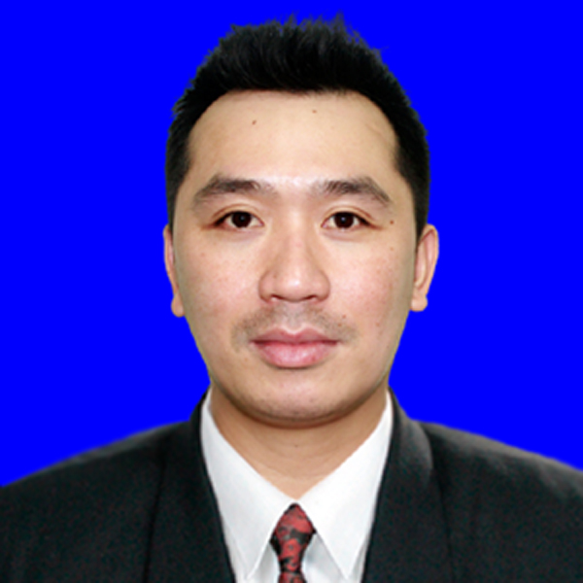JAYSON REBOLLAR CORTEZ

Home Address : Block 2 Lot 4 Phase 4, Rhonaville Gate I Fruto Santos Avenue,
Zapote, Las Piñas City
Mobile Number : +639368201736
E-mail Address : jaycor0028@gmail.com

WORK EXPERIENCE

CASKOD | SOUTH KOREA
PERSONAL DATA
Date of Birth: March 23, 1987
Place of Birth: Cavite City
Civil Status: Married
Religion: Roman Catholic
Citizenship: Filipino
Height: 5’7” ft.
Weight: 80kgs
Spouse’s Name Mea Ann B. Cortez

No. of Children: 1 (one)

Name of Child: Hyuna Anika B. Cortez

Dialects: Tagalog, Korean
& English
(Manufacturer of Basic Metals)
Engine Blocks
July 2, 2018 – May 5, 2020

(JU) WIDEUIENJI | SOUTH KOREA
(Manufacturer of Rubber and Plastic Products)
Plastic Injection
May 12, 2016 – June 1, 2018

EN | SOUTH KOREA
(Manufacturer of Machinery and Equipment)
Die Casting
November 20, 2015 – April 1, 2016

HWA JINGIEOP | SOUTH KOREA
(Manufacturer of Other Transport Equipment)
Ship Builder
September 9, 2015 – November 2, 2015

YU MYEONG SA CO., LTD | SOUTH KOREA
Laser Cutting
April 05, 2011 – September 9, 2014
EDUCATIONAL BACKGROUND

PERSONAL DATA

Hilda Algonajota
Teacher
+639650599295

Ariel Pagkaliwangan
Brgy. Captain Cavite City
+639271854257

PRIMARY
Julian Felipe Elementary School
2000

SECONDARY
Cavite National High School
2004

VOCATIONAL
Cavite City Technical and Vocational School
Computer Software

I hereby certify that the above information is true and correct to the
best of my knowledge and belief.

Jayson R. Cortez

