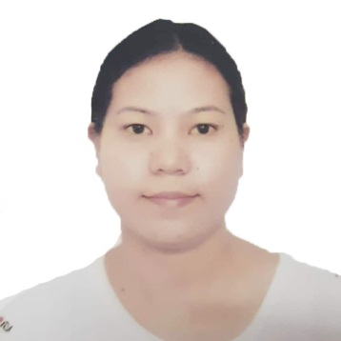

SHERELYN UNTALAN FERRER
No. 111 Ambonao Calasiao
Pangasinan
Contact Number: +639184167735

CAREER GOAL:
Seeking a challenging position requiring demonstrated skills in leadership, planning and communication. Thus, utilizing inter-personal skills with my experience, educational, qualifications and technical knowledge.

WORK EXPERIENCE:

Company Name : Advantech Company
Company Address : Linkou Taoyuan, Taiwan
Position : Factory Worker (Spareline)
Period of Employment : April 21, 2017 to Sept.18,2020

Company Name : Pegatron Company
Company Address : Taoyuan, Taiwan
Position : Factory Worker (Testing))
Period of Employment : February 12, 2014 to February 10, 2017

Company Name : SM Appliance Center
Company Address : Malate, Manila, Philippines
Position : Cashier
Period of Employment : June 12, 2013 to November 11, 2013

Company Name : Nanox Philippines Inc.
Company Address : Clark Field, Pampanga
Position : Repair Process
Period of Employment : June 2012 to April 2013

EDUCATIONAL BACKGROUND

Tertiary Lyceum Northern Luzon
Associate in Computer Science
April 2010 to 2012 (Graduate)

Secondary Bued National High School
Bued Calasiao, Pangasinan
April 2001 – 20015 (Graduate)

Primary Ambonao Elementary School
Ambonao, Calasiao, Pangasinan
April 1995 – 2001 (Graduate)

SPECIAL SKILLS:

- Good communication skills , able to speak English and little bit of Chinese
- Quick learn
- Enthusiastic, Hard worker and responsible
- Good team player and can work under pressure
- Hardworking, responsible, and honest

PERSONAL DATA:

Contact No. : +639184167735
Philippine Address : #111 Ambonao, Calasiao, Pangasinan
Email Address : ernzkie_26@yahoo.com
Gender : Female
Status : Single
Birthday : February 21, 1989
Birth Place : Calasiao, Pangasinan
Height : 5’3
Weight : 51 kg

Nationality : Filipino
Languages : English, Tagalog, little bit Chinese language

CHARACTER REFERENCES:

MS. Marife V. Pegoria
Factory Worker

MR. ERNIE FARILLON
Factory Worker

I hereby certify that the facts contained in this sheet are true and correct.

SHERELYN U. FERRER

