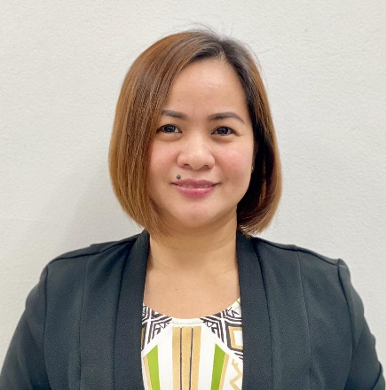
venalyn r.lucas
Address:Brgy.25#82, T.Pasion St.Laoag City
Contact Number: 09209759364
E-mail Address: vena_0915@yahoo.com

"Attitude is a little thing that makes a Big Difference" - Winston Churchill
O B J E C T I V E
To obtain a position as a team player in a people-oriented organization where I can maximize my customer-service experience in a challenging environment to achieve the Corporate goals

P E R S O N A L D A T A
Birthday: September 15, 1981
Place of Birth: Sto. Domingo, Ilocos Sur
Age: 39 Years Old
Status: Married
Religion: Roman Catholic

E D U C A T I O N A L B A C K G R O U N D
TERTIARY
S.Y. 2000 – 2002 S.Y. 1998 - 2000
Bachelor of Science in Commerce – Management Bachelor of Science in Business Administration –
Divine World College of Laoag Entrepreneurship Accounting
Ilocos Norte Mariano Marcos State University
P E R S O N A L Q U A L I F I C A T I O N S
- Possesses an analytical mind with good written and oral communication skills.
- Possesses a well-rounded personality, honest, socially presentable in handling confidential data.
- Can work with minimal supervision
- Can work under pressure
- Highly motivated personality

A W A R D S
2015 Top Collector Auto Loan PBC
2017 Top Collector Auto Loan PBC
2020 Top Collector PBC
January 2004 – June 2004
Accounting Clerk II

July 2012 – March 2014
Bucket 0 – 30 Days / Junior Assistant
Manager 1
Provincial Business Center
3rd Floor, Ilocano Heroes Hall
SM Hypermarket, Laoag City

June 2004 – June 2012
Quedan Operations Officer 1
Quedancor Laoag District Office
Heroes Hall Building, Laoag City
- Credit Assessment Group
- Loans Management Group

W O R K E X P E R I E N C E
March 2014 – Present
Bucket 2/3/4/5/6 & Special Payment Arrangement Auto Collections
Junior Assistant Manager 2
Provincial Business Center
Insular Life Building

C H A R A C T E R R E F E R E N C E S
Cheryl Claire S. Guevarra
Team Head
Front – End Secured Auto Collections
BDO Corporate Center
Ortigas, Mandaluyong City, Metro Manila

S E M I N A R S & T R A I N I N G S A T T E N D E D
July 2013
Collections 101
April 2016
ICS 4.9 PBC Training and Complaints Refresher
June 2018
E D U C A T I O N A L B A C K G R O U N D
SECONDARY PRIMARY
S.Y. 1994 – 1998 S.Y. 1988 - 1994
Mariano Marcos State University Shamrock Elementary School
Laboratory High School
Laoag City

