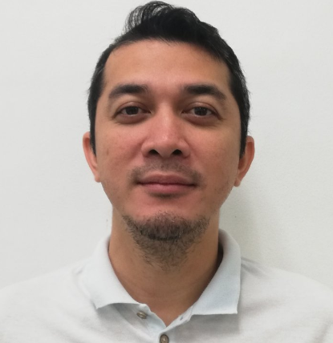
EMMANUEL S. FILIPINO
2G Gateway Regency, Robinsons Cyber City,
Edsa Cor. Pioneer St. Mandaluyong City
+63910-9071290 / 0923-1686459
filipinoes314@gmail.com
___________________________________________________________________________________
Tive

Field Operation Team Leader
Asticom Tecnology Inc./Globe Telecommunication
#134 15th Ave. Bayantel Bldg., Cubao, Quezon City
November 2019 up to present

SR. BROADBAND SPECIALIST
Asticom Tecnology Inc./ Globe Telecommunication
#134 15th Ave. Bayantel Bldg., Cubao, Quezon City
May 2018 - October 2019

Duties and Responsibilities
- Provides install / repair services for Voice and/or Data Service at customer’s premise in addition to install and troubleshoot additional connected devices
- Acts as the primary representative of Globe who engages in the conversation with the subscriber i.e. Intro, MSF, WiFi customer education, cross sell / upsell
- Accountable in ensuring that a Permit is secured for gated premises
- Follows the procedures as documented in the operating and standards manual
- Ensures the service provided meets with customer’s requirement and/or Company standards
- Explains / demonstrates the services provided to the customer for their acceptance
- Answers or refers customer inquiry on general services/products provided by the company
- Liaises with other internal working parties to solve any problems during service provision
- Performs shift, mid-night or standby duty as schedule
- Passes customer’s feedback and comments to field supervisor for corrective/preventive action

TRAINING & SKILLS:
Lopez Municipal Training Center / TESDA
Shielded Metal Arc Welding ( SMAW )
September 2017 - December 2017
Lopez Quezon

Globe Telecommunication
Fiber optic specialist (FTTH)
VDSL & ADSL Installation and trouble shooting
LTE / Wireless Installation

PROFESSIONAL EXPERIENCES:
May 2015 - December 2016
Skilled Supervisor
Gela Construction
Punta Princesa, Cebu City

Duties & Responsibilities:
- Inspection of all phases of residential development construction, such as subgrade for curb and gutters, walks; roadways and lanes to ensure line and grade are specified.
- Ensure that backfills are compacted to specifications before gravelling, soil cementing
- Prepare and record all measurements and calculations for the project, and submit reports.
- Investigate public complaints concerning damaged sidewalks, road base, curbs and curb
- Document all decision concerning
- Performing construction work
- Ordering or purchasing materials
- Directing the work of the contractor, volunteer labor, or any entity performing construction work.
- Coordinating or scheduling the construction work

SSANES KUNSTRAKSYUN
FITTER / WELDER
U-1 Carepa Apartment 1st Street Fatima 6000
Cebu City

- Fabricate and assemble metal structure and equipment through the use of welders, cutters, shapers and measuring tools.
- Produce metal products according to employer specification
- Use multiple welding machine to repair and maintain metal equipment and structures of various sizes

LBC Express Inc.
Customer Associate / Shuttler
5fth Flr., Star Cruises Plaza, New Port, PasayCity
March 2010 – July 2014

DUTIES&RESPONSILITIES:
- Operates computerized cash register to conduct sales transactions; handles cash, and makes change as required.
- Comply with federal and state laws by requesting personal identification from customers Maintain proper cash levels in register drawer.
- Stock and refill register area inventory.
- advises customers on merchandise price, features, and on fees and services.
- Assists individual or institutional customers in appropriate delivery of
merchandise
- Prepares routine daily reports such as sales, accounts receivable/payable, and do bank deposits.
- Turn over cash to airport after banking hours.
- Pick up cargoes to branch and turn over to airport

Eton Properties Phils. Inc.
Personal Exect. Assistant
Sales Department
12th Flr., Allied Bank Bldg., Arnaiz St., Makati City
February 2007

DPWH Toledo City
Draftsman, Survey Section
DPWH Toledo City, Cebu
May 2005

Bachelor of Science in Geodetic Engineering
Immaculate Conception College La-Salle
Burgos Extension., Bgy. Aguada, Ozamiz City, Misamis Occidental
June 1999 – October 2003
Personal Detai
Age: 39 Yrs. Old

Birthday: March 14, 1982

Civil Status: Married

Citizenship: Filipino

Religion: Roman Catholic

Languages: English, Filipino / Cebuano

Height: 5’10”

Weight: 75 kg.

Character references available upon request.

