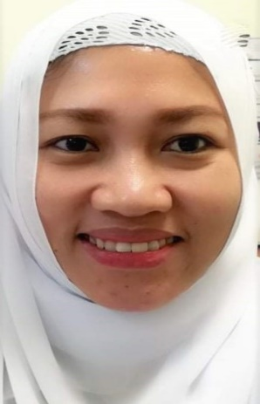 |  |  |  | Kristine B. Pascual

Experience
February, 2018 – February, 2021
STAFF NURSE
KING FAHAD HOSPITAL HOFUF
AL AHSA, KINGDOM OF SAUDI ARABIA

February, 2015 – February, 2018
STAFF NURSE
WESTERN PANGASINAN DISTRICT HOSPITAL
ALAMINOS CITY, PANGASINAN, PHILIPPINES

July, 2014 – January, 2015
STAFF NURSE
ALAMINOS DOCTORS HOSPITAL
ALAMINOS CITY, PANGASINAN, PHILIPPINES

Education
June, 2009 – March, 2013
GOLDEN WEST COLLEGES
BACHELOR OF SCIENCE IN NURSING
ALAMINOS CITY, PANGASINAN, PHILIPPINES

Licensure and Certification

Registered Nurse in KSA
Registration No: 18-L-N-0029758
Category: SPECIALIST
Exp. Date: January, 2023

Registered Nurse in the Philippines
Registration No: 0825775
Registration Date: 02/05/2014
Valid Until: 01/08/2023

Basic Cardiac Life Support Provider Course

Affiliated to Saudi Heart Association
King Fahad Hospital Hofuf
Al Ahsa, Kingdom of Saudi Arabia
Expiration Date: May, 2021

Hofuf, Al Asha
Kingdom of Saudi Arabia
 |  | +966 57 089 2227
 |  | krisvin0208@gmail.com

