Curriculum Vitae
Azer B. Cueme
Address: 5B Sampaguita St., NCCC Village Bajada, Davao City Philippines
Country: Philippines
Email: cuemeazer09@gmail.com
Contact No: 0946-522 2874 / 0935-032 8082
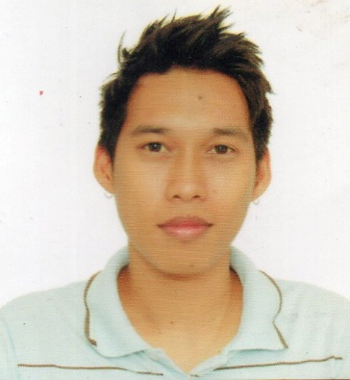

PERSONAL INFORMATION:
Date of Birth: September 09, 1982
Place of Birth: Davao City, Philippines
Citizenship: Filipino
Gender: Male
Marital Status: Married

EDUCATION:
● 2000 – 2002 – DMMA College of Southern Philippines – Associate Hotel & Restaurant Management
● March 2000 – Ford Academy of the Arts – Completed Secondary Course
● March 1995 – F. Bangoy Central Elementary School- Completed Intermediate Course

EMPLOYMENT HISTORY:
● 2016 – 2021 – B&N Food Products Production Quality Control
● 2010 – 2015 – SANNOR Catering Services Assistant Cook
● 2006 – 2009 – EXPD TWO Medical Equipment Medical Service Delivery
And Supplies Trading
● 2003 – 2005 – Grand Regal Hotel Waiter

PROFESSIONAL QUALIFICATIONS:
● Literate in Basic Computer Skills
● Can speak English and Filippinsk
● Upholds good rapport towards others
● Details oriented in task completion

