Dante Dubouzet Villegas  Sitio Candaya, Talisay City  +639176269931  ddvillegas@yahoo.com | 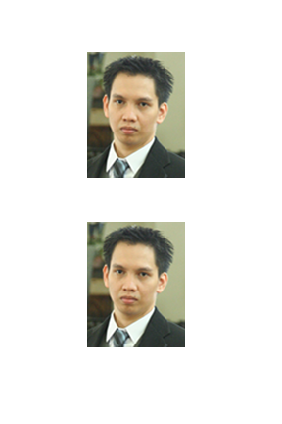

_________________________________________________________________

Personal Information:

Birth Date : March 23, 1977 Height : 5’4”
Birth Place : Parang, Maguindanao Weight : 60kgs.
Sex : Male Civil Status : Married
Nationality : Filipino Religion : Roman Catholic
Age : 43

Skills Summary:

Leadership Ability
Civil Service Professional Passer
WELDING SKILLS:
- GMAW (Gas Metal Arc Welding)
- FCAW (Flux Cord Arc Welding)
- SMAW (Shielded Metal Arc Welding)
- First Class 6G
Cutting Torch and Gouging Tools Skill
Good in Oral and Written Communication in English
Good in General and Basic Electronic Circuitry
Well verse in:
- Computer assembly and maintenance
- Designing and maintenance of Local Area Network (LAN)
Computer Applications:
- Windows Platform
- DOS / Linux OS
- Proficient in MS Office applications
Driving Skill
- Licensed Professional Driver
- Qualified Forklift Operator
Languages:
- English and Tagalog (Excellent)
- Spanish (Moderate)
- Japanese (Moderate)

Education:

College Bachelor of Science in Computer Engineering
University of San Carlos – Technological Center
Nasipit Talamban, Cebu City

Secondary Ateneo de Zamboanga University

La Purisima St., Zamboanga City

TRAININGS:

Cisco Networking Associates Program(CNAP)
- Center for Industrial and Technological Enterprises(CITE)
Talamban, Cebu City, Philippines

Gas Metal Arc Welding(GMAW) / Flux Cord Arc Welding (FCAW)
Cutting Torch and Gouging Tools
- TAMAKUGYO/YUKI WELDING
Yuki, Ibaraki Ken, Japan

Shielded Metal Arc Welding (SMAW)
- Brilliant Metal Craft and Machine Design (BMC)
Mabolo, Cebu City, Philippines
- Technical Education and Skills Development Authority (TESDA)
San Roque, Zamboanga City, Philippines

Professional Experience:

PhilWorld Online Cebu Inc.
Cebu City
(April 1997 - January 1998)

Function:
- Troubleshoot LAN/WAN, Customer/technical support.

Ultralife Taiwan Incorporated
Chunan Science Park
Republic of Taiwan
December 2002 – December 2003

Function:
- Electronic Machine Operator, Quality control

Siphon Plastic Corporation
Chunanchen
Republic of Taiwan
January 2004 – December 2004

Function:
- Machine Operator, Quality Control

Eastern Pacific Lines
Cor. Legaspi & Lapu-lapu St.
Cebu City 6000
December 2004 – August 2005

Function:
- Computer Technician

Tokyo Food
Shimotsuma
Ibaraki Ken, Japan
January 2005 – January 2006

Function:
- Machine Operator, Quality Control

Tamakugyo/YUKI WELDING
Yuki
Ibaraki Ken, Japan
January 2006 – April 2008

Function:
- Welder, Fabricator

Cebu Normal University
Osmeña Blvd. Cebu City
September 2008 – February 2009

Function:
- Computer Technician

Chery Automobile Cebu
M.C. Briones St., National Highway, Mandaue City, Cebu
March 2009 – October 2009

Function:
- Sales Executive

Universidad de Zamboanga
J.S. Alano St. A.E. Quadrangle
Zamboanga City
June 2013 – June 2014

Function:
- Welding Instructor

