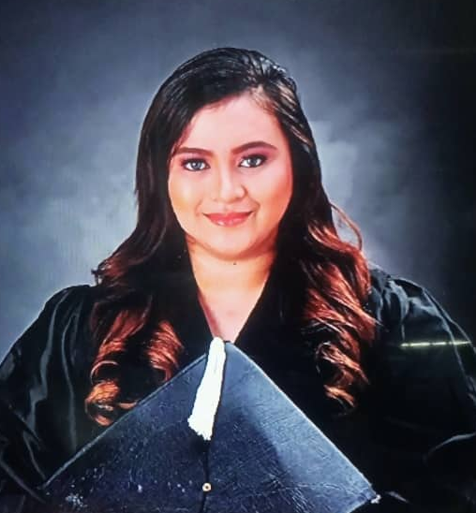
Zaira Gutobat
F. Martir street, Lapu-Lapu City Cebu
Mobile No.: 09225048703/09398877227
Email: Zairacabaral@gmail.com

PERSONAL INFORMATION:
Full Name: Zaira Gutobat
Gender: Female
Age: 21 years old
Date of Birth: March 13, 1999
Status: Single
Interests: Reading, swimming, travelling, watching documentary films, Leading and Social activities.

CAREER OBJECTIVE: To acquire a challenging position with growth, where my knowledge, skills and positive attitude can be used as a Nursing Attendant because I can do all my best to do my job better and I am ready to serve People and I would also like to utilize my skills and experience. Moreover, I would also like to work with other people and professionals to improve my skills.

EDUCATIONAL BACKGROUND:
Elementary: Lapu-lapu City Central Elementary School (2011-2012)
High School: Pajo National High School LLC (2015-2016)
Senior High School: Southwestern University (2016-2017) University of Cebu (2017-2018) Graduated in a Major of (STEM) Science, Technology, Engineering and Mathematics.

Technical and Vocational Education and Training (TVET):
Graduated from St. Paul College Foundation Incorporated: Studying Health Care Services NC II holder.

SUMMARY OF QUALIFICATIONS:
-CPR and first-aid certified
-Responsibility and fast-learning traits.
-Excellent time management skills
-Problem solving skills
-Vital signs and patients observation

WORK EXPERIENCE:
-Student assistant of teacher (June 2012-March 2016)
-Children of Mary (Youth Volunteer VDR 2013-2020)
-Red Cross Volunteer 2016-2017
-Sangguniang Kabataan (SK Councilor 2018-2022)
-Waterfront hotel Mactan and casino as a Valet runner/checker and I also know how to be a housekeeping attendant.
-SALES ASSOCIATE in Mactan International Airport Cebu Philippines.
-On the job training as a Nursing Aide in Vicente Sotto Memorial Medical Center
-Currently working in Chong Hua Hospital Mandaue as a nursing attendant assign in ICU and RENAL UNIT (almost 1year during Covid19 pandemic)
-Covid frontliner

TRAININGS AND SEMINAR ATTENDED:
-SK mandatory training as per DILG Memorandum Circular No. 2018-48
-K-12 Training workshop and orientation
-Red Cross seminar
-Children of Mary Orientation and Seminar
-Basic Life Support (October 23, 2019)
-B-Braun Training

HONORS AND AWARDS RECEIVED:
Most Trusthworthy in Lapu-Lapu city central elementary school
Top 4 Student in Pajo National High school S.Y. 2014-2015
Top 7 Student in Pajo National High school S.Y. 2015-2016
Southwestern University-PHINMA scholar 2016-2017
Best in Leadership UCLM, 2017-2018
Outstanding Youth Volunteer 2016-2018
RLE awardees 2018

Zaira Gutobat
F. Martir street, Lapu-Lapu City Cebu
Mobile No.: 09225048703/09398877227
Email: Zairacabaral@gmail.com
I am applying for Nursing attendant position. As requested, I enclose a completed job application, my certification and my resume.
The role is very appealing to me, and I believe that my experience in hospital and education make me a highly competitive candidate for this position. I recently completed a nursing assistant program that has qualified me to hold this position. My knowledge includes having the ability to take vital signs, check weight, test urine, monitor patients for changes and more. My skills also include the ability to keep accurate documents of the data gathered in addition to recording all other relevant information. My key strengths that would support my success in this position include:
Assisted with bathing, feeding, suctioning. Documented in each patient’s medical records.
With a Health Care Services Nc II holder, understanding. Please see my resume for additional information on my experience.
I can be reached anytime via email at Zairacabaral@gmail.com or by cellphone numbers, Mobile No.: 09225048703/09398877227
Thank you for your time and consideration. I look forward to speaking with you about this employment opportunity.

Sincerely,
Zaira Gutobat

