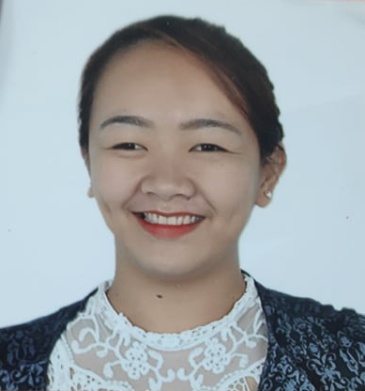
IVY RAMIREZ LEGASPI
18 B1 Damayan Street Pilot, Commonwealth Quezon City
+639662793241
Email: legaspiivy802@gmail.com

Career Objective:
To obtain a position that will fit from my working experience, skills, educational background and ability to serve other people.

Experience of Employment:

Samsung Excellent Consultant
Protempo Promotions and Marketing Corporation
May 2017 – November 2017

Sales Assistant
Krave Minerale Cosmeceuticals
February 2013 – April 2017

Cashier
NE Supermarket – Crossing Branch
June 2016 - January 2017

Educational Background

Tertiary Business Information Management
AIE College- Gapan
2015 – 2016

Bachelor of Elementary Education
Nueva Ecija University of Science and Technology
Undergraduate

Secondary Sto. Rosario National High School
Sitio Deepwel., Sto Rosario, Sta Rosa Nueva Ecija
2012 - 2013

Relevant Trainings Attended:

On the job Trainings:
Office of the Mayor; Municipality of Santa Rosa
Eighty Hours (May 18-29, 2015)

AIE College- Gapan (Registrar)
One Hundred hours (February 20, 2016 – May 18, 2016)

Front Office NC II
AIE College- Gapan
April 15, 2015

Bookkeeping NC II
AIE College- Gapan
January 15, 2015

Microfinance Technology II
AIE College- Gapan
January 16, 2015

Seminars:
Paano Maging Successful
Cinema 3 NE Pacific Mall, Cabanatuan City
November 8, 2014

Overcoming Trials
Cinema 3 NE Pacific Mall, Cabanatuan City
November 8, 2014

E-Commerce Convention 2015
Crossroad 77, Convention Center, Mother Ignacia Street, Quezon City
March 5, 2015

Skills:
- Bookkeeping
- Computer Literate
- Good English Communication
- Typing

Personal Data:

Date of Birth: April 20, 1996
Age: 23 years old
Civil Status: Single
Religion: Roman Catholic
Citizenship: Filipino

Ivy R. Legaspi
Applicant

