`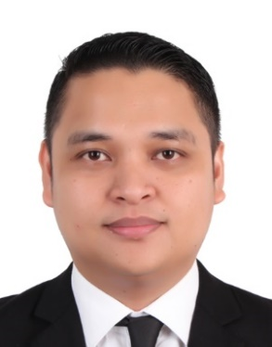
High Hopes Enterprises, Tagum city
Position: Branch Operation Supervisor / Culinary expert
June 2017 – June 2021
- Ensuring the employees are doing their task & assignments. Also implementing rules & regulation of the branch even the safety of employees.
- Making sure all clients is dealt with good customer service.
- Branch planning, trainings, sales, recruitment & activities.
- Making sure important documents are filed properly.
- Addressing and solving branch issues properly.
- Planning and preparing recipes
- Purchasing and preparing ingredients
- Cooking demonstration and teaching cooking tips using company products.
High Hopes Enterprises, Tagum city
Position: Culinary expert / Sales representative
January 2015 – May 2017
WORK EXPERIENCE
Most Promising Employee – Dining (2012)
Max’s Restaurant
AWARDS
- Preparing cooked rice for maki & sushi
- Making sushi, sashimi and maki roll
- Filleting 9-15kg salmon
- Cooking tempura (Shrimps and vegetables)
- Making sukiyaki sauce
- Properly clean and store food, utensils, and cookware
EDUCATION
GOURMET BITES (Cooking school)
G/F Dr. 2 Suarez Bros. Bldg., 112 Ilustre Street, Davao city

Bread and Pastry 2013
TECHNICAL EDUCATION AND SKILLS DEVELOPMENT AUTHORITY
Commercial Cooking
November 19, 2009

Food and Beverage Services
November 13, 2009

College Undergraduate
Davao Doctors College
Bachelor of Science in Hotel, Restaurant and Management
June 2008 – October 2010

High School Graduate
United Institute Daraga Albay, Philippines
June 1999 – March 2003

Elementary Graduate
MABA Laboratory School
June 1992 – March 1998

PERSONAL INFORMATION
ALDRIN A. ORDOÑA

SKILLS

Attentive
Creative
Good customer service
Teamwork
Adaptability
Communication
Organize
PASSPORT NO.: P9113898A
Date Issued: Oct. 11, 2018
Valid until: Oct. 10, 2028
CONTACT NUMBER:
+63 908 428 3907
+63 991 211 1867

EMAIL:
drin0h29@Gmail.com
ordona.a2908@yahoo.com

AGE: 35
BIRTHDAY: December 29, 1985
RELIGION: Catholic
CIVIL STATUS: Married
HEIGHT: 5’11
WEIGHT: 80 kg
ADDRESS:
#24 Palosapis street, Barangay Hizon, Nova tierra, Davao City, Philippines.

- Planning and preparing recipes
- Purchasing and preparing ingredients
- Cooking demonstration and teaching cooking tips using company products
- Setting private cooking activity outside office for clients
YAKIMIX Sushi & Smokeless Grill Restaurant
Position: Japanese Cook
July 2014 – December 2014

