MELVIN KARWIN R. BAUTISTA 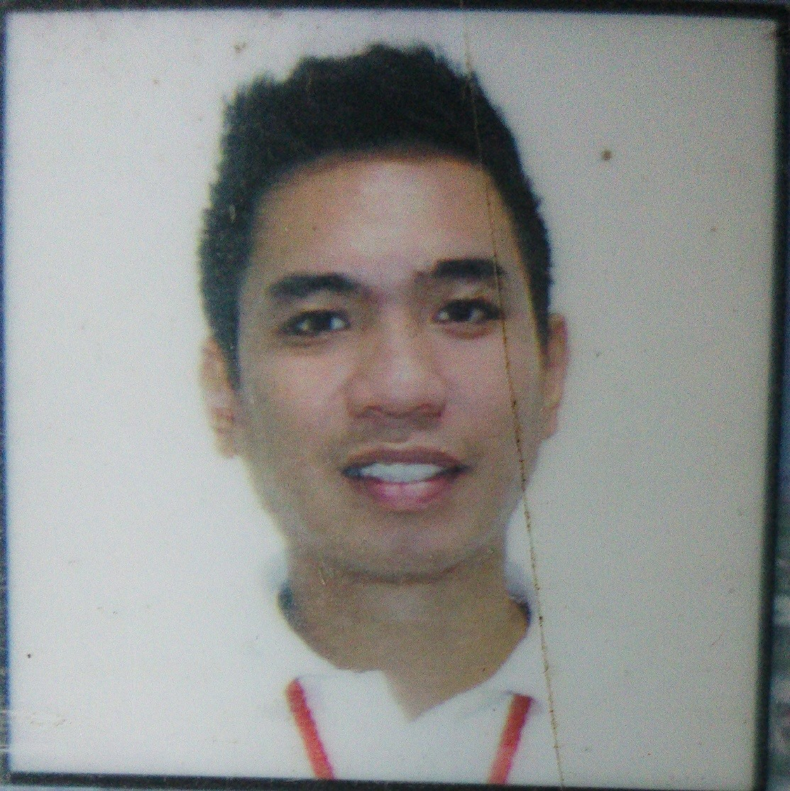
Block 18 Lot 8 Victory Heights, Amparo
Village Subdivision Caloocan City.
09482659148
bautistamelvinkarwin@gmail.com

OBJECTIVE

To use my knowledge and experience appropriately in order to flourish within any given position that I may encounter in your company.

PERSONAL DATA

Birth date: July 19, 1987
Birth place: Libya
Civil status: Single
Citizenship: Filipino
Sex: Male
Height: 5'6
Weight: 70 kg
Religion: Roman Catholic

EDUCATION

- Tertiary: Our Lady of Lourdes Technology College
Bachelor's Degree in Hotel and Restaurant Management
- Secondary: Amparo High School Sy. 2000-2005
- Primary: Largo High School Sy. 1994-2000

EXPERIENCE

PROMODISER - RL Design Auto seat cover. February 2014-2016
- Keylargo Car Accessories. March 2016-February 2017

BUFFALOS WINGS AND THING RESTAURANT (APRIL 2017 – MARCH 2018)
866 Nicanor Reyes St, Sampaloc, Mana, 1015 Metro Manila
(LINE COOK/FRYER)
BAI NIAN TANG BAO RESTAURANT (JUNE 25, 2018 – APRIL 30 2019)
Uptown Bonifacio Information Center . Ground Floor Uptown Parade, 9th Ave Corner, 36th St, Taguig, Metro Manila (LINE COOK)

SAMSTEW SAMGYEOPSAL + KOREAN STEW (SEPTEMBER 2019 up to now)
. Vertis North, KTown Level 2 Ayala Malls, Quezon City, Metro Manila
(LINE COOK TEAM LEADER)

SKILLS

- Able to use my initiative
- Hardworking
- Flexible
- Knowledge in Microsoft Office (Word, Excel, PowerPoint)
- Can work under pressure

REFERENCE

- Alma Codera
09297099682

I hereby certify that the information above is true and accurate.

Signature:_________________________ Date of Applicant:______________

