JOE MARI CABUAL

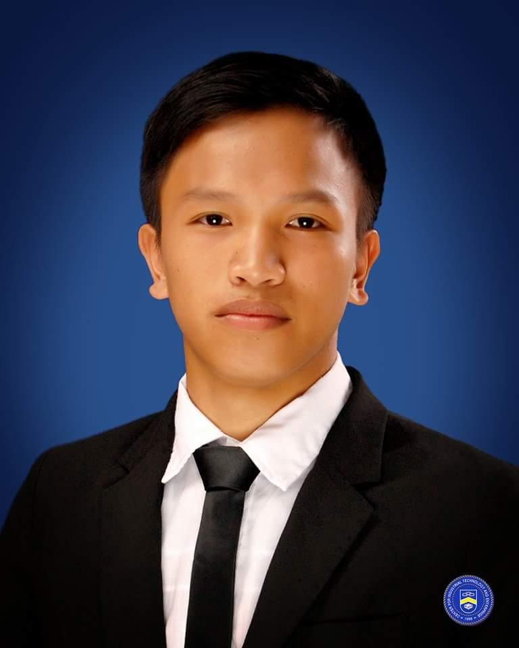
Salmeron Malabuyoc, Cebu 6029

Cellphone number: (0905)7724694

Email Address:cabualjoemari153@gmail.com

EMPLOYMENT OBJECTIVE

A job where I can use my knowledge about electrical, mechanical,electronics and computer

EDUCATION

Center for Industrial Technology and Enterprise (San Jose, Cebu City)
- Belonged to top five students in the class (S.Y 2015-2016)
- Best in technology awardee
- Exemplery behavior awardee

The Sisters of MAry School Boystown INC.

- best in science

AREAS OF COMPETENCIES

Mechanical Technology
- Operate and maintain standard tools such as lathe, drill press, and milling machines
- Perform basic bench work operation such as filing, turning and boring

Electronics Technology
- Layout, build troubleshoot, and repair development and production of electronic components and parts
- Assemble and maintain electronic systems
- Install and maintain instrumentation and control devices

Electrical Technology
- Install and program logic controller systems and service pneumatics and electro-pneumatics devices
- Troubleshoot electronic and digital system controls
- Working knowledge in electric circuit boards

Information Technology
- Working knowledge in MS Word, MS Excel, and MS Powerpoint
- Knowledgeable in computer hardware servicing
- Proficient in internet use and e-mail correspondence
- Computer Hardware Servicing

NC 2 Holder

SEMINARS AND TRAININGS

Aspire to Inspire: Summit on the Family, Society and Education in Character (September 2016)

IECPavilion (Mabolo, Cebu City)

International Conference Entitled Life's Greatest Lessons: Better Character for a Better Quality of Life (March 2016)

Waterfront Hotel Grand Ballroom (Cebu City)

Fire Prevention and Rescue Operation Seminar (September 2015)

Center for Industrial Technology and Enterprise (San Jose, Cebu City)

WORK EXPERIENCE
- Gaisano Mall SRP(Bagger)2014
- San Miguel Yamamura Packaging Corporation (ACL MAINTENANCE) 2017
- MAPLE (Production Technician)
- Crown Regency Hotel and Towers (Engineering Maintenance Technician)

REFERENCES

Mr. Reymond Pasaylo

Industry Coordination Officer

Center for Industrial Technology and Enterprise

San Jose, Cebu City

Phone no. 09258599664

Mr. Arnold Quono

Industry Coordination Officer

Center for Industrial Technology and Enterprise

San Jose, Cebu City

Tel. no. 346-1611

Mr. Reynaldo Gimena

Instructor

Center for Industrial Technology and Enterprise

San Jose, Cebu City

Tel. no. 346-1611

