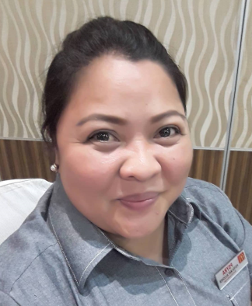
PSYRA-MAY L. ALCOVER
SitioMAharlikaSambag II Urgello Cebu City
Mobile # (+63)-9478392145
E-mail Address: blusnake28@yahoo.com

POSITION DESIRED : FOOD SERVER, FACTORY WORKER, MANAGER

PERSONAL DATA
Birth Date : May 28, 1983
Birth Place : Cebu City
Age : 38 years old
Height : 5’2”
Weight : 120 lbs.
Civil Status : Married
Sex : Female
Religion : Roman Catholic
Nationality : Filipino
Name of Spouse : Ranil G. Alcover
Occupation : Electrician
Name of Father : Mr. Jovito Y. Lascuňa Jr. ( deceased )
Occupation : Businessman
Name of Mother : Mrs. Celerina D. Lascuňa ( deceased )
Occupation : Housewife

EDUCATIONAL BACKGROUND

VOCATIONAL : Cebu Center for Skills Development & Training Inc.
Gen. Maxilom Ave., Cebu City
Caregiving Course

TERTIARY : Southwestern University
Aznar Road Urgello Cebu City
BSPE 3rdyear college

SECONDARY : Southwestern University
Aznar Road Urgello Cebu City
March 2000

PRIMARY : City Central School
Osmeňa Blvd. Cebu City
April 1996

WORK EXPERIENCE

Company : Coast Pacific Golden Milestone Corp. (McDonalds)
Address : Coast Pacific Mahiga Creek, KasambaganBanilad Cebu
Date : March 1, 2016– Present
Position : Marketing Manager
Description : Look for Sales & Incharge in any Markting Events

Company : Golden Arches Development Corp. (McDonalds)
Address : Citibank Center, Paseo de Roxas Makati
Date : October. 10, 2007 – Present
Position : Service Crew / Local Store Marketing
Description : Party Hosting, Order Taking, Marketing Sales

Company : John Paul II home for Priest
Address : Seminario Mayor de San Carlos Compound
Date : July 12, 2008 – July 12, 2010
Position : Volunter Caregiver
Description : Monitor Vital Signs, Assisting Patients, Serving Meals & Meds

Company : Golden Arches Development Corp. (McDonalds)
Address : Citibank Center, Paseo de Roxas Makati
Date : March 31, 2006 – June 30, 2006
Position : Service Crew – Kitchen Department
Description : Toasting and Dressing the buns

Company : Tradewinds Rattan and Handicrafts
Address : THRI ppound, Tabok, Mandaue City
Date : February 16,2005 – June 10, 2005
Position : Production Worker – Veneering Department
Description : Making Designs for the furniture by using veneers

Company : JJ-LL Furniture Manufacturing
Address : Sacris Road Ext., TipoloMandaue City
Date : June 30, 2004 – February 21, 2005
Position : Production Worker – Veneering Department
Description : Making Designs for the furniture by using veneers

Company : Mehitabel Inc. Plant 2 LFI
Address : Tac-an Road Talamban, Cebu City
Date : December 4, 2003 – March 3, 2004
Position : Production Worker – Veneering Department
Description : Making Designs for the furniture by using veneers

Company : Maitland-Smith Co. Inc.
Address : MEPZ 1 Pusok, Lapu-lapu City
Date : July 8, 2002 – March 4, 2003
Position : Production Worker – Veneering Department
Description : Making Designs for the furniture by using veneers
REFERENCES

Name : FR. AGUSTINE ANCAJAS
Company/Address : John Paul II Home for Priest
Position : Administrator/Priest

Name : Mrs. Elilzabeth Lima
Company/Address : McDonalds Cebu-Philippines
Position : Resraurant Manager

Name : Ms. RolletaAbala
Company/Address : McDonalds Cebu-Philippines
Position : Resraurant Manager

