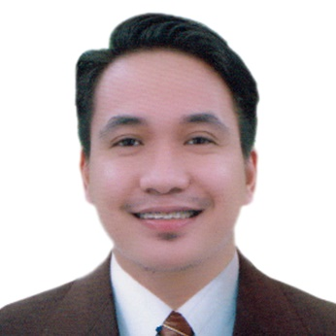

Christian R. Carubio
# 26 Camia St. Castillo Park Subd. Almanza Uno,
Las Piñas City, Philippines
Contact No. 0912-664-5275
Email: chriscarubio20@yahoo.com

Job Objective: Seeking management position in fast growing company where I can utilize my skills, knowledge, experience and educational background to improve operations, increase profitability and enhance growth.
Qualifications:
- Good in interpersonal and communication skills.
- Established good working relationship with co-employees.
- High skills in responding rationally and calmly to guest and employee conflicts.
- Can handle and manage people/staff.
- Computer literate.
Work Experience:
December 2020 – Present Robinsons Retail Holdings Inc. Store Manager Robinsons Supermarket
January 2020 – Sept. 2020 Popeyes Philippines Assistant Restaurant Manager SM Southmall, Las Piñas City
September 2018 - January 2020 Golden ABC Inc. (Penshoppe) Store Manager Festival Mall Alabang Muntinlupa City

Aug. 2017 - September 2018 The SM Store (MLC Shoes and Bags Mgt. Corp) (formerly Shoe Mart Inc.)
Selling Department Supervisor
Bay City Mall of Asia, Pasay City

Dec. 2013 – July 2016 Arabian Food Supplies (Chili’s)
Captain Server/Dining Supervisor
Jeddah, Kingdom of Saudi Arabia

June 2012 - Dec. 2013 Philippine Pizza Incorporated (Pizza Hut)
Team Leader
Festival Mall Alabang, Muntinlupa City

Educational Background:

June 2008 – April 2012 Pamantasan ng Lungsod ng Muntinlupa
Bachelor of Arts major in Political Science

June 2002 – April 2006 Muntinlupa National High School
High School Diploma

Training and Seminar Attended:

Certificate of Attendance, Reproductive Health Bill Seminar with Hon. Miriam Defensor-Santiago.November 25, 2011 at Pamantasan ng Lungsod ng Muntinlupa.

Certificate of Attendance, Leadership Training Seminar Year 2 of College of Arts and Sciences.November 21, 2010 at Pamantasn ng Lungsod ng Muntinlupa.

Certificate of Attendance, AKO MISMO A Seminar for a Newly and Better Philippines,
December 9, 2009 at Pamantasan ng Lungsod ng Muntinlupa.

Extra-Curricular Activities:

January 2011 – January 2012 Political Science Society (PLMUN)
Vice-President

January 2010 – January 2011 College of Arts and Sciences (PLMUN)
College Representative

Personal Background:

Date of Birth: October 12, 1989
Place of Birth: PGH, City of Manila
Gender: Male
Civil Status: Married
Height: 5’6
Weight: 55 kg.
Nationality: Filipino
Language: English, Tagalog, Arabic
TIN #: 303-648-015
SSS#: 33-9961603-4
Phil health#: 01-050604641-1
Pag- IBIG#: 1210-4482-5223
Passport#: P3775547B

