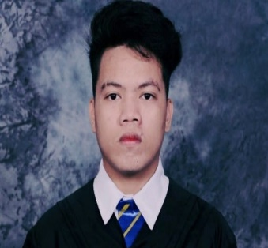
ADRIAN C. TUGADE
73 A. Ricarte St.
West Rembo Makati City
Mobile Number :09217336348
Email Address: Tugadeadrianne29@gmail.com

SUMMARY OF QUALIFICATIONS | - College – Human Resource Development Management  - Good written and oral communication skills  - Great in working with others and passionate in work
RELEVANT SKILLS | Leadership Skills  - Ability to adapt to changes  - Flexibility  - Consistent  - Efficient  Communication Skills  - Good in understanding  - Building connections  - Interpersonal Communication  - Cooperative  - Teachable
EMPLOYMENT HISTORY | - Summer job as a utility worker last April 2019 to June.
- COLLEGE - Present
UNIVERSITY OF MAKATI – Human Resource Management
JP Rizal Ext., West Rembo, Makati City
- SENIOR HIGH SCHOOL - April 2019
UNIVERSITY OF MAKATI - TV Health care
JP Rizal Ext., West Rembo, Makati City
- JUNIOR HIGH SCHOOL - March 2017
Fort Bonifacio High School
JP Rizal Ext., West Rembo, Makati City
- ELEMENTARY – March 2013
West Rambo Elementary School
- Mabini St. West Rembo Makati City
ORGANIZATIONAL EXPERIENCE | NONE
SPECIALIZED TRAINING and SEMINAR | - GLOBAL YOUTH SUMMIT  MOA Arena  August 17, 2019
HONORS and AWARDS | - DEANS LISTER IN GRADE 12  HIGHER SCHOOL NG UMAK

