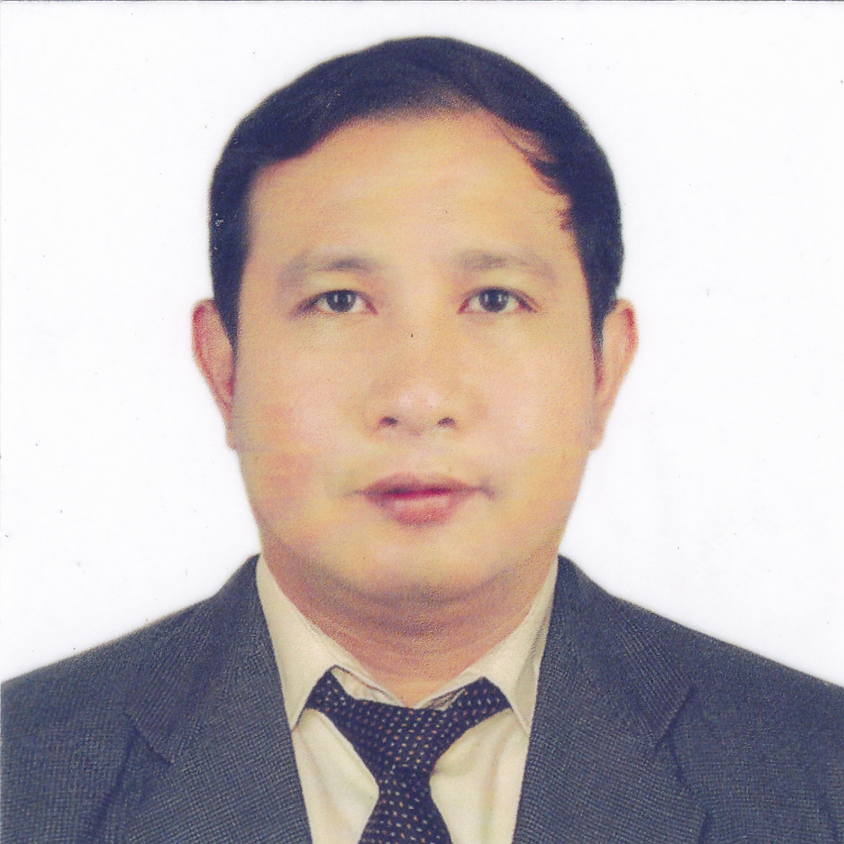
JUN P. CORTEZ
POSITION DESIRED: CHIEF COOK
No. BLK 09 LOT 12 BONIFACIO ST. LAS VILLAS
URDANETA CITY PANGASINAN
Mobile No. : 09955912698
Email Add: junpcortez0018@yahoo.com

EMPLOYMENT HISTORY

CHIEF COOK
Sea Power Shipping Enterprises
Shaw Blvd Cor Priceton St. Mandaluyong City Philippines
025709265
March 27, 2017 – TO PRESENT

D’Amico Ishima Fleet
` Burginde Tower Hidalgo St. Hill Puyat, Makati City
February 5, 2014 – January 11, 2017

Posfil Shipping Management Corporation
Pedro Gil, Hidalgo St. Malate Manila
May 18, 2013 – November 14, 2013

DUTIES AND RESPONSIBILTIES

- Making and publicizing Provision Procurement Plan, and controlling related related document
- Requisitioning provisions and controlling Provision store
- Proper Management of provision including classified storages in cold/ freeze/ Dried condition
- Making and posting weekly Menu
- Food arrangement and catering for outside guest
- Obligation of providing diverse and balanced meals
- Providing Meals in clean and hygienic manner
- Management of gallery and store sanitation
- Regular reporting of provision consumption under direction of Master

CHEF / DE PARTIE

Magsaysay Maritime Corporation
Costa Cruise Ship Line
T.M Kalaw St. Ermita Manila
August 06, 2005 – March 20, 2012

DUTIES AND RESPONSIBILTIES

- For this contract I worked in the station alone as the station chef
- Make Requisition every day, preparing and cooking dishes such as Roast Beef, Chicken, pork and fried fish for lunch and Dinner.
- Also preparing and cooking vegetables and starches in restaurant and self – services buffet every day.
- In charge in 24 hours menu for specials order such as hamburgers, hotdogs, Pizza, and pasta and others
- Monitoring my food stocks every day.
- In charging of cleaning the station.
- Follow strictly the recipe and sets menu set by the company standards procedure
- Worked under strict sanitation procedure under HACCP method.

TRAINING AND SEMINARS ATTENDED:

- National Certificate (NCIII)
January 23, 2017 – January 22, 2022
- National Certificate (NC II)
January 07 , 2014 – January 07, 2019
- Certificate of Competency (TESDA)
May14, 2012 – May 14, 2017
- Certificate of complexion (COC)
Korean Cuisine Certificate
April 29, 2013 – May 03, 2013
- Advancing for excellence (HACCP
December 13, 2012
- HACCP Training Course
November 03, 2010
- Costa cruise line Training Course
October 31, 2005

EDUCATIONAL ATTAINMENT:

Elementary : Piglisan Elementary School
1989 -1994

Secondary : Fort Andres Bonifacio High School
1994 – 1998

Tertiary : Pangasinan Merchant Marine Academy
1998 – 2000

PERSONAL INFORMATION:

Age : 39 years old
Gender : Male
Date of Birth : April 01, 1979
Civil Status : Married
Citizenship : Filipino
Height : 5’5”
Weight : 71 kls.
Religion : Roman Catholic
Spouse : Rowena T. Cortez

Special Cuisine: European Cuisine, Western Cuisine, Asian Cuisine.

I HEREBY CERTIFY that the above information is true and correct to the best of my knowledge.

JUN P. CORTEZ
Applicant Signature

