
SYMOND S. LAG-EY
#82 Cresencia Village, Bokawkan Rd., Baguio City
09772738032
syyada171825@gmail.com

OBJECTIVE:

To secure a position with a stable and profitable organization where I can have personal growth, both mentally and physically with increased benefits for my family, and the opportunity to help the company advance efficiently and productively.

EDUCATION:

- College: Bachelor of Science in Industrial Engineering
Saint Louis University
Bonifacio Street, Baguio City

- Secondary Level: Pines City National High School
Bonifacio Annex
Bado Dangwa Street, Guisad, Baguio City

- Elementary level: Bonifacio Elementary School
Bado Dangwa Street, Guisad, Baguio City

SKILL AREAS:

- Excellent planning skills
- Excellent organizational skills
- Excellent interpersonal skills
- Strong multitasking skills
- Trustworthy, honest, discreet, hardworking, good attitude and ethical
- Strong decision making skills
- Ability to work both as part of a team
- Computer proficient. (MS Word, MS Excel, MS PowerPoint)

WORK EXPERIENCE:

- Syner G Outsourcing Inc.
Auditor
#2 Roman Ayson Road, Crescencia Village, Baguio City
June 2015 - June 2016

- Mitsubishi Heavy Industries Engine and Turbo Charger
Techinical Trainee Machinist/Machining Line Operator
Japan, Kanagawa-ken, Sagamihara-shi
February 2018-December 2020

TRAININGS AND SEMINARS:

- On the job training

- MOOG Controls Corporation
Baguio Economic zone, Loakan Rd., Baguio City
April – May 2013

- Syner G Outsourcing Inc.
#2 Roman Ayson Road, Crescencia Village, Baguio City
May 2014

- Phil-Nippon Technical College
Calamba, Laguna
February 2017-January 2018

- Seminars
- Green Development
Saint Louis University
September 12, 2012

- Climate Change
Saint Louis University
September 21, 2012

- Managing Your Finances
Saint Louis University
January 31, 2013

- Continuous Improvement
Saint Louis University
September 17, 2013

- Personnel Management
Saint Louis University
September 17, 2013

- Creative Thinking And Innovation In Engineering The Call Towards A Sustainable Future
Saint Louis University
September 20, 2013

- Introduction to Six Sigma and the Makeover
Saint Louis University
March 14, 2015

- 5S
Saint Louis University
March 21, 2015

- Leadership
Saint Louis University
April 11, 2015

- IE Tools Application
Saint Louis University
April 18, 2015

CHARACTER REFERENCE:

- Mrs. Michelle C. Adiwang
Department Head
Industrial Engineering Department
Saint Louis University, Baguio City
09157737171
- Mrs. Rita A. Par-ogan
Teacher
Mallare Street Middle
Quezon Hill Elementary School Baguio City
09122477817

- Mr. John Mark R. Sibayan
Policeman
# 94 Cresencia Village
Bokawkan Road, Baguio City
09480644402
Personal Information:

Sex: Male
7Age: 27
Place of Birth: Baguio City
Date of Birth: June 25, 1993
Civil Status: Single
Citizenship: Filipino

I hereby certify that the above information is true and correct to the best of my knowledge.

Symond S. Lag-ey
Applicant
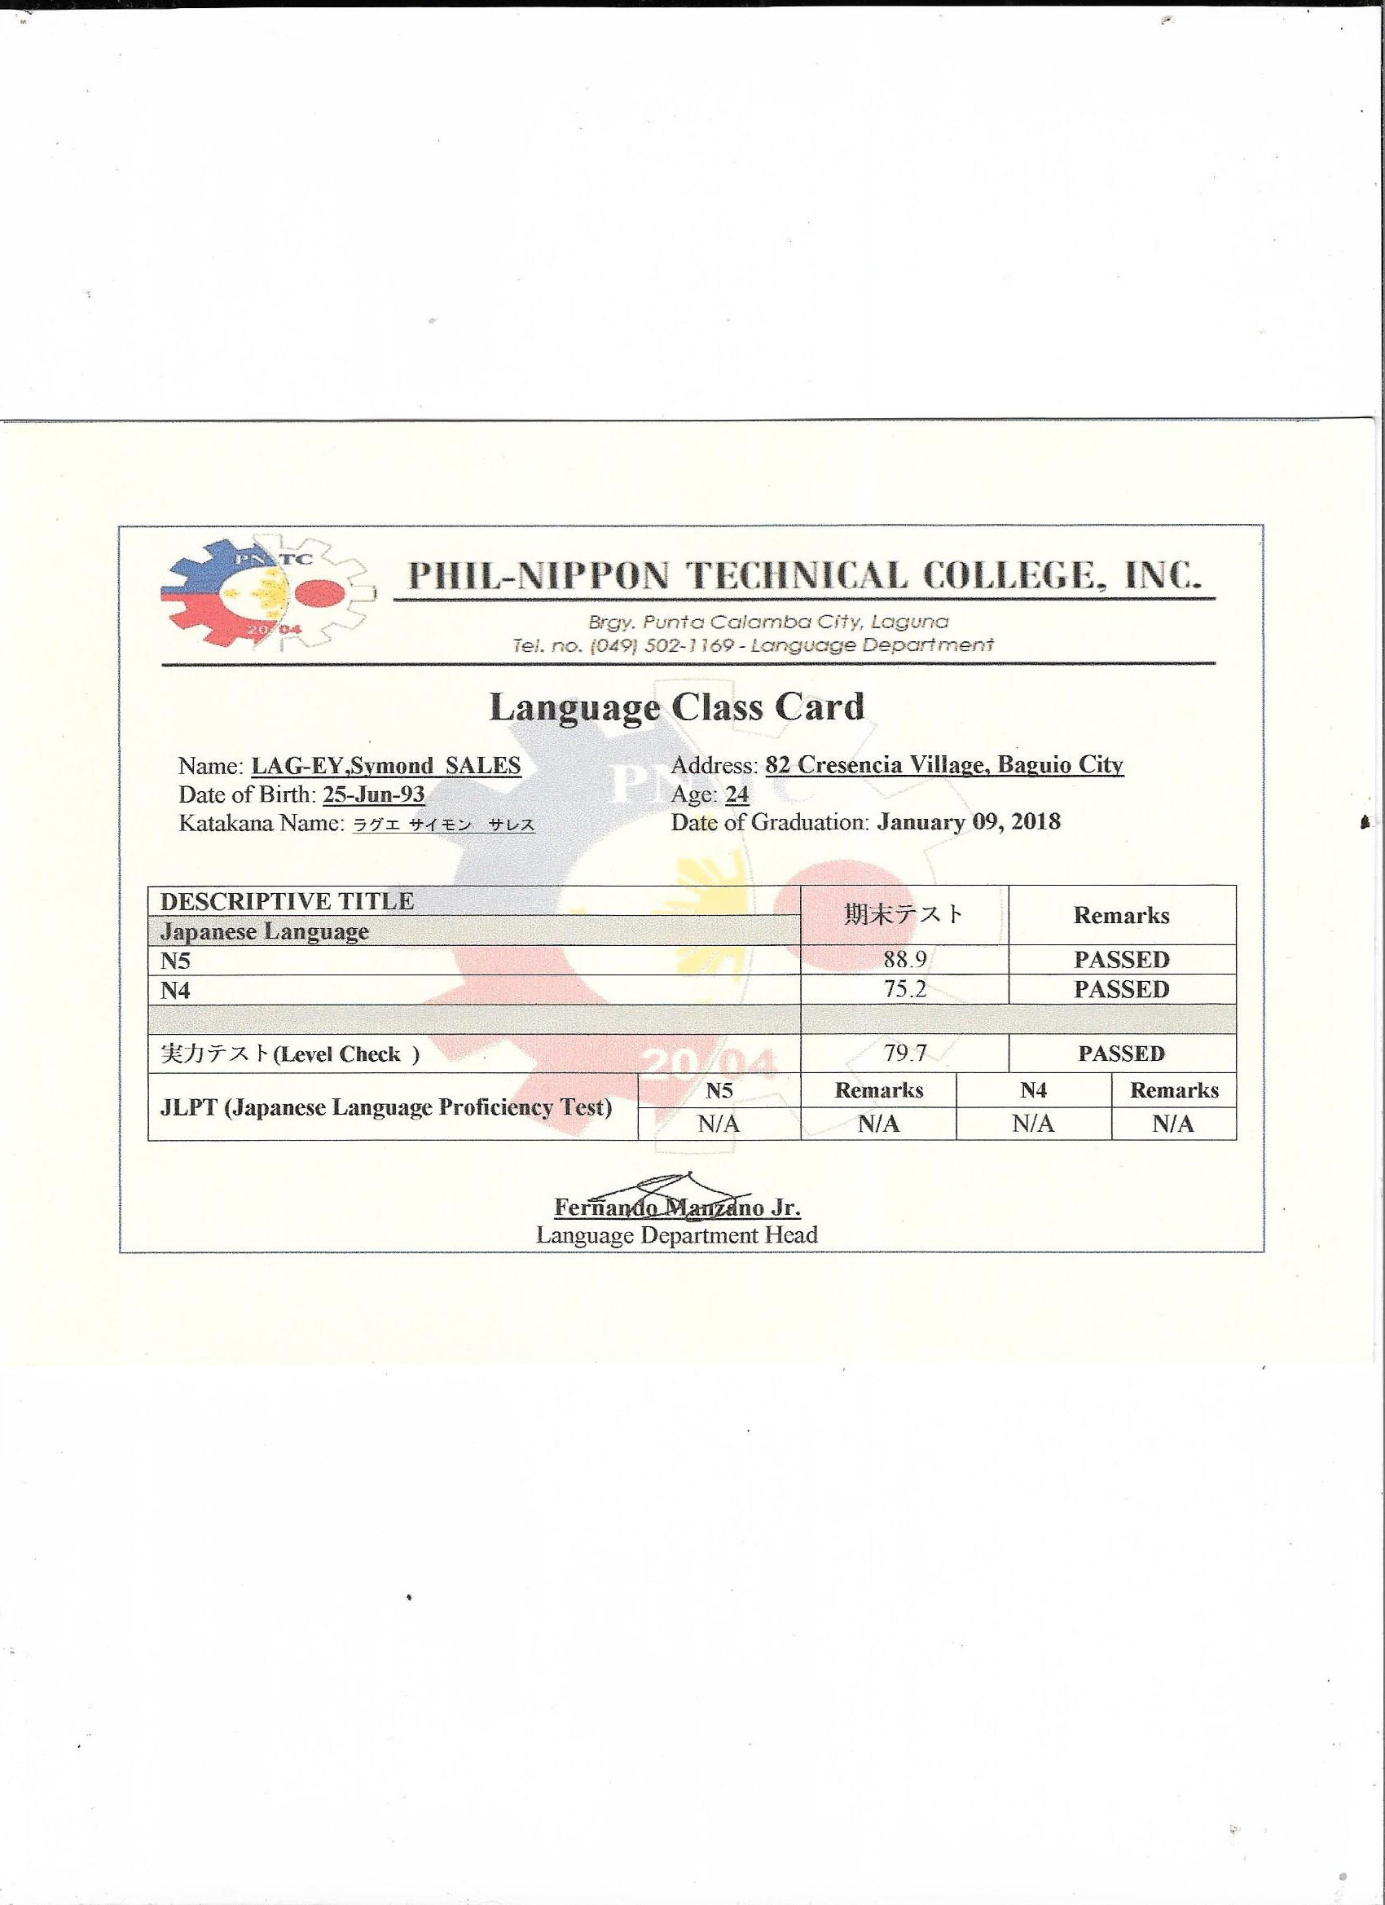

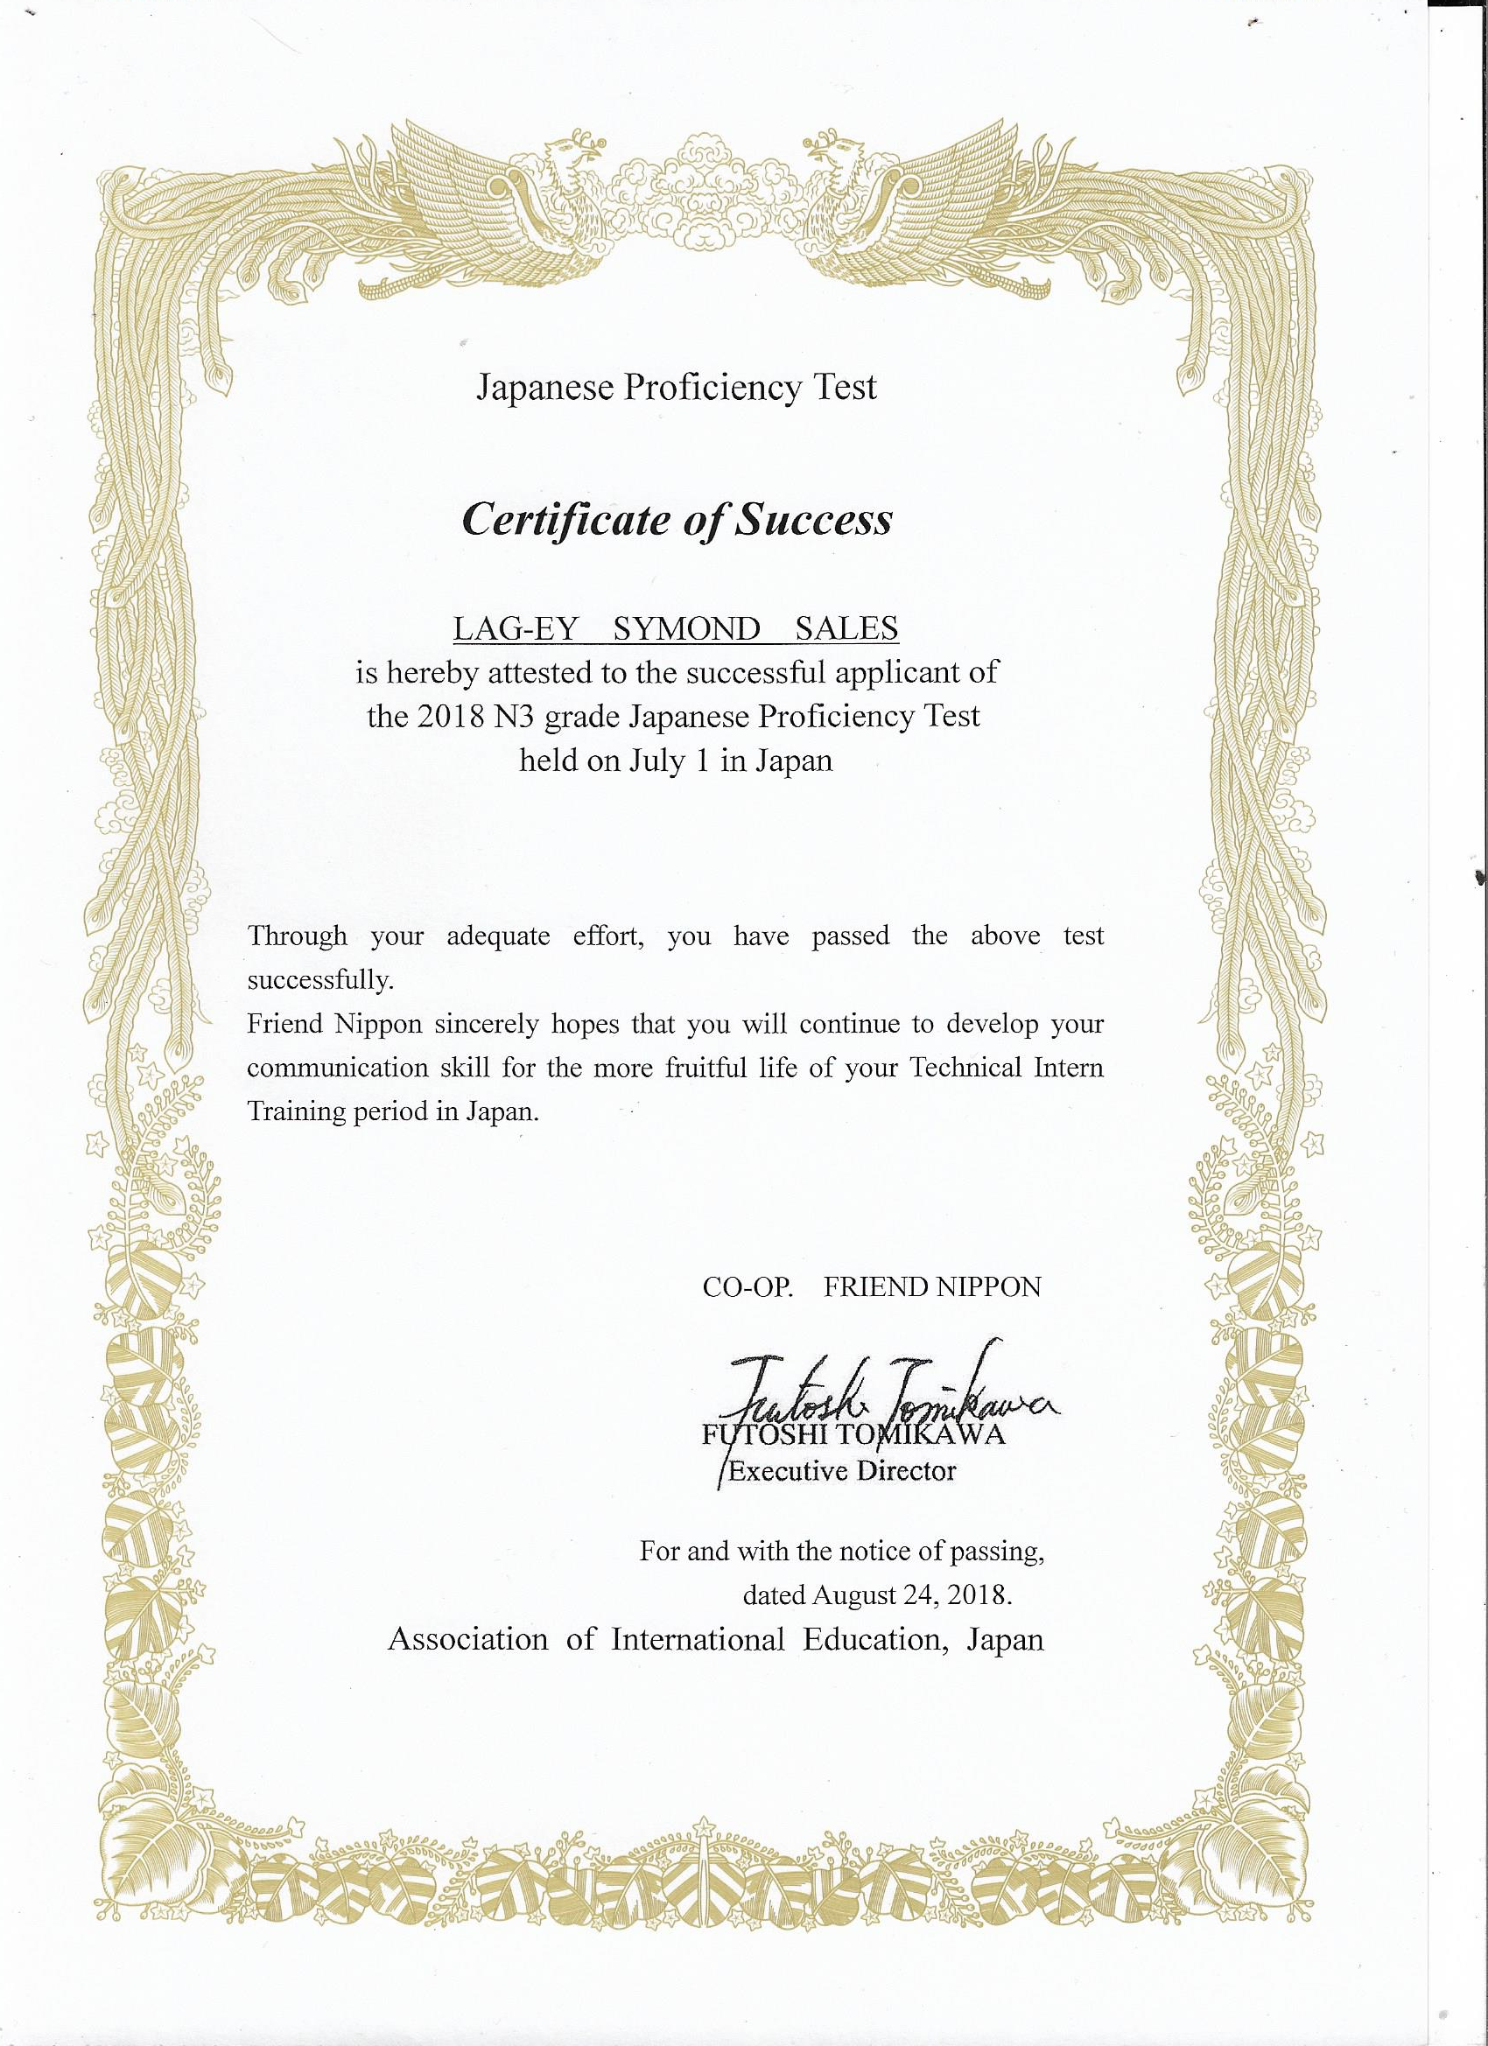

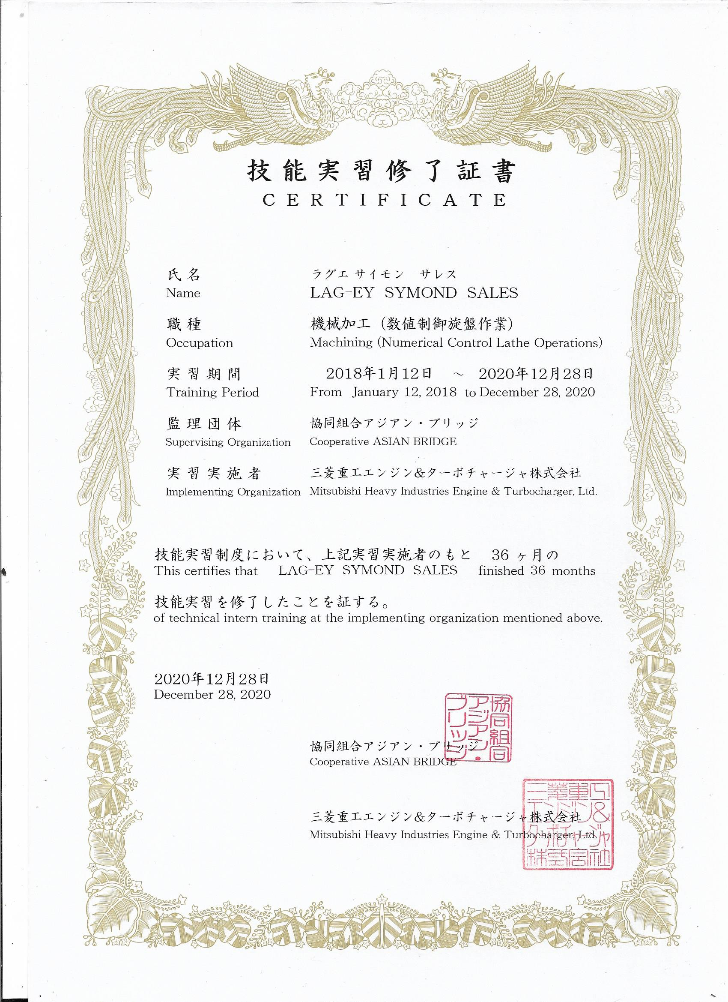

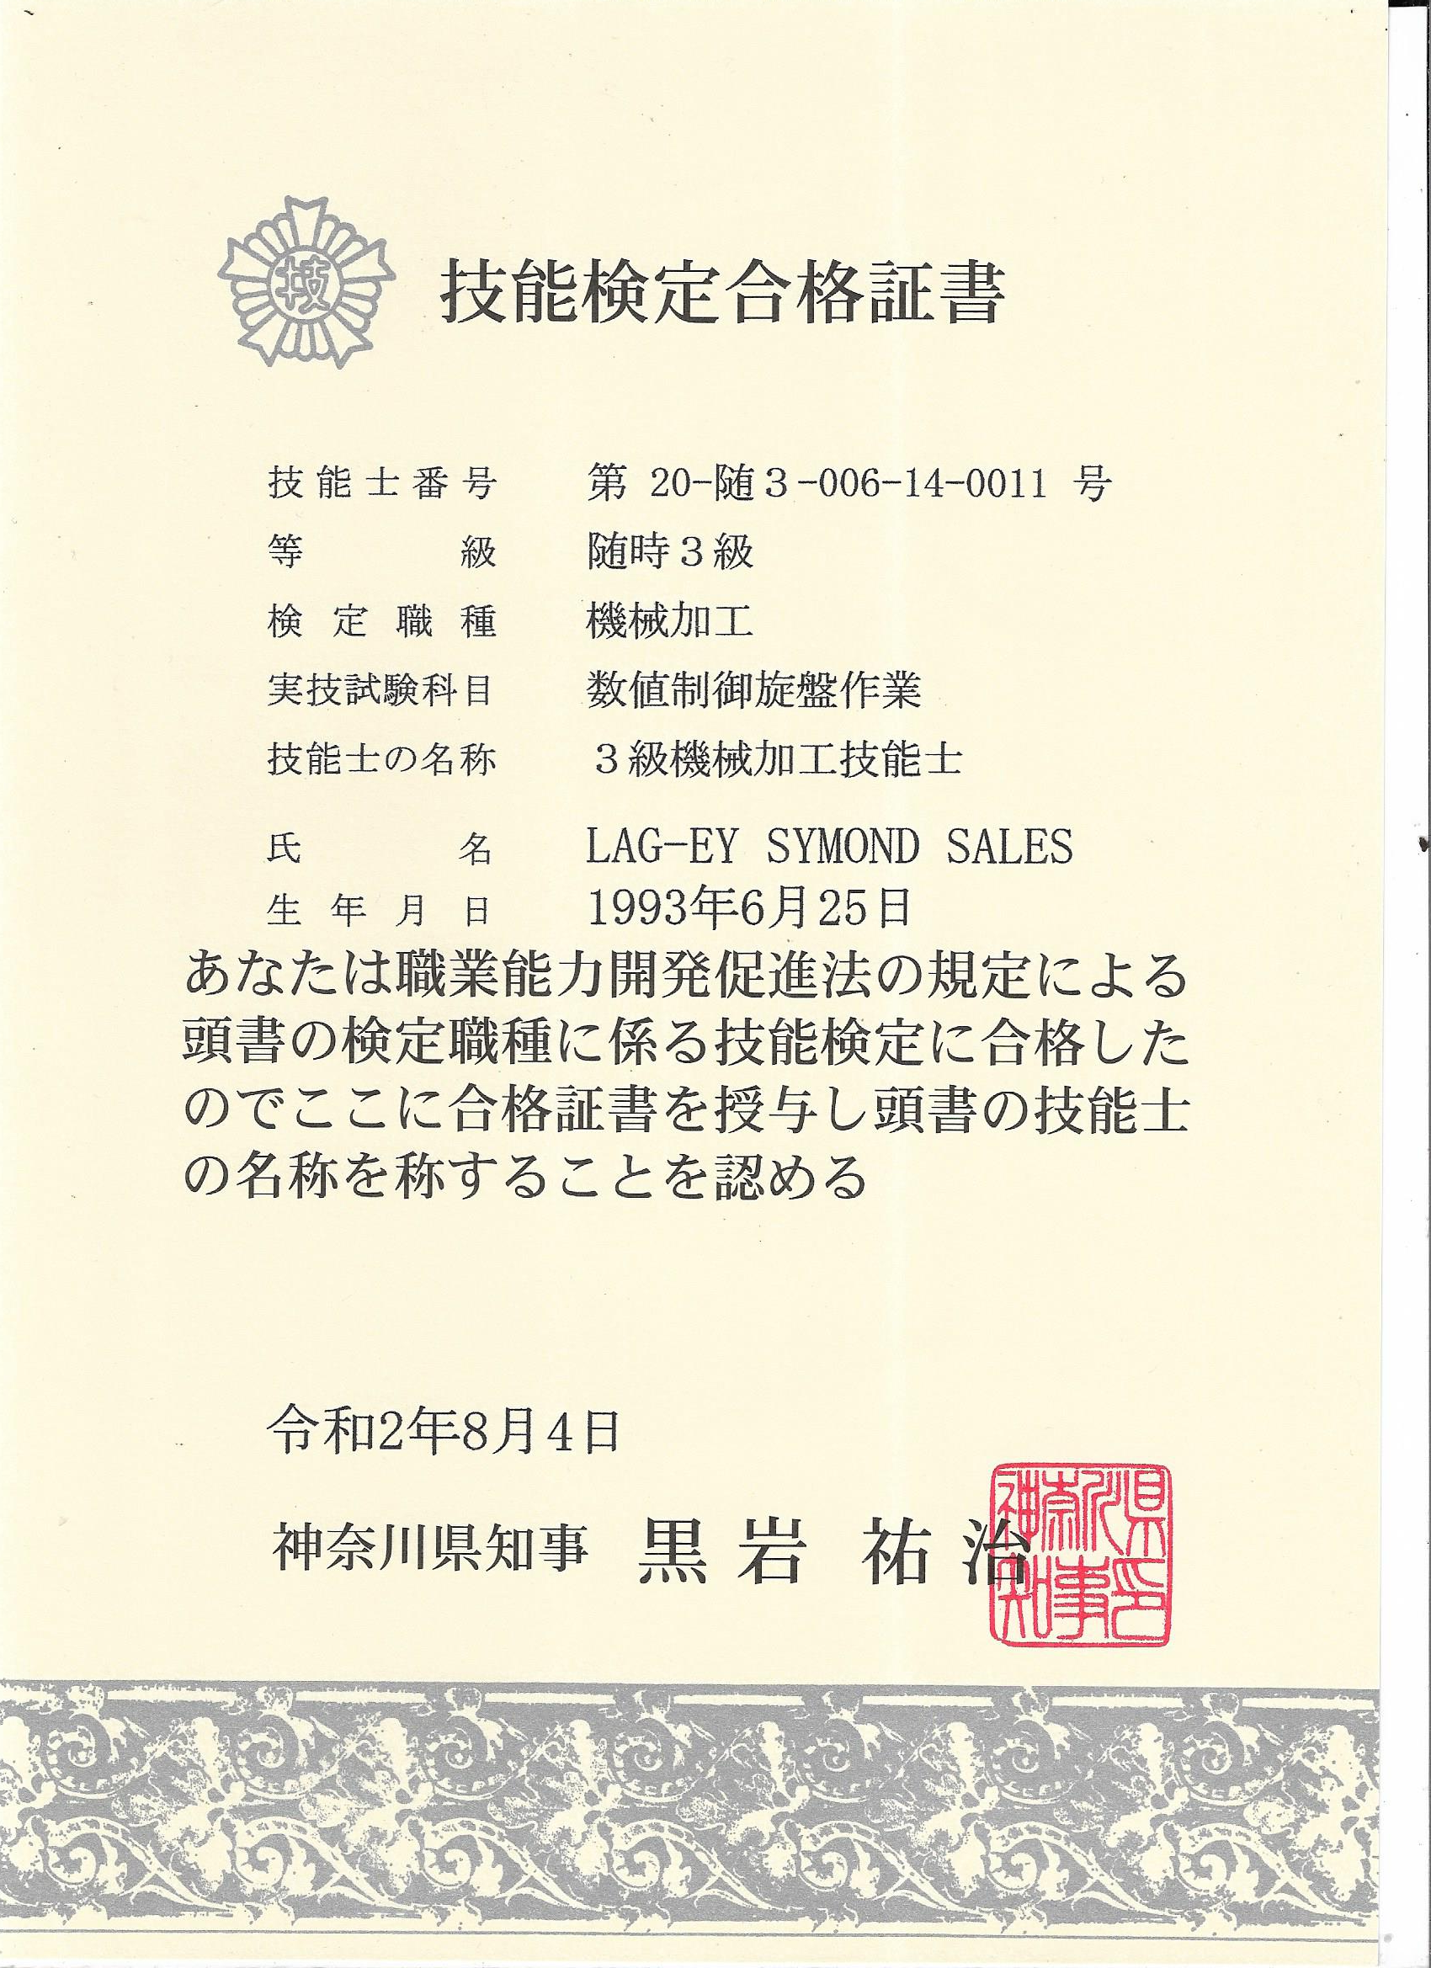

(Government exam certificate for NC Lathe 3 Kyuu Level *Passed)

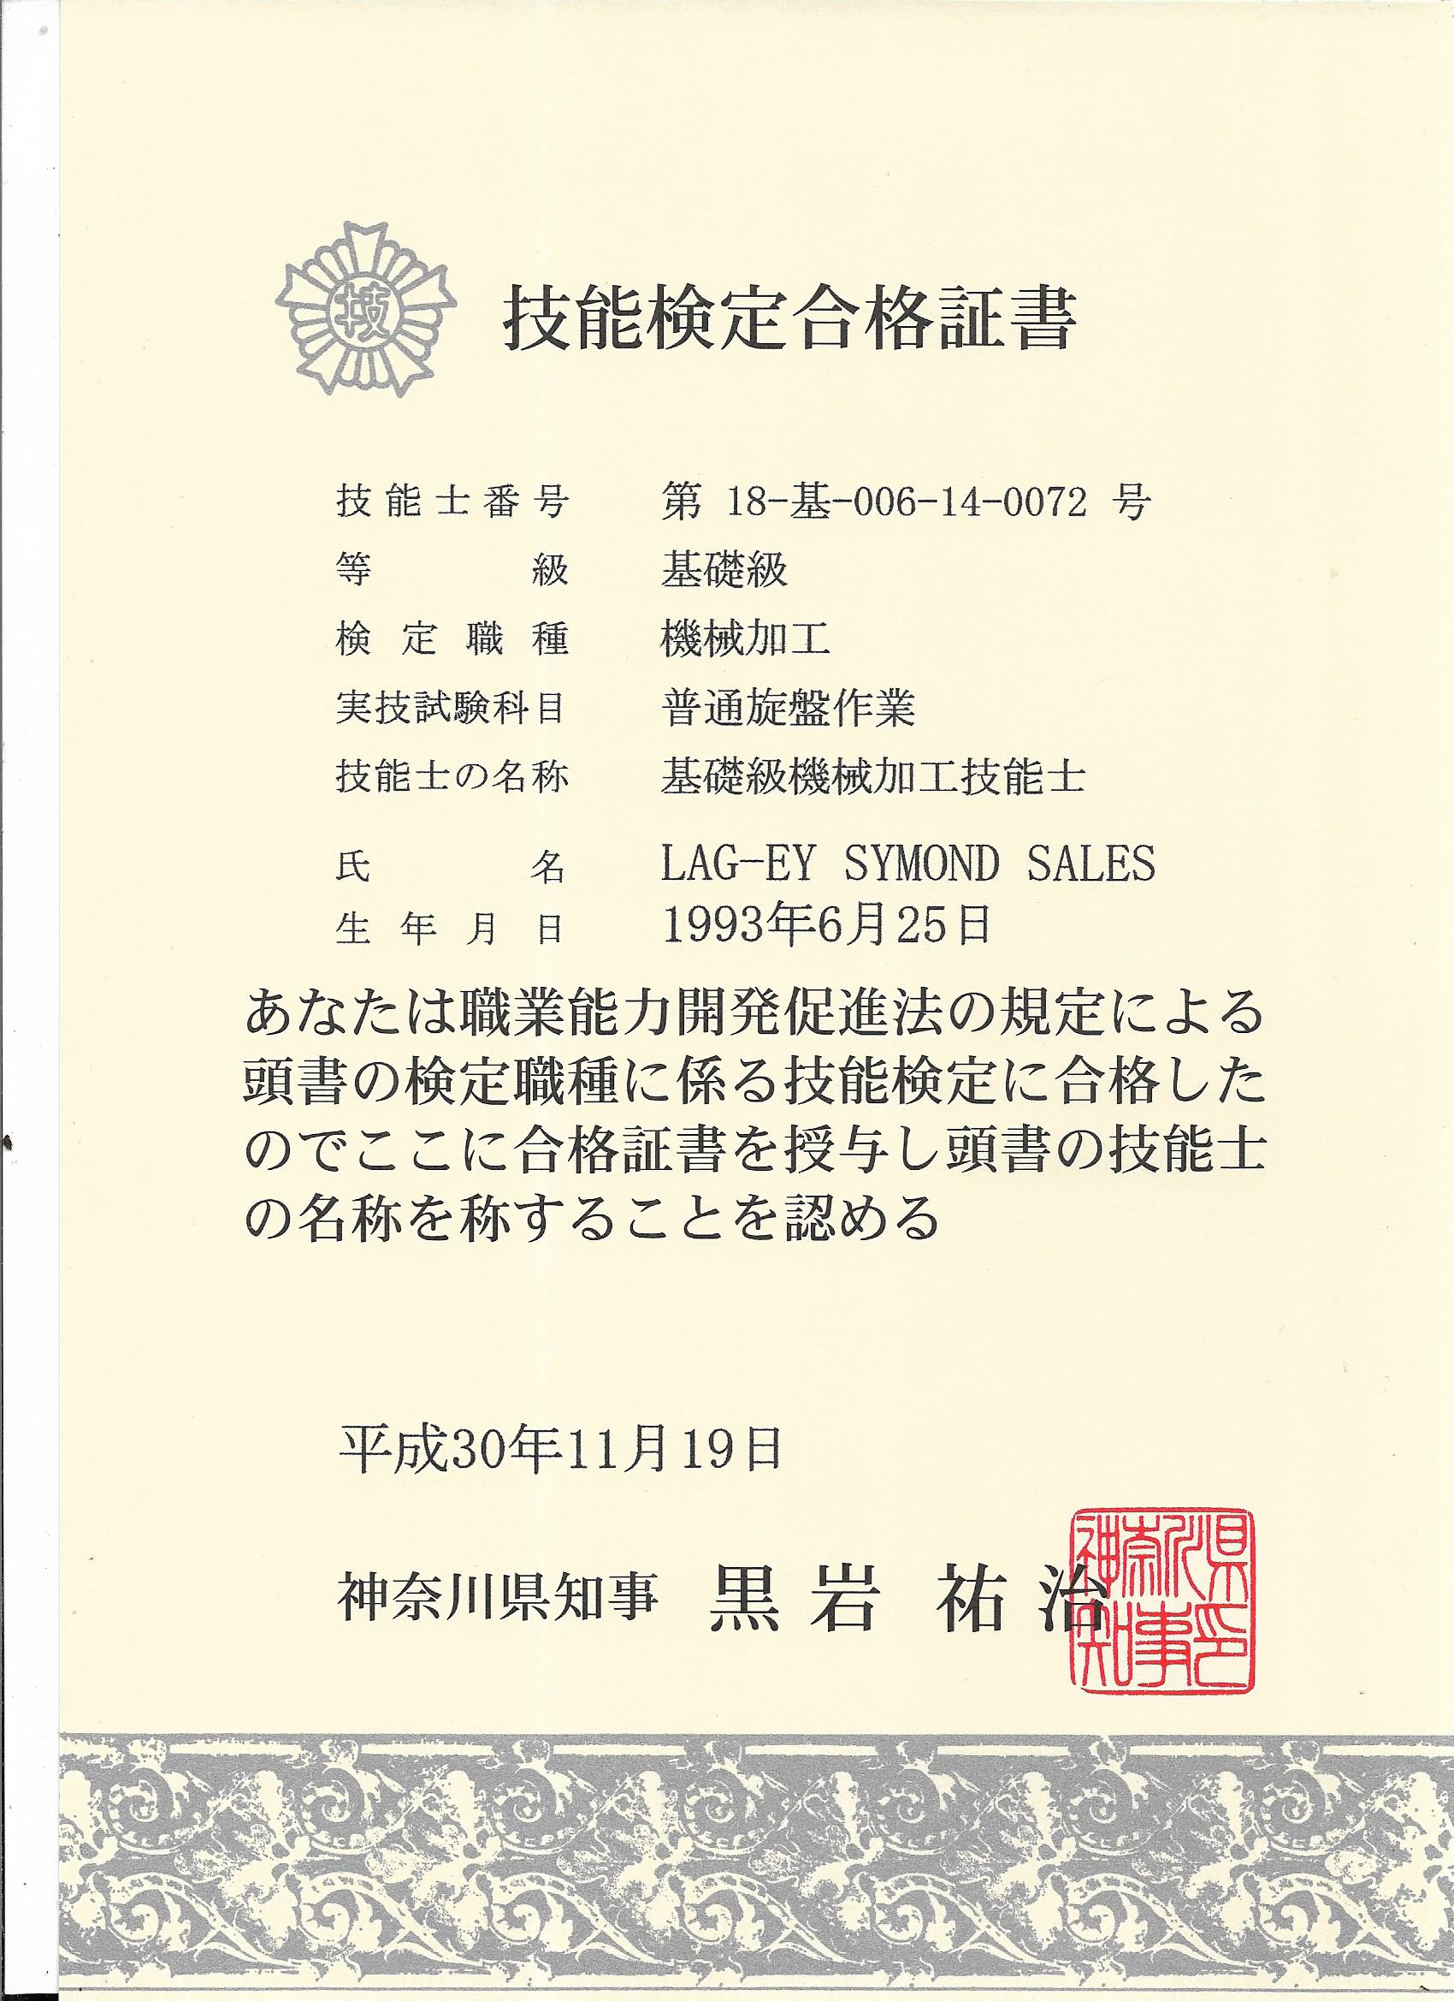

(Government exam certificate for Lathe 2 Kyuu Level *Passed)

