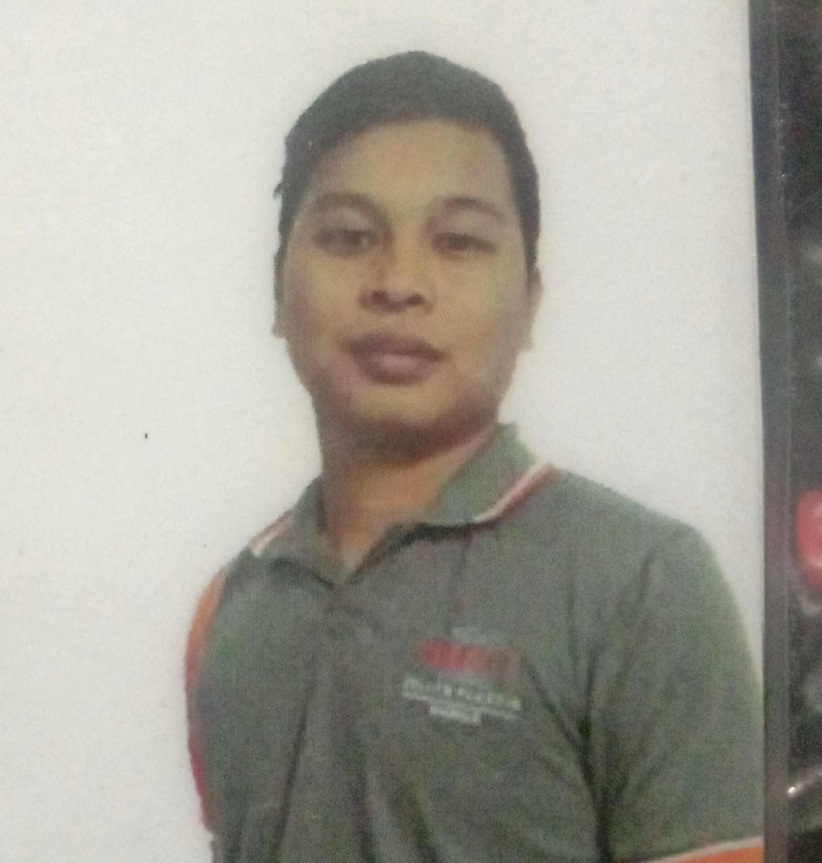
ALVIN V. GENGOS
1118 Espeleta ST. Poblacion, Muntinlupa city
09205354468
PERSONAL INFORMATION

Date of Birth : May 27, 1994
Place of Birth : Muntinlupa City
Height : 5’6”
Weight : 65kg
Religion : Catholic
Civil Status : Single
Citizenship : Filipino
Sex : Male
Mother’s Name : Evelyn V. Gengos
Father’s Name : Abraham V. Gengos
EDUCATIONAL ATTAINTMENT

Tertiary : Pamantasan ng Lungsod ng Muntinlupa
Poblacion, Muntinlupa City
S.Y. 2013 – 2014
BSCS 1st Year
Secondary : Muntinlupa Business High School
Buli, Muntinlupa City
S.Y. 2012 – 2013
Primary : Alabang Elementary School
Alabang, Muntinlupa City
S.Y. 2006 – 2012
CHARACTER REFERENCES

Archie Alfonso Business Owner Muntinlupa City
Michael Teacher Muntinlupa City
EMPLOYMENT RECORD

Nordel Manpower & Job Contracting Service
Uratex Foam Philippines
Production Helper
July 9, 2014 –November 8. 2014
Kawasaki Motors Philippines
Production Operator Assembly Line
February 19, 2016 – July 29, 2016

Authentic American Apparel
Warehouse Man
May 13, 2015 – October 31, 2015

Miramar Manpower
RPC Zeller Plastik Phil. Inc
Production Helper
April 10, 2017 – August 2018

Zeller Plastik Phil. Inc
Production Operator
August 24, 2018 - Present

Skills and knowlegde
-Trouble shooting machine
-Set up camera setting
-Set up and start up injection molding machine
-Adjust injection machine setting
-Knowledge driving forkclift

Machine hadle
-Sacmi Lining Machine
-Sumitomo Demag Injection Molding Machine/Sacmi Camera Vision System
-Ferromatic Injection Molding Machine

I hereby certify that the above information is true and correct to the best of my knowledge and belief.

ALVIN V. GENGOS
Applicant’s Signature

