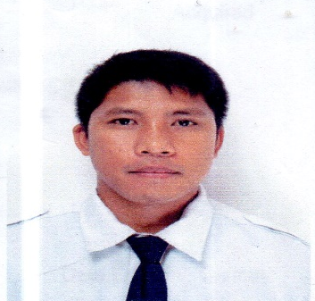
JOHN ANDREW GUERRERO AGUEDAN
J_aguedan@yahoo.com
Contact NO. 09195708623

Personal Information
Date of Birth September 16, 1984 Sex Male
Age 37 years old Civil Status Married
Religion Aglipayan Height 161 cm
Weight 73 kg
Address San Lorenzo, (Pob), Bangui Ilocos Norte

Identifications
Identification Type Identification Number Expiry Date
PASSPORT P8117370A July 26, 2028
SEAMAN BOOK C0894437 August 20, 2026
Tin no. 938-317-439
Drivers License A03-16-004560 September 16, 2024
SSS 01-1631479-0

Educational
Attainment School/Course Year Graduated
College Graduate Northwestern University 2004
Bachelor of Science in
Marine Transportation

Certificates
Occupational Title Certificate No. Issued by Issue Date Expiry Date
BASIC TRAINING 24-522514 MARINA January 14,2016 Jan. 14,201

Trainings
Name Profile Conducted By Special Skills Acquired
UPDATING TRAINING COURSE FOR Duration (HRS) MAGSAYSAY TRAINING CENTER
PERSONAL SAFETY 8
AND SOCIAL RESPONSIBILITY

Work Experience
Company Position Date Started Date Ended Country
MAGSAYSAY MARITIMECORP DEMI CHEF DE PARTIE Nov. 11,2014 Present Philippines
Northern Security Agency Security Guard June 2005 September 2007

Languages Spoken
Language Competency Level Language Proficiency Level Writing Proficiency Level
Tagalog N/A 10 10
American English N/A 10 10

Job Preference
Class Preference Applicant Of Position Industry/Vessel
Seabased Agency Hire Demi Chef De Partie Passenger
Landbased Agency Security Guard

I hereby certify that all information stated above are true and correct

JOHN ANDREW GUERRERO AGUEDAN
Printed Name and Signature

