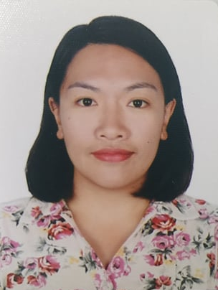
JARETTE LONGBUAN
Address: Block 4, Middle Quirino Hill, Baguio City, CAR, Philippines
Contact No. +63919 345 0963
Email: longbuanjarette@gmail.com

OBJECTIVE:

Seeking a challenging opportunity where I will be able to utilize my strong organizational skills, educational background, and ability to work with people, which will allow me to grow personally and professionally.

ACADEMIC BACKGROUND:

Tertiary : Bachelor of Science in Elementary Education
Baguio Central University
18 Lower Bonifacio St. ABCR, Baguio City, Benguet, CAR, Philippines
(S.Y. 2005- 2009)

Secondary : Barlig National High School
Balig Mountain Province, CAR, Philippines
(S.Y. 2001- 2005)

Primary : Barlig Central School
Barlig Mountain Province, CAR, Philippines
(S.Y. 1995- 2001)

WORK EXPERIENCE:

Domestic Helper
Hong Kong Special Administrative Region
July 2018 - July 2020

Production Operator
Adriste Philippines, INC
June 2017- December 2017

Administrative Aide
Office of the Municipal Mayor
Barlig Mountain Province, Philippines
September 2012 - December 2012,
June 2016 - June 2016, and August 2016 – October 2016

Administrative Aide
Office of the Municipal Mayor
Barlig Mountain Province, Philippines
September 1, 2012 - December 31, 2012
June 7, 2016 - June 30, 2016

Classroom Teacher
Learning by the Hillside, INC
Irisan, Baguio City, Philippines
June 2010- March 2011

SKILLS:
    - Language: Fluency in English
    - Communication: Comfortable writing and speaking
    - Computer Literacy: Proficient at MS Excel, MS Word and MS Powerpoint
    - Gardening

