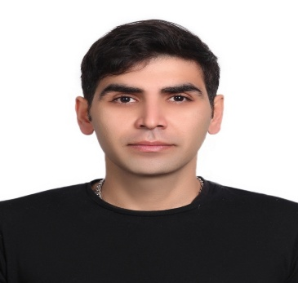
Arash Mostafaei Nejad
Phone: +98-913-105-4423
E-mail: arash.mostafaei@gmail.com

Education:
Electerical Engineering, University of Najaf Abad-Iran
2006-2010
Tourism 2018

Work expriences:
-2010-2013, Omran-Abshar Co., which makes Apartement for Army of Iran: as an electrical engineer.
- 2013, Electronic Service office, as an electrician: test and repair electronic boards
- 2013-2015, R&P group(produces equipments for tiles factories): as coordinator
- 2015-2017 ESCo.(Esfahan Steel Co.) :as an electrical engineer with a german group, Küttner. The recommendation letter could be found in the next page.
- Negar tile Co.: repairing electrical equipments
- Back to R&P group. up to now.
Skills and Languages:
English:
Deutsch:(lerning)
Persian:
Eplan:
Altum designer:
Exel:
Word:

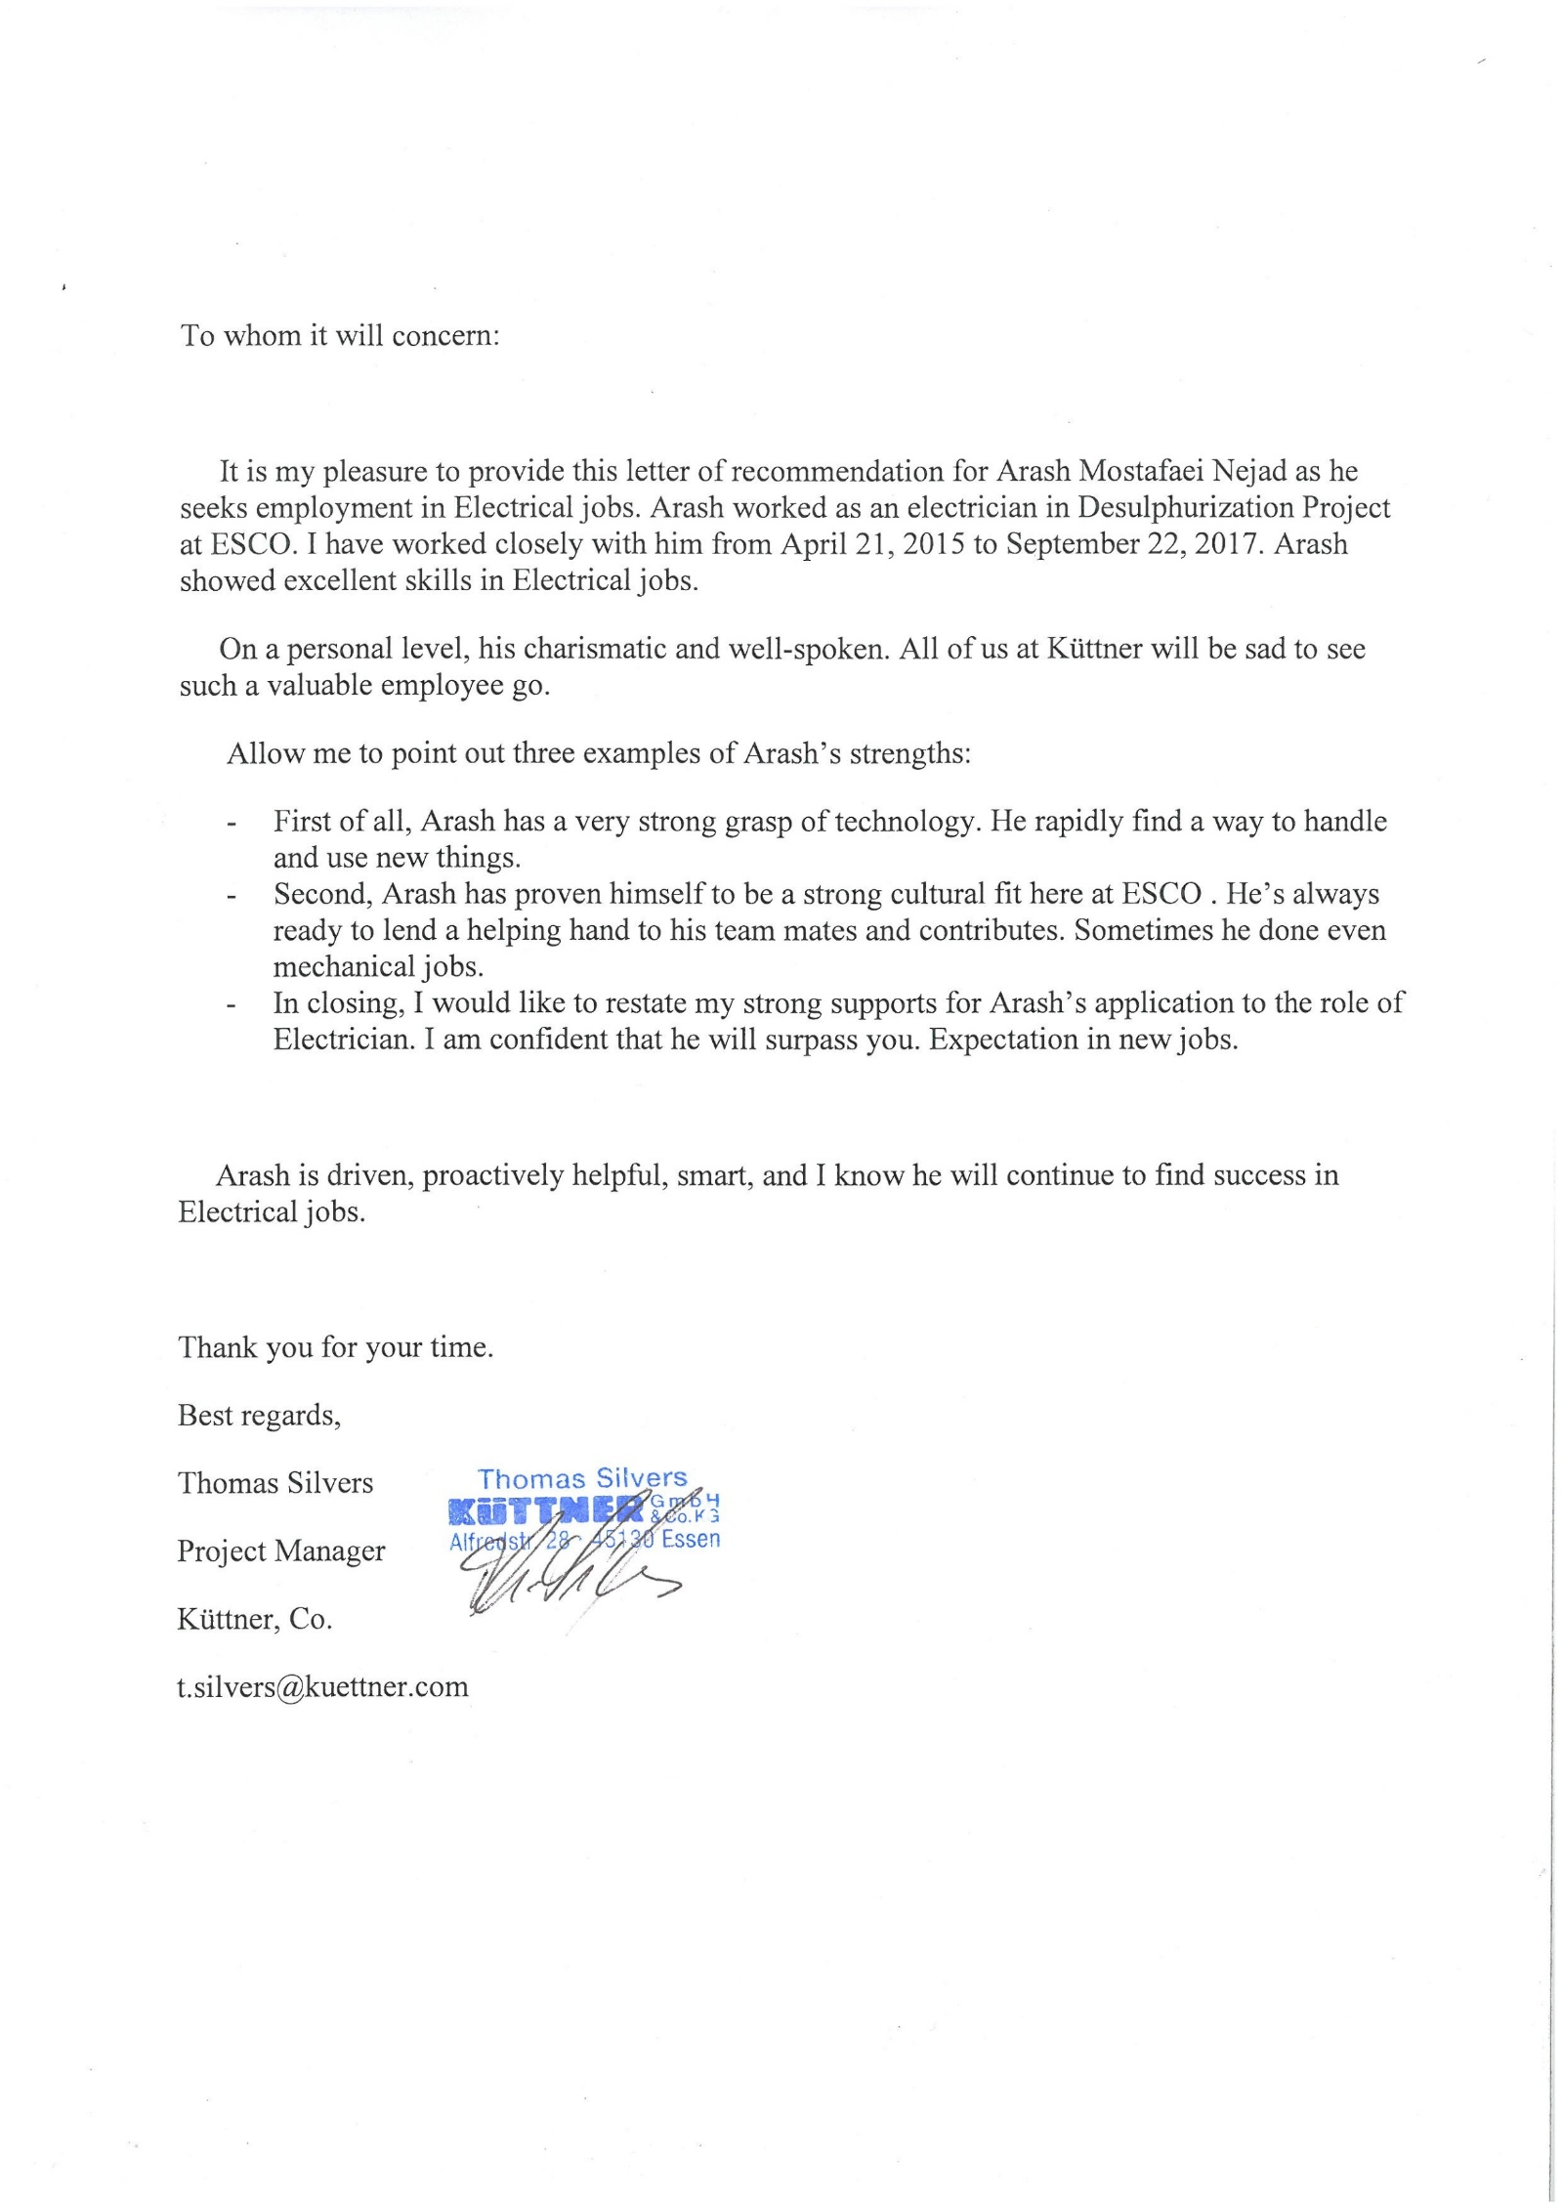
Recommendation letter from site manager of Küttner group:

