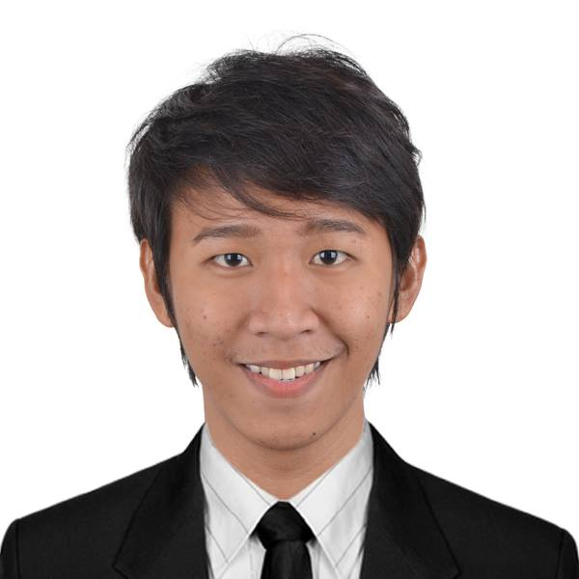
DJ ANFERNEE C. TAMARAY
Linao East, Tuguegarao City, Cagayan 3500
Cellphone number: 09159146910
Email address: djtamaray144@gmail.com

PERSONAL INFORMATION

Birth date: March 14,1996
Civil Status: Single
Age: 24
Sex: Male
Citizenship: Filipino
Religion: Roman Catholic

CAREER OBJECTIVE

An endowed Medical Technologist in performing chemical, biological, hematological, immunologic, microscopic, and bacteriological tests, working within the scope of Laboratory policies and procedures, identifying opportunities for and contributing to the improvement of quality, safety and cost, as well as patient, customer, and employee satisfaction.

EDUCATIONAL BACKGROUND

Tertiary: Cagayan State University-Andrews Campus
Tuguegarao City, Cagayan 3500
Bachelor of Science in Medical Technology
June 2016

Secondary: University of Saint Louis Tuguegarao
Tuguegarao City, Cagayan 3500
May 2012

Elementary: Linao Elementary School
Tuguegarao City, Cagayan 3500
March 2008

SPECIAL SKILLS
-Proven leadership skills and ability to motivate others
- Good Communication skills both oral and written
- Highly organized and efficient
- Ability to work independently or as part of a team

ELIGIBILITY
Examination Passed:
-Licensure Examination for Medical Technologists August 2016

SEMINARS AND LECTURES ATTENDED

-31st Annual Student Congress in Cagayan State University- Carig Campus (March, 2014)

-5th Annual Medical Technology Students Leadership Training and Strategic Planning (May 2014)

TRAININGS

-INTERNSHIP TRAINING at CAGAYAN VALLEY MEDICAL CENTER (Tertirary Hospital

-BLS/CPR-AED for Healthcare Provider Training (August, 2015)

WORK EXPERIENCE

01/02/2020 |  | 12/31/2020 | MEDICAL TECHNOLOGIST II DEPLOYMENT PROJECT | DEPARTMENT OF HEALTH R02
7/16/2019 |  | 12/31/2019 | MEDICAL TECHNOLOGIST II DEPLOYMENT PROJECT | DEPARTMENT OF HEALTH R02
7/18/2018' |  | 10/31/2018' | MEDICAL TECHNOLOGIST DEPLOYMENT PROJECT | DEPARTMENT OF HEALTH R02
2/18/2018' |  | 6/30/2018 | MEDICAL TECHNOLOGIST DEPLOYMENT PROJECT | DEPARTMENT OF HEALTH R02
8/15/2017' |  | 12/31/2017' | MEDICAL TECHNOLOGIST DEPLOYMENT PROJECT | DEPARTMENT OF HEALTH R02

SEMINARS AND LECTURES ATTENDED

-31st Annual Student Congress in Cagayan State University- Carig Campus (March, 2014)

-5th Annual Medical Technology Students Leadership Training and Strategic Planning (May 2014)

TRAININGS

-INTERNSHIP TRAINING at CAGAYAN VALLEY MEDICAL CENTER (Tertirary Hospital

-BLS/CPR-AED for Healthcare Provider Training (August, 2015)

I do hereby certify that the above information are true and correct to the best of my knowledge.

Dj Anfernee C. Tamaray
Applicant

