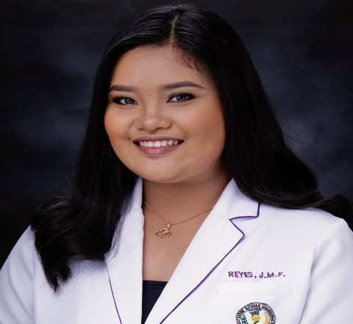
JOANNA MAE F. REYES
Address: Bldg 25 Unit 113 Centennial Village
Brgy. Western Bicutan, Taguig City
Mobile Number: (0916) 4238851
Email Address: reyesjoanna27@gmail.com

CAREER OBJECTIVE
To seek a pharmacist position that requires counseling skills and strong customer service to improve efficiency and to execute exceptional care to patients.

PERSONAL BACKGROUND
Age : 22 years old
Birth Date : February 27, 1999
Birth Place : Balaoan, La Union
Sex : Female
Civil Status : Single
Citizenship : Filipino
Religion : Roman Catholic

EDUCATION
Bachelor of Science in Pharmacy – Centro Escolar University – Makati, 2019
Passed the August 2019 Licensure Examination

TRAININGS & WORK EXPERIENCE

Community Pharmacist – Watsons Personal Care Inc, SMCO A Venue Branch September 25, 2019 – Present
On-the-Job Training: Mercury Drug Corporation – Market Market Branch, April 2016
On-the-Job Training: Army General Hospital, April 2017
On-the-Job Training: Vexxa Lifesciences Ltd. (VE Pharma), April 2018
On-the-Job Training: Pasay City General Hospital, May 2018

SEMINARS ATTENDED:

Gastroesophageal Reflux Disease: The Role of Pharmacist - Online CPD on SwipeRx, March 4, 2021
NextGen Pharmacist: Adapting in the New Retail Pharmacy Imperatives – Watsons Head Office, November 26, 2020
Watsons NextGen Pharmacist love to L.O.V.E (Leadership, Optimum Service, Values, Exceptional Care) – El Cielito Makati, March 11, 2020
Seminar on Handling and Storage of Insulin on Diabetes Management – Watsons Head Office, February 2, 2020
Patient Counseling of Community Pharmacist in Diabetes Management – Watsons Head Office, February 2, 2020
Seminar on “Lower to Lower” Lowering Cholesterol to Lower Cardiovascular Risk – Watsons Head Office, October 27, 2020

CHARACTER REFERENCES:

Dr. Ma. Donnabelle U. Dean
Program Head, Pharmacy Department – Centro Escolar University

Ruth Anne Taupo
Senior Pharmacist, Watsons Personal Care SMCO A Venue branch

joanna mae f. reyes
Address: Bldg 25 Unit 113 Centennial Village Brgy. Wester Bicutan, Taguig City
Mobile Number: (0916) 423 8851
Email Address: reyesjoanna27@gmail.com

To Whom It May Concern,

Good day!

Your posting for a Pharmacist position indicated requirements that match my background. I have attached my resume to provide a summary of my qualifications and background for your review. I am a graduate of Bachelor of Science in Pharmacy at Centro Escolar University - Makati campus on April 2019 and had satisfactorily passed the licensure examination for pharmacists on August 2019. I am interested to apply as Pharmacist in your prestigious company known for excellence in health care delivery.

My credentials suggest that my academic preparation can permit me to make a valuable contribution to the community pharmacy. I gained exposure to the pharmacy department in the same field of pharmacy setting when I had my on-the-job training upon completion of the 960 hours’ internship program. I would also be willing to be trained to cope up with the current settings of the pharmacy. During the internship experience in a community pharmacy, among my duties and responsibilities include providing assistance in the preparation of prescription drugs as well as evaluating drug use. I have experience in a community setting that makes me want to do more in other field of pharmacy just like in your company. Through this, I had the chance to develop my leadership and communication skills, as well as expanding and retaining my knowledge in pharmacy, which would necessary when dealing with physicians and patients.

Should I be qualified for an initial interview, you may reach me via phone (0916-423-8851) or via e-mail ( reyesjoanna27@gmail.com ). Thank you for your time and consideration.

Sincerely,

Joanna Mae F. Reyes

