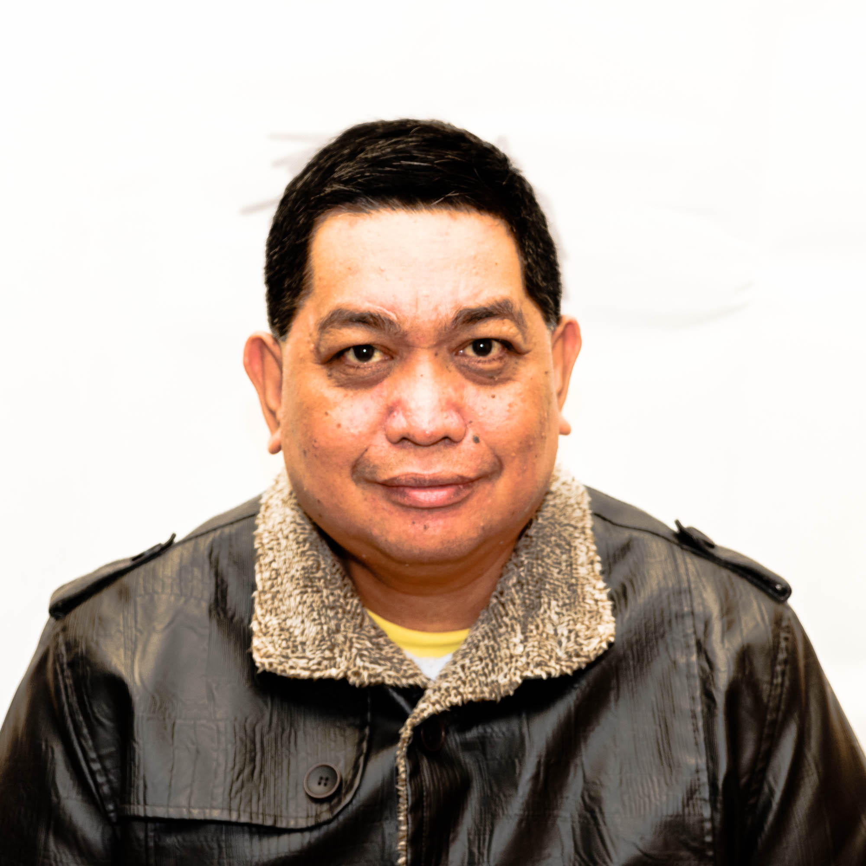

RALPH ABELLA CALIBO
1706 YongXin Octopus Plaza QingNian Road Nantong City
ralph0632003@yahoo.com
+639476405146
+630888161741

PERSONAL SUMMARY

An articulate TESOL Certified teacher and Master’s Degree holder who is able to effectively communicate with students from diverse backgrounds or varying degrees of ability. A committed and dedicated professional with a proven ability to teach, motivate and direct students to maximum performance by encouraging a positive and energetic environment.

- PROFESSIONAL WORK EXPERIENCES

ESL Teacher - Nantong NewChannel English Training Center
September 1, 2014 – present

Duties:

* Teach students of all ages from Kindergarten to University Students including Adults such as Middle School and College Teachers

* Coach students in Jiangsu who are applying for scholarship programs at the National Junior College in Singapore how to answer interview questions in English.
* Teach IELTS and TOEFL Courses
* Teach students how to write essays for National Competitions in China

ESL Teacher - New Day Training School Nanjing, China
July 1, 2014 – August 31, 2014

English Teacher - Jurong Senior High School of Jiangsu Province China
September 1, 2013 – June 30, 2014

CONVERGYS PHILIPPINES SITE
Floor Support Specialist – COMCAST (#33 in Fortune Top 500 Companies)
August 18, 2011 – August 18, 2013

Customer Care Specialist - General Motors Assurance Company Car Insurance August 17, 2009 – August 18, 2011 Department (#10 in Fortune Top 500 Companies)
Awards:
Perfect attendance award for December 2009 - April 2010
Senior Customer Care Specialist - IBM SPRINT June 14, 2007 – August 16, 2009
Awards:
1st Advanis Issue Resolution Award 14 Counts Ranked#1, Feb 2008
Circle of 10 Award Ranked # 4, May 2008
Circle of 10 Award Ranked# 1, June 2008
Circle of 10 Award Ranked# 6, July 2008
Number 1 Agent for the 3rd Quarter of 2008
Perfect Attendance Award for the 3rd Quarter of 2008
Perfect Attendance Award for the Year 2008

Freelance ESL Teacher 2007 - 2013
Awards:
Excellence in ESL Teaching Award May 2012

Saint Columban College
FULL TIME TEACHER
June 1997 – May 2007
Teach the following subjects:
Basic and Advanced English, Business English, Health care/Family Planning,
Social Science Humanities, General Psychology Management and Public Administration
Human Behaviour in Organization, Abnormal Psychology, Educational Psychology
Business Psychology, Developmental Psychology, Experimental Psychology,
Projective Techniques, Psychometrics, Guidance and Counselling, Child and Adolescent Psychology and Basic Kindergarten Teacher's Course
Psychology and Social Sciences Department Area Chair Person
Duties:
Supervise instructors who teach Psychology, Social sciences, Public Administration, personnel management and human behaviour in organization
Conducts meetings and evaluations to the instructors concerned, checks syllabi every semester to make sure all are calibrated.
Does coaching opportunities to instructors who do not meet the required performance evaluation in every semester.
Achievements:
Area Chairperson for Psychology and Social Sciences
Completed training for Syllabi Making
Completed seminar for Organizational Conflict and Labor Management
Completed Seminar for Human Sexuality
Completed Seminar for Parliamentary procedures, Jaycees sponsored
Completed Seminar for Officers Bearing Course Jaycees Sponsored
Social Organizations:
Letran Alumni Association Member
Saint Columban College Alumni Association Member
Jaycees (Pagadian Heights Jaycees) – Officer

- EDUCATIONAL BACKGROUND
TESOL Asian EFL Journal (2012) Cebu City
Master in Public Administration (2000) Saint Columban College Pagadian City
Bachelor of Science in Psychology (1992) Colegio de San Juan de Letran Manila

Professional Courses Attended:
TESOL Training Program (Teacher Training Program for Japanese ESL and Conflict Management Seminar)
Relationship Management Seminar
Syllabi Making Seminar (Training and Delivery Seminar, Teaching Preparations Seminar and Preschool Handling Seminar)

- PERSONAL INFORMATION
Date of Birth:1st July, 1970
Sex: Male
Marital Status: Married
Children: One
Nationality: Filipino
Languages Spoken: English Filipino a little Spanish and few Chinese words

Hobbies
Reading
Music
Travel
Movies
Sports
Photography

