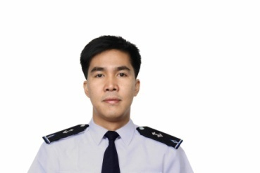
CHARLIE PAPELERA JUSI

- Safety and Security Officer – 2017-present
Company: RJS Industrial Construction Development Corporation
Address : kM. 18 Crossing Eliong Road, Tibungco, Davao City, 8000 Davao del Sur
Phone :(082) 238 0220 , (082) 238 0219 ,

- Security Manager/Chief Security Officer- 2016 - 2017
Company : Enterprise Bank Incorporated
Address : CSSO Building KM.5 Buhangin Road Davao City
Phone : (082) 305 3978 , (082) 225 – 8892

- Private Contractor Armed Security Personnel -June,2015 – February 2016
Address : B1 & B2, 6th Floor, Gundecha Onclave,
Sakinaka, Andheri (East), Mumbai, India - 400072.
Off: +91 22 66010800; +91 22 67256765/66 |24x7 Emergency: +91 22 67254100.

- Maritime Security Professional -March 26,2014- December 30,2014
Company: SecuriState Pte Ltd.
Address: 20 Sin Ming Lane Midview City, #05-66 Singapore 573968
Email: info@securistate.com Phone number: +65 6684 5650 / 5652 Fax number: +65 6684 5651

- Maritime Security Operator-September 03,2013- February 09,2014
Company: MA CREW INC PTE LTD (MCI) / Titanium Security International (
Address: The Vertex 33 Ubi Avenue 3 #07-33 Singapore 408868,(+65 6634 1183)

- Team Leader/Member Security TM no.233-October 23,2011–Sept 29,2012
Company: Gulf of Aden Group Transit Ltd.( GOAGT)
Address: 1 John Lopez Street. Floriana FRN 1400 Malta
Skills Proficiency:
- Knows how to Operate and Drive Vehicle AT / MT
- Computer literate
CRB and Clearances
- Drivers Licenses No.M06-98-01017577
- With Valid United States R-C1/D Visa.
Personal Details:
` Status: Married
Place of Birth: Makilala North Cotabato
DoB: November 12,1978
Place of Res: Km.14 RJS Bldg. Brgy. Panacan Davao City
Contact No. +63915631325, Email: charliejusi@gmail.com
STRENGTHS:
- God fearing
- My family they are my inspirations that’s why I worked hard, Family Loving/Oriented
kind of person
- Hardworking and Very Flexible kind of person
- Easy to catch up, adapt and understand things and instructional operations.
- Humble and down to earth kind of person
- Friendly and Approachable person
- Self-Motivated kind of person
- Worked Professionally
Summary:
A highly professional, hardworking ,flexible, motivated self-disciplined and adaptable individual that performs well under pressure with a wide variety of experience in Personal Security Detail, Close protection and Security Training.

