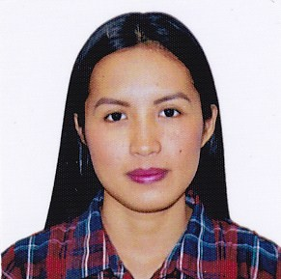
RizhelIbanada
Blk 7, Lot 18, Nitrogen St., Phase 3 Deca Homes,
Brgy. Tungkil, Minglanilla Cebu City
09430133650
ibanadarizhel@gmail.com

Personal Profile / Personal Background :
Date of Birth :Oct. 29, 1990
Place of Birth:Cebu City
Height:5’ 2”
Gender:Female
Civil Status:Single
Nationality: Filipino

Educational Background:

University of San Jose Recoletos Bachelor of Science in Nursing
Magallanes Street, Cebu City March 2011
Graduate

Saint Paul College Foundation Inc. Secondary Education
Bulacao Cebu City March 2007
Graduate

Saint Paul College Foundation Inc. Elementary Education
Bulacao Cebu City March 2003
Graduate

Licenses / Certificates and Work Experience:

- Registered Nurse (License Number 0827714)

- Certificate of BASIC IV THERAPY TRAINING (April 2014)

- Vicente Gullas Memorial Hospital – Nurse trainee (February 2014 – March 2015)

- Exxpert Communications Inc. – SALES AGENT-POD DEPARTMENT(September 2015 - April 2017)

- ACCENTURE INC – Customer Service Representative: SALES, BILLING, COLLECTIONS, TECHNICAL, RETENTIONS, COMPLAINTS(October 10, 2017 – May 2021)

- Mitsubishi Motors – Sales Agent (July 2021 – present)

Strengths and Capabilities:
- Strong analytical and thinking skills
- Adaptable to sudden changes in social environment
- Can work under pressure with minimal supervision
- Good communication skills in written and spoken english
- Knowledgeable in basic Microsoft Office operations

Character Reference:

Mr. Edgar Moncillier
Manager
Deltek Systems Inc.
Mobile No. 09178869534

Virginio C. Garces III, RN
Clinical Instructor
Cebu Normal University
Mobile No. 09989396408

Ms. Almarie Graciano
Assistant Leader
Accenture Inc.
Mobile No. 09225469722

Mr. James Lim
Manager
Wipro Limited
Mobile No. 09228747171

