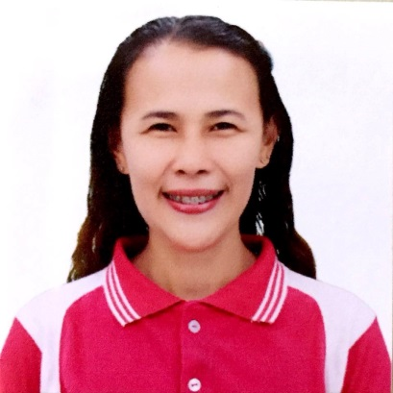
DONAVILLE
PURISIMA

donaville.purisima@deped.gov.ph l +639153916153
Purok 4, Barangay Talavera, Toledo City Cebu 6038

PROFESSIONAL SUMMARY
Responsible Secondary School Teacher that is proficient in teaching Social Studies. Learns and integrate new technologies and teaching strategies as part of leadership and classroom management.

SKILLS
- Time Management
- Verbal and written communication
- Technology Integration
- Differentiated Instruction
- Educational research

WORK HISTORY
Secondary School Teacher
Department of Education, Toledo City Division
Toledo City, Cebu 6038
August 2016- CURRENT

Job Description:

- Talked with students in need of extra attention and made plans to assist with concerns.
- Teaches Government concepts, Asian history, World History, Economics, and Current events to different grade level in Junior High School.
- Utilized curriculum which reflected diverse educational, cultural and linguistic background of student body.
- Taught students building blocks of Social Studies, as well as advanced concepts and tricks to simplify processes.
- Set class objectives and monitored daily performance to offer equal access to education.
- Inspired academic success based on belief that all students can achieve excellence, regardless of background.
- Implemented different technologies such as Computer Assisted Instruction to engage students in class instruction and diversify approaches.
- Created engaging lesson plans, fostered culture of discovery and provided well-organized classroom structure to help students succeed in program.
- Consulted with teachers in different disciplines to identify and adopt successful instructional strategies.
- Assessed students' strengths and weaknesses regularly to provide appropriate methods for addressing learning needs.
- Evaluated academic performance and social relationships to identify and help struggling students.
- Upheld commitment to educational excellence and fostered atmosphere of mutual respect and trust.
- Established and maintained rapport with other staff, students, and parents to facilitate communication and academic progress.
- Created new lesson plans based on course objectives.
- Collaborated with team of faculty to develop after-school tutorial program for students in need of extra help.
- Documented student attendance and progress against goals.

EDUCATION
- University of the Visayas- Main Campus
Masters of Arts in Education
Major in Social Studies
Date of Graduation: Undergraduate (36 Units)

- University of the Visayas- Toledo Campus
Bachelor of Secondary Education
Major in Social Studies
Date of Graduation: March 2015

CERTIFICATIONS
- Licensure Exam for Teachers
License No. : 1421624
- Technical Education and Skills Development (TESDA)
National Certificate II
Bread and pastry Production

