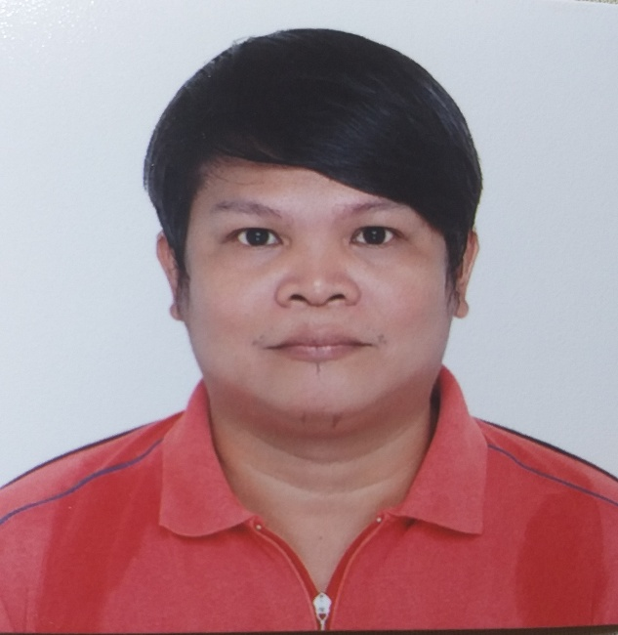
COMPLATE NAME
NAME: RENEN B.CABANGON
House No: B8 Street No: L7 Street Name: Esmeraldas street
City/Town: Mabalacat Province State: Pampanga
Country: Philippines Postal/Zip Code: 2010
Mobile No: +639294945568 Telephone No:
Contact Person in case of emergency: Marcela Cabangon
Contact number in case of emergency: 09295962754

PERSONAL INFORMATION

Age: 42
Birthday: January 23,1979
Birth Place: Caloocan City
Height: 5’4
Weight: 78 kgs.
Marital Status: Married
Nationality: Filipino
Language: Tagalog English Mandarin
Mother's Name: Marcela Cabangon
Father's Name: Ruben Cabangon
Provincial Address: Mulanay Quezon

HIGHLIGHTS
MACHINE USED ( TYPES OF WELDING PROCESS)

- MIG ( Metal Inert Gas)
- FCAW ( Flux Cored Arc Welding)
- SMAW ( Shielded Metal Arc Welding)

TYPE OF WELDERS

- Manufacture Welders
- Structural Welders
- Sheet metal Welders
- Shipyard Welders

KINDS OF WELDERS

- Semi-automatic Welding
- Fabricator
- Fitter
- Assembler

BASIC WELDING POSITION

- Flat Position (1G)
- Horizontal Position (2G)
- Vertical Position (3G)

Able to read and interpret mechanical drawing and welding process specifications,shipyard,heavy industries.Fabricator,fitter reading of blueprint drawing and lay outing.And working as marking in shipyard heavy industries fabricate metal component.Excellent in oral and writing communication,driving code 12 friendly man and hard working.Knowledge of the properties and characteristics of metal used for cutting,welding and forming objects and various welding fluxes and rods.
Conduct test and inspections of product,services or processes to evaluate quality or performance.

JOB DESCRIPTION

- Coded welder mig,smaw,fcaw,tig welding process sheet metal or steel plate.
- Structural sheet metal to heavy wall welding of bracket,stiffiner.Welded heavy wall or butt joint and used ceramic at the back for good root pass.
- Work under pressure,leadership and communication skill,work under minimal supervision.

WORKING EXPERIENCE

Company Name: P.A ALVAREZ PROPERTIES AND DEVELOPMENT CORP.
Address: Calamba Laguna
Position: WELDER SMAW
Duration: (Month,Date,Year ):August 30,2003 to Nov 5,2003
Working hour per Week: 8 hours

DUTIES AND RESPONSIBILITIES

- Welding angle bar for installation of color roof.
- Welding or fabricate steel bar to used in window grill.
- Assemble and fabricate all kinds of gate in all finish house.
- Cleaning area after the 8 hours work
- Always check the material and machine

TOOLS/MATERIALS/EQUIPMENT/MACHINE USED

- Stick weld 6010 6011
- Grinder
- Hummer
- Measurement
- Angle bar,round bar
- Mask,gloves,safety belt
- Manual machine

Company Name: TYC BROTHERS INDUSTRIAL CORP.LTD
Position: MACHINE OPERATOR
Duration (Month,Date,Year): January 14,2010 to June 01,2012
Working hours per Week: 8 hours plus 4 hours ot
DUTIES AND RESPONSIBILITIES

- Operate automatic machine to make a housing of head light and back light of vehicle.
- Always checking the good quality of the product
- Set up the machine before starting for good quality
- Always checking the machine for good condition
- Make a lot every day for output
- Follow the leader and inform for bad situation

TOOLS/MATERIALS/EQUIPMENT/MACHINE USED

- Cutter,plastic,paper,box
- Water
- Screw driver
- Mold,battery
- Overhead crane
- Hydroulic machine

Company Name: HANJIN HEAVY INDUSTRIES & CONSTRUCTION CORP.LTD
Address: SUBIC ZAMBALES
Position: WELDER FCAW,MIG,SMAW,TIG
Duration (Month,Date,Year): October 27,2013 to February 10,2018
Working hour per Week: 8 hours plus 4 hour ot
DUTIES AND RRESPONSIBILITIES
- We build international cargo vessel CMA CGM oil tanker welded steel plate heavy wall
- Welded frame inside one by one welded t-joint long process flat position.
- Working as a marking position reading shipyard plan,writing into plate the thickness for

For welding process.Mark the wall for welding process and bring the material like bracket.

- Coded welder im a qualified to production full welding of different size of heavy sheet metal.Im so qualified to perform MIG/FCAW welding w/backing ceramic for ABS Q2 all steel standard.
This plate is for ultra sonic test in accordance to standard ASME code section IX and AWS DI.I-2004 structural welding code of steel.With complies of ABS (American Bureau of Shipping ).
- Welding of leg platform heavy wall steel using fcaw process.Welding of plate,anodes,bracket,
Stiffiner and t-joint.
- Reading blueprint for structural column and handrails fabricate and fit-up
- Understand the basic layout and structure before starting with welding procedure.
- Select and install torches torch tips,filler wire and flux according to welding chart specification or type and thicknesses of metal.
- Mark dimension and refference line on material.
- Positioned,aligned and clamp component for welding.
- Lay out,fit,and fabricate metal component to assemble structure form.
- Clamp,hold,tack weld,grind component parts to obtain required configurations and position for
Welding.
- Operate manual or semi-automatic welding equipment to fuse metal segment using process
Such as mig,fcaw,smaw.
- Welded metal parts in flat,horizontal,vertical.
- Perform gas cutting,grinding.
- Remove rough spot from work piece using portable grinder,handfile or scraper.
- Qualified and performed welding as per (WPQT) Welding Performance Qualification Test.
- Weld qualification for fcaw E71T-8NIL filler wire.
- Performed and full welding butt joint w/ceramic backing.
- Quality and quantity of work and time management,punctuality and cleaning after.
- Attend every day tool box and safety performance.
- Analyze defective equipment and inform supervisor.
- Ensure clean weld joint to obtain smooth look.
- Maintain disc grinder and perform all cleaning and grinding of metal.
- Analyze speed and length of welding arc for all welding process.
- Assemble all component with help of power and hand tool.
- Perform all kind of welding brazing and cutting on any type of metal using tool commonly
Used in welding work.
- Informed supervisor of any unsafe project condition.

TOOLS/MATERIALS/EQUIPMENT/MACHINE USED

- Filler welding machine,wire brush,capping,flashlight,air blow,measuring tape,welding torch,
Hammer,chalk,caliper,lever block,cutting torch,belt,safety belt,hard hot,gloves,marker.
- Welding mask,disc sander,6010 6011 7018 electrode for smaw,1.0 and 1.2 filler wire for
Mig and fcaw 304 308 filler wire for tig,10mm 12mm 15mm 20mm steel plate,ESAB 300 welding
Machine,manual oxy-acetylene cutting.

Company Name: YOKOHAMA TIRE PHIL
Address: CLARK PAMPANGA
Position: MACHINE OPERATOR
Duration (Month&Year): May 30,2019 up to present
Working hour per Week: 8 hours plus 4 hour ot
DUTIES AND RESPONSIBILITIES

- Operate automatic machine and check the quality of the product.
- Set up the machine before starting and check for the good running.
- Change the mold for another order of the product.
- Always cleaning the area after work for good environment.
- Follow the rules of company for good behavior.

TOOLS/MATERIALS/EQUIPMENT/MATERIAL USED

- Automatic machine
- Mold
- Rubber tire
- Cutter
- Tire rack

EDUCATIONAL BACKGROUND

ELEMENTARY SCHOOL
School Name: R.T CAMACHO ELEM.SCHOOL
Address: ALABAT QUEZON
Duration(Month&Year): March 30,1992

HIGH SCHOOL
School Name: RESPSCI
Address: PASIG CITY
Duration(Month&Year): March 30 1996

COLLEGE(Indicate if you are Graduate/Undergraduate)
School Name:T.I.P
Address: QUIAPO MANILA
Course Taken: Mechanical Engineering
Duration(Month&Year): June 10,1996 to March 17,1998

VOCATIONAL
School Name:SAMSON COLLEGE
Address: CUBAO, QUEZON CITY
Course Taken: ELECTRONICS TECHNICIAN
Duration(Month&Year): June 07,1998 to October 08,2000

LICENSE TAKEN(If have)
Type of License: DRIVER LICENSE
License Number: NO197215551
Expire Date: December 23,2018

CHARACTER REFFERENCE
Name: JAMES EVANGELISTA
Work Position: SUPERVISOR
Mobile/Telephone Number: 0912 8375727

Name:ROMMEL PANERGO
Work position: MANAGER
Mobile/Telephone Number:

I here by certify that the above information is the true and correct to the best of my knowledge and belief.

RENEN B. CABANGON
APPLICANT SIGNATURE

