Good Day!

I am writing to apply in your company as a full-time barista. I am eager to extend my skills, ability and quality service with dedication. I have a 1 year experience as a barista at starbucks here the Philippines.
I am a person who gets things done and handles a variety of tasks efficiently, organizes my time and completes tasks quickly and accurately. I can work under pressure. I am conscientious and service oriented.
I can be reached anytime via email norleeannyap@gmail.com or my cellphone number 09773146745.
Thank you for time and consideration. I look forward to speak with you about this employment opportunity.

Sincerely,

Norlee Ann A. Yap
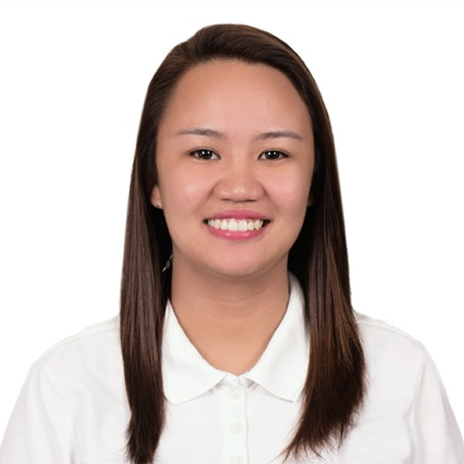
NORLEE ANN ALANES YAP
Address: Purok YBL, Brgy. Sto. Nino, Koronadal City
Contact Number: +639773146745
Availability: Anytime
Email Address: norleeannyap@gmail.com

Career Objectives: To obtain a position where I can maximize my potentials as a productive and active individual giving quality performance at all times for the attainment of the company I aim to be a part of.

PERSONAL INFORMATION
Age: 25 years old
Date of Birth: May 21, 1996
Height: 5’3
Civil Status: Single
Citizenship: Filipino
Father: Norlan A. Yap
Occupation: Human Resource Manager – Yellow Bus Line Inc.
Mother: Anita A. Yap
Occupation: Housewife

EDUCATION
University/School Name: Notre Dame of Marbel University
Location: Koronadal City, South Cotabato
Graduation date: March 20, 2016
Field of Study: Bachelor of Science in Hotel and Restaurant Management
University/School Name: Koronadal National Comprehensive High School
Location: Rizal St. Koronadal City, South Cotabato
Graduation Date: March 30, 2012
University/School Name: Mary Land School
Location: Baldostamon St. Koronadal City, South Cotabato
Graduation date: March 2008

WORK EXPERIENCE

Full-Time Barista- Starbucks Coffee Corporation
June 2019 – January 2021

Tasks/Responsibilities:

- Preparing hot or cold beverages, such as coffee, blended drinks.
- Appropriately suggest additional items to customers to increase sales.
- Assigned in multiple areas.
Barista/Waitress- Bean and Grape Bistro Corporation
October 2016 – June 2018
Tasks/Responsibilities:

- Preparing hot or cold beverages, such as coffee, blended drinks and cocktails.
- Appropriately suggest additional items to customers to increase restaurant sales.

On-the-job Trainee (Housekeeping Department)-Company name: The Farm @ Carpenter Hill
December 2015 – February 2016
Tasks/Responsibilities:

- Make up the room.
- Clean public areas of the hotel like Lobbies, CR and Hallways.

On-the-job Trainee (Food and Beverage Department)- The Farm @ Carpenter Hill
April 2015
Tasks/Responsibilities:

- Welcome the guests and take their orders.
- Answer questions about menu selections and make recommendations when requested.
- Prepare and serve drinks to the guests

SPECIAL AWARDS AND CERTIFICATIONS
- 8th Negosyo Festival Barista Competition 1st Runner up @ Koronadal City
- International Yacht Training “ Professional Superyacht Hospitality” Certification
- International Yacht Training “Superyacht Crew” Certification
- Student On-Board Program at Star Cruises (Superstar Virgo)
- Shipboard Training at 2GO Travels (St. Leo the Great)
- Best Laundry Attendant at The Farm @ Carpenter Hill
- Coffee ology 101; The Basic and New Trends in Coffee making
- Wine making and Salad preparation Seminar at Swiss Deli
- Bar Management Exposure at T.G.I Friday’s
- Seminar on Bartending at Kanto Bar, Matina Town Square

SKILLS & QUALIFICATIONS
- Computer Skills ( MS Word, MS PowerPoint )
- Coffee Making and Latte Art
- Housekeeping
- Customer Service
- Silver Service
- Table Setting
- Table Napkin Folding

CHARACTER REFERENCE
AILEEN VELIGANIO
Head Housekeeper of M/Y Saluzi
aileen.gveliganio@gmail.com
+639611209979
DR. ARIANE DIANE G. PINGOY
CHAIRMAN of Bean and Grape Bistro Corp.
+639177069505
FRANCIS LLOYD GINISERAN
Seafarer, OIC lic N/W
09272578008

