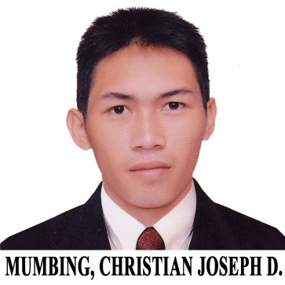
Christian Joseph D. Mumbing
260 Estelita st, Greenfield, Bagbag I, Rosario, Cavite
09356075540 (Christianjoseph_mumbing@yahoo.com)

EDUCATIONAL ATTAINMENT:

Western Mindanao State University AB Political Science
Normal Road, Baliwasan, Zamboanga City (Graduate)
2010-2014

Tesda PTC Rosario Electrical Installation
EPZA, Rosario, Cavite and
July-September 2015 Maintenance NC II

SKILLS AND ABILITIES:

- Computer Literate
- Debate and Public Speaking
- Communicate through different language/Dialect (English, Tagalog, Bisaya, Chavacano)
- House Wiring Installation/Troubleshoot and different light switch installation
- Basic Plumbing
- Drive
- Good Work Ethics (Following instruction, analyzing Situation, Strategic, Punctual, Committed, Problem solver, respect Authority and co-workers, can work under time pressure, can handle multiple task)

WORK EXPERIENCE:

Customer solution Agent II
Paypal
Northgate Cyberzone, 1781 Northgate Ave, Alabang, Muntinlupa, Metro Manila, Philippines
Aug 03,2020 - Present

Call Center Agent (Tier II)
Telstra powered by Teletech
Five E-com 7th Floor Harbor Bldg, Mall of Asia, Pasay City, Metro Manila
January 23, 2017 – July 15, 2020

Line of Business / Skills: Level 0 Complaint / Saves / Consumer

Awards with Certificate: Brilliance Award (January 2018)
Over All Top Performer (December 2017)
Top Case Manager (January 2018)
Net Promoter Score Champ (January 2018)
Close Rate Champ (January 2018)
2 Time New Hire Top Performer (March 2017)

Call Center Agent (Tier I)
Collective Solution Inc.
2nd Floor Lancaster Square Suntech iPark, Imus, Cavite
June 2016 – December 2016
(Finish Contract)

Awards with Certificate: Over all Top Performer (November)
99’ers award (October and November)
Commendation Call (December)
Office Staff
House Research and Development
Block 3, Cavite Economic zone II, General Trias, Cavite, Philippines
November 20, 2015 – May 5, 2016
(Finish Contract)
- Presenting, Arranging and Designing Houses for Japan Through Walk in Computer design system
- Arranging, recycling and disposing used house plan files
Production Operator
International Precision Assembly Inc.
EPZA, Rosario, Cavite
Dec.2, 2014-May 11, 2015
(Finish Contract)
- Operates different kinds of machines and equipment (Hi-Pot Machine, Final test machine, Computer scanner, Press jig, torque driver)
- Assembles different kinds of Replacement Battery Cartridge
- Inspecting product whether its good or reject
- Loading different kinds of product to its respective boxes

FREELANCE:
- Automotive Shop Helper
- Construction Worker
- Sari-Sari Store Helper
- House Painting
- House Boy

References :
Pastor Ramon S Basco # 09158388352
Teacher Gloria N. Devilla # 09177103603
Prof. Rolie Mendoza # 09493730413

